  - Uganda Intergovernmental Fiscal Transfer Programme

UgIFT Asset Verification Report
  - Field findings, service gaps and recommended actions

Client
Ministry of Finance, Planning and Economic Development
Reporting date
27 September 2026
National institutions and local governments
Central, Eastern, Northern and Western regions
Contents
3 Executive summary 7
4 Introduction and background 8
4.1 Introduction 8
4.2 Background to the verification 8
4.3 Justification 8
4.4 Objectives of the assignment 8
4.5 Scope of work 8
5 Approach and methodology 9
5.1 Preparation 9
5.2 What teams checked 9
5.3 Fieldwork and itinerary 9
5.4 Quality assurance 9
5.5 Bringing the findings together 10
5.6 How the findings are presented 10
6 Project context 10
6.1 Programme background and design 10
6.2 Programme components 10
6.3 Programme objectives 10
6.4 Delivery position at programme closure 10
7 Findings 11
7.1 Facilities expected and what was found 11
7.2 National institutions 16
7.3 Regional findings 19
7.4 Condition and use of assets 40
7.5 Asset management practices, gaps and actions 41
7.6 UgIFT support to service delivery 44
8 Appendices 46
8.1 Full summary count schedule 46
8.2 Asset totals by report category and register class 47
8.3 Condition tables behind the charts 48
8.4 Recorded value and net book value schedules 50
8.5 Use and engraving schedules 52
8.6 Master-list reconciliation and ground-return identities 53
8.7 Accompanying IFMIS-ready registers 57
8.8 Evidence supporting the findings 57
List of tables
Table 1: Local government field itinerary 9
Table 2: Programme outputs at closure 11
Table 3: Facilities on the verification master list 11
Table 4: Facilities requiring completion or preparation for use 12
Table 5: Facility reconciliation outcomes 14
Table 6: Expected facilities and the outcomes established during verification 14
Table 7: Examples encountered outside the master-list names 15
Table 8: Asset identification at the listed national ministries and agencies 16
Table 9: Central region: findings and recommended actions 20
Table 10: Central assets and identification by category 20
Table 11: Eastern region: findings and recommended actions 23
Table 12: Eastern assets and identification by category 24
Table 13: Northern region: findings and recommended actions 30
Table 14: Northern assets and identification by category 31
Table 15: Western region: findings and recommended actions 36
Table 16: Western assets and identification by category 37
Table 17: Priority actions to protect assets and restore service 43
Table 18: Whole programme and regional summary counts 46
Table 19: Asset rows by report category and region 47
Table 20: Asset rows by register class and region 47
Table 21: Condition classifications by report category 48
Table 22: Condition classifications by sub-region 49
Table 23: Recorded value and net book value by region 51
Table 24: National ministry and agency value schedule 51
Table 25: Use flags and recorded reasons by report category 53
Table 26: Engraving by region 53
Table 27: Master-list entries accounted for through reconciliation 53
Table 28: Ground-return identities outside master-list names 56
Table 29: Asset information prepared for handover 57
List of figures
Figure 1: All 629 master-list entries were accounted for 12
Figure 2: Unfinished school block at Got Apwoyo Seed Secondary School, Nwoya District (Acholi) 13
Figure 3: Building works at a seed secondary school, Kiboga District (Buganda) 13
Figure 4: School block awaiting completion at Butungama Seed Secondary School, Ntoroko District (Tooro) 13
Figure 5: School buildings and courtyard at a seed secondary school, Buvuma District (Buganda) 21
Figure 6: Raised water storage tank at a seed secondary school, Buvuma District (Buganda) 21
Figure 7: Boxed pulse oximeters at a health centre, Makindye-Ssabagabo Municipal Council (Buganda) 21
Figure 8: Programme and school engraving on a chair at Budde Seed Secondary School, Butambala District (Buganda) 21
Figure 9: Laboratory benches and sinks at Bweema Seed Secondary School, Buvuma District (Buganda) 22
Figure 10: Classroom desks at Bweema Seed Secondary School, Buvuma District (Buganda) 22
Figure 11: Sanitation block at Bweema Seed Secondary School, Buvuma District (Buganda) 22
Figure 12: Science laboratory tables and stools at a seed secondary school, Kalangala District (Buganda) 22
Figure 13: Oxygen cylinders at Kibiri HC III, Makindye-Ssabagabo Municipality (Buganda) 22
Figure 14: Infant radiant warmer at a health centre, Makindye-Ssabagabo Municipal Council (Buganda) 22
Figure 15: ICT laboratory interior under construction at Kitawoi Seed Secondary School, Kween District (Sebei) 25
Figure 16: Unfinished laboratory building at a health centre, Sironko District (Bugisu) 25
Figure 17: Empty computer laboratory at a seed secondary school, Kween District (Sebei) 25
Figure 18: Computer sets stacked in a store at Bumufuni Seed Secondary School, Bulambuli District (Bugisu) 25
Figure 19: Examination lamp in protective wrapping at Buwumba HC III, Busia District (Bukedi) 25
Figure 20: Pedal suction unit in packaging at Majanji HC III, Busia District (Bukedi) 25
Figure 21: Cracked health centre block above collapsed ground, Bulambuli District (Bugisu) 26
Figure 22: Stained and peeling ceiling at a health centre, Sironko District (Bugisu) 26
Figure 23: Cracked desk surface bearing a school marking, Tororo District (Bukedi) 26
Figure 24: Water tank on a cracked base at a seed secondary school, Kibuku District (Bukedi) 26
Figure 25: Broken desk frame at a seed secondary school, Namisindwa District (Bugisu) 26
Figure 26: Damaged chair back joint at a seed secondary school, Budaka District (Bukedi) 27
Figure 27: UgIFT engraving on a health centre bench, Bududa District (Bugisu) 27
Figure 28: Engraving on a wheelchair armrest at Bumugibole HC III, Bulambuli District (Bugisu) 27
Figure 29: Institutional engraving on equipment at Moyok HC III, Kween District (Sebei) 27
Figure 30: Autoclave at Atar HC III, Kween District (Sebei) 27
Figure 31: Solar batteries and control equipment at Atar HC III, Kween District (Sebei) 27
Figure 32: Kangaroo care chair at Atar HC III, Kween District (Sebei) 28
Figure 33: Solar batteries at Bunangaka HC III, Bulambuli District (Bugisu) 28
Figure 34: Infant weighing scale at Buwembe HC III, Busia District (Bukedi) 28
Figure 35: Autoclave above a gas cylinder at Buwembe HC III, Busia District (Bukedi) 28
Figure 36: Computer equipment in the school ICT room at Kabeywa Seed Secondary School, Kapchorwa District (Sebei) 28
Figure 37: Library shelving and tables at Kabeywa Seed Secondary School, Kapchorwa District (Sebei) 28
Figure 38: Delivery bed with a torn mattress cover at a health centre, Busia District (Bukedi) 29
Figure 39: Desktop computers and classroom furniture at a seed secondary school, Busia District (Bukedi) 29
Figure 40: Building works and construction materials at Ndhew Seed Secondary School, Nebbi District (West Nile) 31
Figure 41: Unfinished classroom block at Sidok Seed Secondary School, Kaabong District (Karamoja) 31
Figure 42: Latrine block under construction at Sidok Seed Secondary School, Kaabong District (Karamoja) 32
Figure 43: Boxed desktop computers at Alerek Seed Secondary School, Abim District (Karamoja) 32
Figure 44: Stacked desks, chairs and stools at a seed secondary school, Napak District (Karamoja) 32
Figure 45: Boxed printer and equipment at Sidok Seed Secondary School, Kaabong District (Karamoja) 32
Figure 46: Damaged drip stand at a health centre, Moroto District (Karamoja) 32
Figure 47: Programme engraving on a weighing scale at Kalemungole HC III, Moroto District (Karamoja) 32
Figure 48: Programme engraving on a delivery bed at Kalemungole HC III, Moroto District (Karamoja) 33
Figure 49: Programme engraving on a table at Kamoru HC III, Kotido District (Karamoja) 33
Figure 50: Classroom furniture with school markings at Rupa Seed School, Moroto District (Karamoja) 33
Figure 51: Laboratory reagent containers at Alerek Seed Secondary School, Abim District (Karamoja) 33
Figure 52: Health centre building, Nwoya District (Acholi) 33
Figure 53: Section of the science laboratory exterior at Iriiri Seed Secondary School, Napak District (Karamoja) 33
Figure 54: Solar panels at Kalemungole HC III, Moroto District (Karamoja) 34
Figure 55: Patient toilet block at Kalemungole HC III, Moroto District (Karamoja) 34
Figure 56: Oxygen concentrator at Kalemungole HC III, Moroto District (Karamoja) 34
Figure 57: Suction apparatus at Kalemungole HC III, Moroto District (Karamoja) 34
Figure 58: Wheelchair with programme marking at Kalemungole HC III, Moroto District (Karamoja) 34
Figure 59: Oxygen concentrator at Kamoru HC III, Kotido District (Karamoja) 34
Figure 60: Borehole apron and pipework at Katikekire Seed School, Moroto District (Karamoja) 35
Figure 61: Water storage tanks at Lopei Seed Secondary School, Napak District (Karamoja) 35
Figure 62: Buildings at a seed secondary school, Nwoya District (Acholi) 35
Figure 63: Water storage tanks at Rengen Seed School, Kotido District (Karamoja) 35
Figure 64: Biology laboratory under construction at a seed secondary school, Buliisa District (Bunyoro) 37
Figure 65: Unfinished laboratory interior at Kihungya Seed Secondary School, Buliisa District (Bunyoro) 37
Figure 66: Library interior under construction at Kihungya Seed Secondary School, Buliisa District (Bunyoro) 38
Figure 67: Laboratory stools and other school furniture in storage, Ntoroko District (Tooro) 38
Figure 68: Clinical equipment packed among cartons at a health centre, Hoima City (Bunyoro) 38
Figure 69: Stacked classroom furniture at King Solomon Seed Secondary School, Kagadi District (Bunyoro) 38
Figure 70: Boxed projector and other equipment at King Solomon Seed Secondary School, Kagadi District (Bunyoro) 38
Figure 71: Hospital beds and screens stacked in storage at a health centre, Kagadi District (Bunyoro) 38
Figure 72: Flood-affected older health facility at Butiaba, Buliisa District (Bunyoro) 39
Figure 73: School engraving on wooden furniture at King Solomon Seed Secondary School, Kagadi District (Bunyoro) 39
Figure 74: Programme engraving on a table at Kyabasara HC III, Kagadi District (Bunyoro) 39
Figure 75: Medical-waste bins and ward beds at Butiaba HC III, Buliisa District (Bunyoro) 39
Figure 76: Laboratory centrifuge at Butiaba HC III, Buliisa District (Bunyoro) 39
Figure 77: Delivery bed and clinical furniture at a health centre, Kabarole District (Tooro) 40
Figure 78: Classroom desks at King Solomon Seed Secondary School, Kagadi District (Bunyoro) 40
Figure 79: Gas cylinders and pipework at King Solomon Seed Secondary School, Kagadi District (Bunyoro) 40
Figure 80: Kangaroo care chair at Kyabasara HC III, Kagadi District (Bunyoro) 40
Figure 81: Power house at Kyabasara HC III, Kagadi District (Bunyoro) 40
Figure 82: Classroom desks at a seed secondary school, Ntoroko District (Tooro) 40
Figure 83: Most assets had no engraved identification 41
Figure 84: UgIFT identification on a desk at a seed school, Tororo District (Bukedi) 42
Figure 85: Boxed computers and related equipment in a seed school store, Nwoya District (Acholi) 43
Figure 86: School furniture forms the largest asset category 48
Figure 87: The Functional classification predominates across sub-regions 49
Figure 88: Eastern holds the largest regional recorded value 50
Figure 89: MoFPED and MoES hold the largest ministry recorded values 51
Figure 90: Recorded use is concentrated in school furniture 52
List of acronyms
CIP Capital work in progress
ID Identifier
PDF Portable Document Format
GOU Government of Uganda
FY Financial year
HC Health centre
ICT Information and communications technology
IDA International Development Association
IFMIS Integrated Financial Management Information System
KCCA Kampala Capital City Authority
LGFC Local Government Finance Commission
MAAIF Ministry of Agriculture, Animal Industry and Fisheries
MDA Ministry, department or agency
MoES Ministry of Education and Sports
MoFPED Ministry of Finance, Planning and Economic Development
MoGLSD Ministry of Gender, Labour and Social Development
MoH Ministry of Health
MoLG Ministry of Local Government
MoLHUD Ministry of Lands, Housing and Urban Development
MoPS Ministry of Public Service
MoWE Ministry of Water and Environment
MoWT Ministry of Works and Transport
NEMA National Environment Management Authority
OAG Office of the Auditor General
OPM Office of the Prime Minister
PPDA Public Procurement and Disposal of Public Assets Authority
REAP Resource Enhancement and Accountability Programme
UBTS Uganda Blood Transfusion Services
UgIFT Uganda Intergovernmental Fiscal Transfer
UGX Uganda shillings
USD United States dollars

3 Executive summary
The verification found that UgIFT buildings and equipment were supporting local services, while unfinished works, power constraints, damage and delayed installation prevented some assets from serving their intended purpose. Health staff described improved access to maternity and antenatal care. Schools described better teaching facilities and wider access to secondary education. The main follow-up is to put unused assets into service and sustain those already working.
The verification and reconciliation accounted for 629 master-list entries: 371 health centres and 258 schools. Outcomes included operating names, replacement facilities, relocated assets and sites not constructed. Section 7.1 explains how the institutions were accounted for.
Construction and service readiness need attention together. Got Apwoyo Seed Secondary School in Nwoya had not been commissioned and its computer equipment remained at district headquarters. At Ndhew and Mamba seed schools in Nebbi, unfinished buildings delayed installation. At Atego in the same district, computers were already working in older rooms while construction continued.
Power and repairs were immediate constraints. Lungulu Seed Secondary School in Nwoya held computers in storage pending a suitable power connection. Pamaka Health Centre III in Nebbi could not use oxygen equipment because of power constraints, and Busaale Health Centre III in Kayunga needed roof, door and solar repairs. Among assets recorded as out of use, 2,569 had damage, fault or repair remarks, while 483 were stored and described as good or new.
Asset identification also needs follow-up. Of 225,133 asset entries, 50,211 carried markings, including 21,023 with UgIFT marking. The findings at Lungulu included unengraved assets. Districts should combine marking with decisions on custody and allocation, particularly where equipment has moved between facilities.
The proposed priorities are to make unsafe items safe, restore essential equipment, complete works and utilities, and install usable stored assets. Facility managers should lead routine checks and minor repairs, supported by district engineers, health and education officers and the relevant technical teams. The action schedule proposes owners, timing and evidence that each action has been completed.

4 Introduction and background

4.1 Introduction
UgIFT invested in facilities and equipment to bring education and health services closer to communities and strengthen the institutions that support them. This verification examined where those assets were, how they were being used and what was needed to keep them working. The findings focus on facilities, equipment, custody, maintenance and the services available to the public.

4.2 Background to the verification
The programme ended on 31 December 2025. The Ministry of Finance, Planning and Economic Development commissioned the verification to support closure and the continued use of programme assets. The exercise covered national institutions, government seed secondary schools and health facilities upgraded from Health Centre II to Health Centre III.

4.3 Justification
Buildings and equipment need staff, utilities, maintenance and clear responsibility for their care. The verification provided a basis for handover and identified practical actions to bring unused assets into service, repair damaged items and protect assets already in use.

4.4 Objectives of the assignment
The assignment was to identify and locate programme assets, check their condition and use, assess how institutions cared for them and recommend action where assets were damaged or unserviceable. It also prepared asset information for government reporting and the Integrated Financial Management Information System (IFMIS).

4.5 Scope of work
Teams reviewed institutional asset information, inspected facilities and equipment, and spoke with the officers responsible for their use and care. The scope included buildings, furniture, medical equipment, computers, vehicles and motorcycles. Small office items such as staplers and punches and disposable school laboratory items were excluded from physical inspection.

5 Approach and methodology
The assignment followed 3 phases: preparation, field verification, and consolidation and reporting.

5.1 Preparation
The entry meeting on 29 May 2026 agreed the scope, approach and work plan. A pilot at Buloba Health Centre III and Sumbwe Seed School in Wakiso District tested the tools and visit arrangements. Teams planned visits with Accounting Officers, district health and education officers, finance staff, head teachers and health centre in-charges.

5.2 What teams checked
At each institution, the team checked the assets present, their location, identification markings, condition and use. Interviews covered repairs, servicing, breakdowns, storage, operating constraints and service benefits. Photographs documented selected assets and facilities.

5.3 Fieldwork and itinerary
National verification began on 24 July 2026 and included 10 working days of collection and repeat visits. Training for the local government teams took place on 20 and 21 August 2026. Local government fieldwork ran from 24 August to 7 September 2026, with 10 working days of collection.
The Consultant deployed 33 teams of 2 to 3 people, comprising 80 research assistants, supported by 6 supervisors and a team leader, across 176 local governments. Teams first met the local government leadership, reviewed the planned investments, visited the facilities and discussed the findings with the responsible officers.
National visits covered the ministries responsible for finance, works and transport, education, agriculture, health, water and environment, gender, public service, lands and housing, and local government. They also covered the Office of the Prime Minister, Local Government Finance Commission, National Environment Management Authority, Public Procurement and Disposal of Public Assets Authority, and Office of the Auditor General.
Table 1: Local government field itinerary
Day | Activity | Work undertaken
1 | Arrival and entry | Register the visit at the Accounting Officer's office and hold the entry meeting with finance and administration.
1 | Document review | Review UgIFT documents and the asset register.
2 | Physical verification | Inspect identified assets in offices, health centres and schools.
2 | Service interviews | Discuss functionality, maintenance and sustainability with institution and facility management.
2 | Follow up and debrief | Complete follow up checks, debrief the responsible officers and finalise verification.
Table 1 sets out the sequence followed during local government visits.

5.4 Quality assurance
Regional supervisors checked daily field activity and reviewed the completed tools. The central technical team carried out spot checks and helped resolve operational questions. Teams compared institutional asset information with the items and explanations provided during visits, while supervisors referred matters requiring clarification to the team leader and field coordinator.

5.5 Bringing the findings together
The analysis brought the facility findings, interviews and asset counts together by region, institution and type of asset. Master-list names were reconciled with operating names, replacements and receiving facilities. Section 7.1 explains those outcomes, while the later sections examine use, condition, marking, maintenance and service delivery.

5.6 How the findings are presented
The findings bring together physical inspection, discussions with facility managers, photographs and the asset inventory. They distinguish assets that were available for service from equipment awaiting installation, items requiring repair and facilities requiring completion. Recommendations address the practical steps needed to put these assets to use and maintain them.
The inventory counts each asset once. School furniture, computer and support equipment, health equipment, maternity equipment, clinical furniture and buildings are presented separately. Regional summaries follow the local government location, with Rwenzori and Tooro presented together. The appendices provide the detailed counts, condition classifications and accounting basis.

6 Project context

6.1 Programme background and design
UgIFT began in financial year 2017/18 to improve the financing and delivery of local government services. Initial support focused on education and health. Later support extended the programme to water and environment and agricultural micro scale irrigation, including services for refugees and host communities.

6.2 Programme components
The programme supported a fairer system of grants to local governments, new secondary schools in underserved subcounties, and construction and upgrading of health facilities. School investments included classrooms, laboratories, administration blocks, sanitation and teachers' housing. Health investments included buildings, equipment, staff accommodation and sanitation.
It also supported local government planning, budgeting, procurement and infrastructure management, together with performance assessment and technical support. National institutions received equipment and transport to support programme administration and oversight.

6.3 Programme objectives
The programme sought more adequate and predictable support, fairer allocation of resources and stronger oversight of local services. Its intended result was wider access to education, health, water and irrigation services and better management of the facilities and resources used to provide them.

6.4 Delivery position at programme closure
At closure, 196 of the 259 seed schools in the programme output account were complete and 189 were operational. The health output account showed 354 of 373 upgrades and new constructions complete. These closure figures show the delivery position before the later verification visits; section 7 describes the facilities and assets found during those visits.
Table 2: Programme outputs at closure
Sector | Outputs
Education | 196 of 259 seed schools complete; 189 operational.
Health | 354 of 373 health facility upgrades and new constructions complete.
Water and environment | 758 piped water systems; 5,398 point water sources; 7,082 water supply systems rehabilitated; 325 designs completed; 256 sanitation facilities.
Micro scale irrigation | More than 6,235 irrigation systems installed, covering 4,843 hectares; 632 demonstration sites in 135 local governments.
Refugee host services | 51 primary schools and 35 health facilities transitioned into local government services.
Blood banks | Arua and Hoima regional blood banks completed and commissioned; Soroti Regional Blood Bank rehabilitated.
Table 2 describes the position at programme closure. The September 2026 field findings are presented separately below.

7 Findings

7.1 Facilities expected and what was found
The exercise accounted for 629 entries on the verification master list: 258 schools and 371 health centres. Follow-up established which facilities retained their original names, which had replacements or relocated assets, and which listed institutions had not received programme support. These distinctions matter because a name on the list does not, by itself, demonstrate that the intended facility and its assets are available for service.
The findings identified 10 entries reported nonexistent or not constructed, four replacements, 30 name corrections, three institutions outside UgIFT, three cases of relocated assets and five existing facilities without UgIFT assets. The cases below explain the differences and the action needed. Identity corrections should be settled alongside decisions on incomplete works, custody, handover and operational readiness so that the programme account reflects where services and assets are actually located.
Table 3: Facilities on the verification master list
Region | Health centres | Schools | Total
Central | 62 | 37 | 99
Eastern | 93 | 76 | 169
Northern | 92 | 74 | 166
Western | 124 | 71 | 195
Total | 371 | 258 | 629
Table 3 gives the facility list against which the teams carried out verification and reconciliation. Every master-list facility was accounted for through verification or reconciliation.
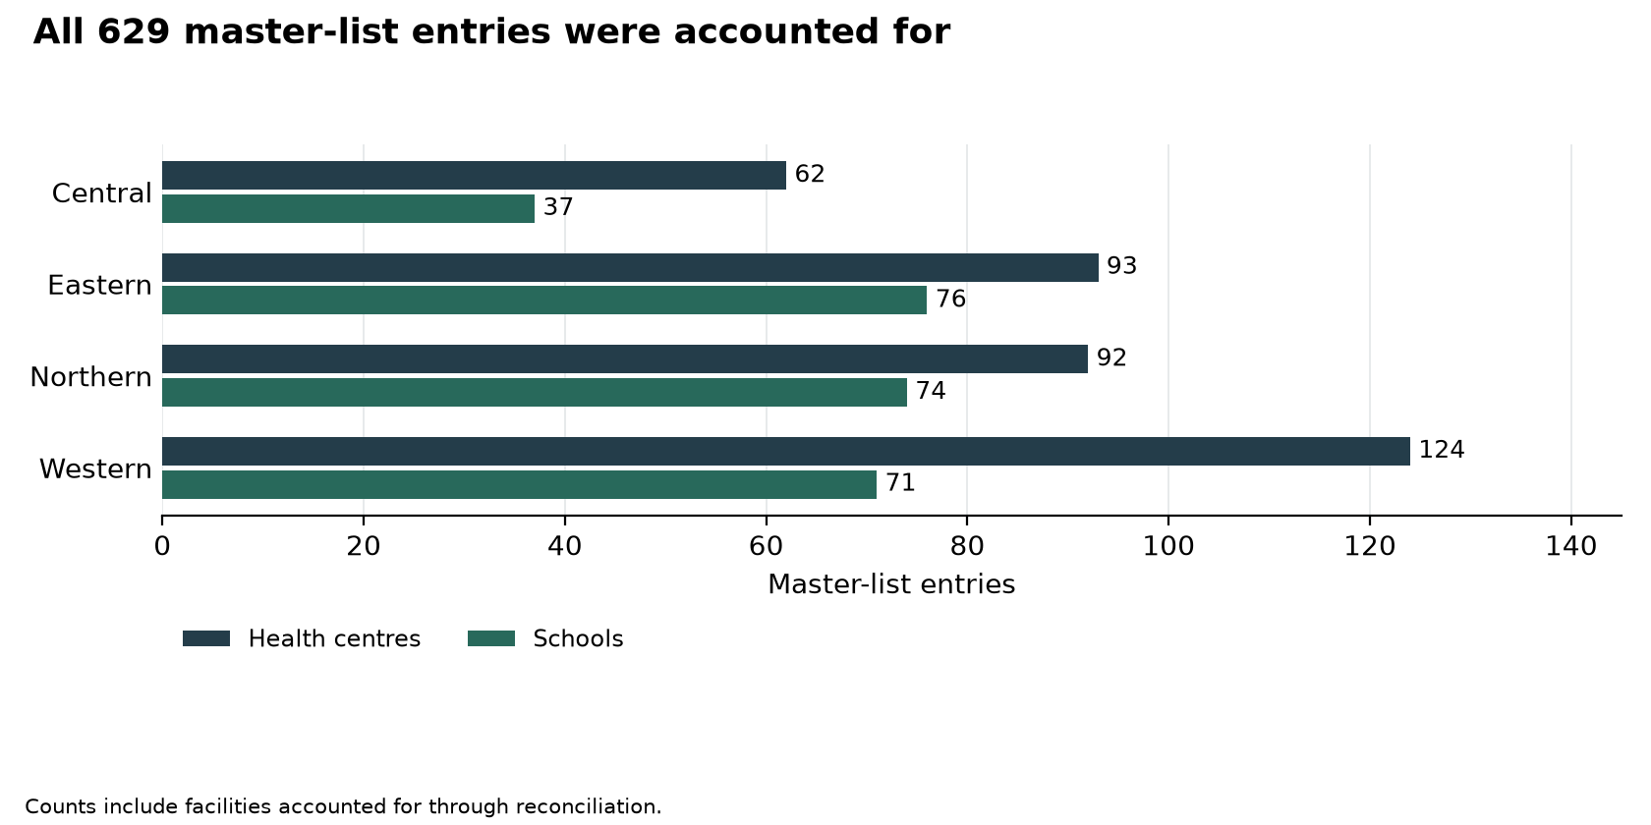
Figure 1: All 629 master-list entries were accounted for

7.1.1 Construction and readiness for service
Table 4: Facilities requiring completion or preparation for use
Location | Expected position and field finding | Gap or service implication |  | Recommended action
Got Apwoyo Seed Secondary School, Nwoya | Expected: Got Apwoyo was intended to provide secondary education with completed buildings and installed ICT equipment.  Found: The team found construction continuing and the school uncommissioned. Its ICT package remained at Nwoya District headquarters, while delivered furniture and structures had not been brought into use. | The assets were not yet supporting teaching at the intended school, and custody was divided between the district and the site. |  | Nwoya District and the Ministry of Education should set a completion and handover plan, check the stored equipment, and arrange installation, testing and signed transfer when the school is ready.
Bukibologoto Health Centre, Bulambuli | Expected: Bukibologoto was listed as complete and was intended to provide care from the constructed health facility.  Found: The team found that mudslides had damaged the works before completion. A corner was undermined and a wall cracked. Care was being provided at Simu subcounty offices, with equipment held in district stores. | The planned facility was unavailable for its intended use, and the temporary service and storage arrangements needed a lasting solution. |  | Bulambuli District and the Ministry of Health should obtain an engineering assessment, decide on repair or relocation, inventory the equipment and provide for continuing care.
Kyangwali Seed Secondary School, Kikuube | Expected: Kyangwali school needed completed works, electricity, security and handover to use its assets fully.  Found: The team recorded continuing construction. The school reported a lack of electricity and an incomplete perimeter fence, and the facility had not been handed over. | Finishing the buildings alone would not make the school ready: power, security and responsibility for the assets also remained unresolved. |  | Kikuube District, the Ministry of Education and the contractor should close these requirements through one readiness plan, followed by joint testing and handover. The plan should name who will operate, safeguard and maintain the assets.
Sidok Seed Secondary School, Kaabong | Expected: Sidok school needed completed buildings and checked equipment before the investment could support full operations.  Found: The team found blocks, a kitchen and toilets under construction, with termite workings on the plaster of two blocks. The school consignment remained unopened and its contents had not been counted. | Both unfinished works and unchecked equipment prevented a complete assessment of readiness for use. |  | Kaabong District should secure completion and treatment of the affected works, then arrange a witnessed opening, count and condition check of the equipment. Accepted items should be recorded, assigned to custodians and issued for use.
Buwagogo Seed Secondary School, Manafwa | Expected: Buwagogo school was intended to use its supplied ICT equipment for teaching.  Found: The team found the March 2024 ICT consignment still boxed in the store, with contractor installation pending and commissioning delayed. | Delivery had not translated into operational ICT capacity. Equipment continued to require secure custody while installation remained outstanding. |  | Manafwa District and the Ministry of Education should agree an installation and commissioning date with the contractor, reconcile the stored equipment against delivery records and test it before acceptance. The handover should assign responsibility for operation, maintenance and reporting of faults.
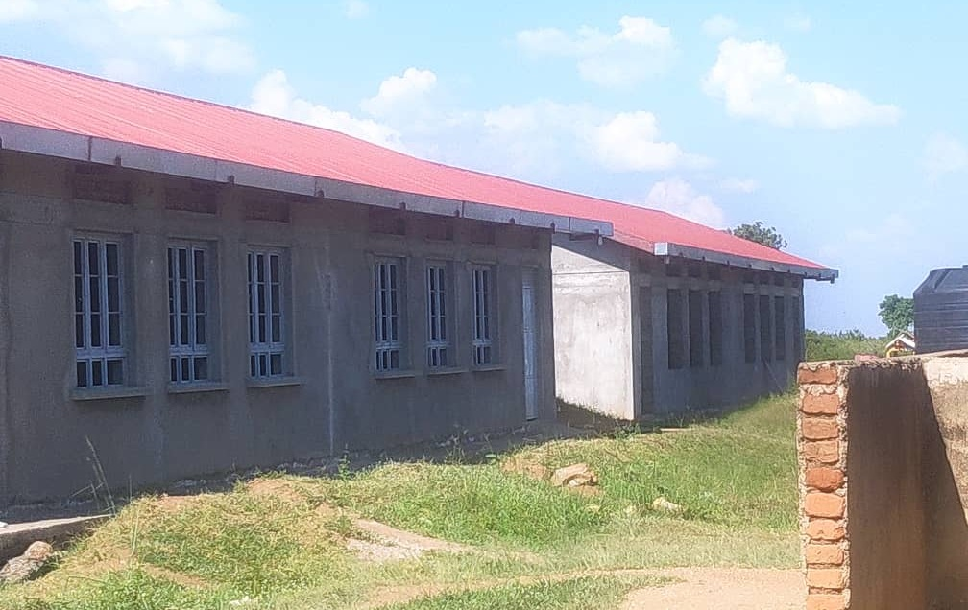  Figure 2: Unfinished school block at Got Apwoyo Seed Secondary School, Nwoya District (Acholi) |  |  | 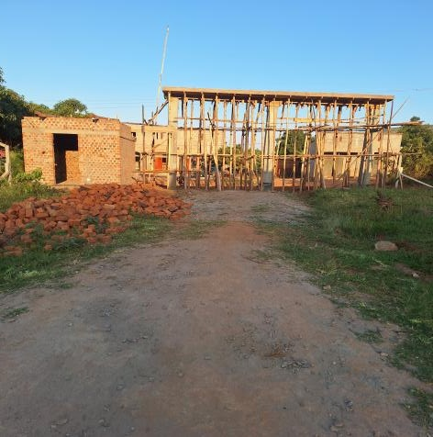  Figure 3: Building works at a seed secondary school, Kiboga District (Buganda)

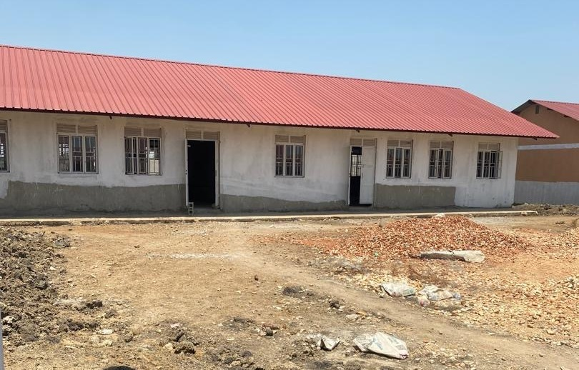
Figure 4: School block awaiting completion at Butungama Seed Secondary School, Ntoroko District (Tooro)

7.1.2 Facilities that differed from the programme list
Table 5: Facility reconciliation outcomes
Outcome | Entries
Does not exist or was not constructed under the programme | 10
Replaced by another facility | 4
Operates under another name | 30
Not a UgIFT beneficiary | 3
Assets relocated to another facility or held at district | 3
Exists with no UgIFT assets | 5
Table 5 groups 55 reconciled entries. These include naming and replacement decisions for facilities that also had verification evidence; the 55 entries are not a separate count of unvisited facilities. Appendix 8.6 gives the outcome for each entry.
Table 6: Expected facilities and the outcomes established during verification
Location | Expected position and field finding | Gap or service implication | Recommended action
Olok Health Centre, Pader | Expected: Olok was listed as a completed health facility intended to serve its catchment in Pader.  Found: The district health officer confirmed to the verification team that Olok Health Centre had not been constructed and did not exist in the district. | The completed entry could not be matched to the intended facility. The reason for non-construction requires a documented resolution. | Pader District and the Ministry of Health should reconcile the approved project, construction and payment records, correct the beneficiary schedule and decide how the intended health-service need will be met.
Busia Eastern Division health-centre entry, Busia Municipal Council | Expected: The beneficiary schedule should identify the particular health facility supported in Busia Municipality.  Found: Reconciliation confirmed that no health facility called Busia Eastern Division existed. A separate return identified Sofia Health Centre III within Eastern Division. | An administrative division had been used as a facility name. The available confirmation did not identify Sofia as its replacement or establish that the two names referred to the same beneficiary. | The municipality and Ministry of Health should resolve the original beneficiary identity and document the programme status of Sofia before linking or changing the two entries.
Ngomoromo, Oweko, Musandama and Loinya health centres, Lamwo, Nebbi, Ntoroko and Maracha | Expected: The beneficiary schedule should name the facility that received each planned investment.  Found: Supervisors confirmed that Pangira replaced Ngomoromo in Lamwo, Pamaka replaced Oweko in Nebbi, Butungama replaced Musandama in Ntoroko, and Liko replaced Loinya in Maracha. Liko was already listed separately. | The programme account needs to link each original entry to its confirmed replacement to prevent duplicate counting and identify the service location. | The districts and Ministry of Health should attach the replacement decisions, link the original projects to their recipients and retain one active facility identity for each recipient.
Alangi, Ther-uru and Abanga, Zombo | Expected: Asset locations and custodians should agree with the facilities holding and using the equipment.  Found: The supervisor confirmed that Alangi, Ther-uru and Abanga existed, but their UgIFT assets had moved respectively to Amwonyo Health Centre, Atyak Health Centre and Kango Seed Secondary School. | The original beneficiary names no longer described where the assets were held. Custody, location and the service arrangements at the original sites needed to be made clear. | Zombo District should reconcile transfer approvals and signed receipts with both sets of inventories, name the current custodians and confirm how the original catchments are served.
Alira Health Centre and Kiziranfumbi Seed Secondary School, Oyam and Kikuube | Expected: The programme beneficiary schedule should include institutions supported under UgIFT.  Found: The later Oyam clarification confirmed that Alira Health Centre existed but was not among the facilities upgraded under UgIFT. The supervisor also confirmed that Kiziranfumbi Seed Secondary School in Kikuube was outside the programme. | The list confused the existence of an institution with its eligibility as a UgIFT beneficiary. Alira had initially been reported absent, but that account was corrected. | The local governments and sector ministries should approve the scope corrections, remove the institutions from the active UgIFT schedule and preserve the reasons for the changes.
Pandwong Health Centre; Bumbaire, Kyamuhunga and Kashenshero schools; Rwamujojo Health Centre, Kitgum Municipal Council, Bushenyi, Mitooma and Sheema Municipal Council | Expected: Each listed beneficiary should have a supported account of the programme assistance it received.  Found: Supervisors confirmed that Pandwong Health Centre, Bumbaire and Kyamuhunga schools, Kashenshero school and Rwamujojo Health Centre existed but had not benefited from UgIFT assets. | Their appearance on the beneficiary list did not establish delivery. The cause of the difference between the list and the reported benefits needs to be resolved. | The responsible districts, municipalities and sector ministries should check beneficiary approvals and delivery records, then correct the schedule or record an approved outstanding delivery with an accountable officer and follow-up date.
Bussi/Zinga and Dabani/Buwumba, Wakiso and Busia | Expected: Each facility should have one stable identity, with local and former names linked to it.  Found: Bussi was confirmed to be the village name for the already-listed Zinga Health Centre in Wakiso. In Busia, the Buwumba return was reconciled to the master entry named Dabani. | Different names could make one facility appear to be two, distort coverage and separate its asset history from the correct institution. | The districts should adopt the confirmed operating names, retain the old names as aliases and link the beneficiary, project and asset information to one facility identifier. Zinga should be counted once.

7.1.3 Facilities and names encountered outside the master list
Teams submitted information under 24 facility names that had no confirmed match to the verification master list. Follow-up expressly confirmed Rukoki General Hospital, Silumira Health Centre III and Bukuuku Community Seed Secondary School as additional programme beneficiaries. Their inclusion in the approved programme account should be regularised.
The remaining names should be resolved through the same checks of facility identity, programme approval and asset custody. Some entries came from combined returns, and Onywako was expressly reported without a physical inspection. All 24 return names are shown separately from the 629 master-list entries while the outstanding identity and scope decisions are completed.
Table 7: Examples encountered outside the master-list names
Location | Expected position and field finding | Gap or service implication | Recommended action
Rukoki General Hospital, Kasese Municipality | Expected: Confirmed beneficiaries should be included in the programme account.  Found: The supervisor confirmed that Rukoki General Hospital was a UgIFT beneficiary in Kasese Municipality, although it was absent from the master list used for verification. | The programme list omitted a confirmed recipient. | The Ministry of Health and municipality should approve the beneficiary entry and link its asset information to a stable facility identifier.
Silumira Health Centre III, Kakumiro | Expected: The beneficiary schedule should include supported health facilities.  Found: The supervisor confirmed that Silumira Health Centre III had benefited in Kakumiro but was not on the master list. | The facility was missing from the list used to plan and account for verification. | Kakumiro District and the Ministry of Health should approve the addition and connect the beneficiary decision to the facility asset inventory.
Bukuuku Community Seed Secondary School, Fort Portal City | Expected: Confirmed seed-school beneficiaries should appear in the programme account, with assets handed over for full use.  Found: Bukuuku was confirmed as an additional beneficiary. The team recorded improved science and computer teaching following laboratory construction, while some asset handover remained pending. | The school was omitted from the master list and handover was incomplete. | The city and Ministry of Education should regularise the beneficiary entry and complete joint handover of the outstanding assets.

7.2 National institutions
National institutions held 15,793 assets, including office equipment, vehicles and assets in hospitals and blood banks. The main management questions were whether assets remained in use, could be identified and had clear responsibility for custody and maintenance. Detailed valuation schedules are provided in Appendix 8.4.
Table 8: Asset identification at the listed national ministries and agencies
Institution | Assets | Engraved | Not engraved
MoFPED | 458 | 282 | 176
MoWT | 88 | 79 | 9
MoES | 1,371 | 395 | 976
MAAIF | 1,975 | 1,162 | 813
MoH | 264 | 46 | 218
OPM | 10 | 10 | 0
MoWE | 2,939 | 2,897 | 42
MoGLSD | 10 | 8 | 2
NEMA | 6 | 1 | 5
PPDA | 5 | 5 | 0
OAG | 20 | 20 | 0
MoLG | 13 | 8 | 5
MoLHUD | 26 | 12 | 14
Table 8 identifies where engraving needs attention. Marking must be linked to the asset number, institution and current custodian.
Accounting Officers should complete the outstanding marking, keep custody and location details current, and include serviceable equipment in routine maintenance. Damaged items require technical assessment and a decision on repair or disposal.

7.2.1 Ministry of Finance, Planning and Economic Development
MoFPED held 194 ICT items, 145 other assets, 99 furniture and fittings and 20 transport assets.
Expected: Staff computers should support their workload, and portable equipment should remain identifiable and accountable. Found: Most computers were working, but some keyboards and power-backup units had failed, and some older computers were freezing. Laptop losses were supported by police letters. The team also reported difficulty obtaining some laptops for engraving.
Gap: Equipment reliability, follow-up of lost assets and completion of identification each required a specific management response. Recommended action: The ministry should assess the failed accessories and freezing computers, follow up the reported laptop losses, and arrange a supervised exercise to identify and mark all remaining portable equipment.
Expected: Furniture should remain assigned to a location and custodian when offices move. Found: When programme staff moved to premises already furnished, their earlier furniture was left in the old building. Some remained in store, while staff said other items had gone to different offices.
Gap: The move had split the furniture between storage and other offices, requiring confirmation of its present custody and use. Recommended action: The ministry should inspect the old store and recipient offices, confirm the condition and custodian of each item, and approve reuse or other appropriate treatment of furniture no longer required.

7.2.2 Ministry of Works and Transport
MoWT held 60 ICT items, 27 other assets and 1 transport asset.
Repairs and servicing of the Toyota Hilux pickup were handled by MoFPED. The custody and maintenance arrangements should remain clear during handover.
Expected: Installed office and conferencing equipment should support the secretariat and carry a traceable asset identity. Found: The secretariat reported that the installed photocopier supported its daily work. The video-conferencing system was installed and functioning, but it had not been engraved or included in the asset list presented for verification.
Gap: An operational system still required clear identification and custody. Recommended action: The ministry should identify the conferencing system and its components, assign a custodian, and apply a suitable durable identifier without damaging the equipment.

7.2.3 Ministry of Education and Sports
MoES held 1,371 ICT items.

7.2.4 Ministry of Agriculture, Animal Industry and Fisheries
MAAIF held 1,138 ICT items and 837 other assets.
The ministry had working laptops and printers carrying programme asset identifiers. Keeping those identifiers linked to the equipment and its custodian will support continued accountability after programme closure. Routine condition checks should identify new faults and keep usable equipment in service.

7.2.5 Ministry of Health
MoH held 200 other assets, 39 ICT items and 25 transport assets.
Expected: Office equipment in use should be identifiable by a durable asset mark. Found: Two heavy-duty printers, one at the Industrial Area engineering office and one at headquarters, were in use and in good condition but unengraved. One headquarters laptop was also recorded without engraving.
Gap: Working equipment at separate offices still lacked the marking needed for straightforward physical identification. Recommended action: The ministry should mark these items, link the marks to their serial numbers and office locations, and obtain custody confirmation from the receiving units.

7.2.6 Office of the Prime Minister
OPM held 10 ICT items.
Damaged laptops were out of use. The institution should assess repair needs and return serviceable equipment to use.
Expected: Computers should have enough capacity for the work assigned to their users. Found: Users reported that the capacity of the HP Envy i3 laptops was below the volume of work handled, although the machines were described as being in fair condition.
Gap: A usable laptop could still be poorly matched to the workload of its user. Recommended action: The office should assess the requirements of the affected users and decide whether upgrading, reallocating or replacing the laptops would provide suitable capacity.

7.2.7 Ministry of Water and Environment
MoWE held 2,735 ICT items and 204 other assets.
Expected: Portable tablets should carry an asset identifier and have an assigned custodian. Found: Ten Apple tablets were recorded without engraving.
Gap: Portable equipment required an identification method that would allow each unit to be traced to its user and location. Recommended action: The ministry should apply suitable durable identifiers, link them to serial numbers, and confirm custody before the next physical check.

7.2.8 Ministry of Gender, Labour and Social Development
MoGLSD held 10 ICT items.
Laptops serving Finance and Administration were functional and engraved. Two tablets, one for Finance and Administration and the other for Youth and Children Affairs, were functional but unengraved. The ministry should mark the tablets and link their identifiers to the units and officers responsible for them.

7.2.9 National Environment Management Authority
NEMA held 6 ICT items.
Expected: Computers and shared office equipment should remain identifiable wherever they are used. Found: Four Lenovo laptops serving the executive office and environmental audit, together with a heavy-duty printer, were recorded as functional but not engraved.
Gap: The equipment could support work, but lacked a durable identifying mark. Recommended action: The authority should mark the five items, record their serial numbers and custodians, and include them in regular physical checks.

7.2.10 Public Procurement and Disposal of Public Assets Authority
PPDA held 3 other assets and 2 ICT items.
The authority had functioning laptops, a tablet and a printer assigned to its legal and strategy/planning units. These items carried programme identifiers. The authority should keep the identifiers linked to current custodians and update custody whenever equipment moves between units.

7.2.11 Office of the Auditor General
OAG held 18 ICT items and 2 transport assets.
The office had working laptops, printers and two pickup vehicles. The pickups had changed registration numbers. The office should retain the link between the earlier and current registrations, the chassis numbers and the assigned custodians so that each vehicle remains traceable.

7.2.12 Ministry of Local Government
MoLG held 12 ICT items and 1 transport asset.
The District Administration unit had a working pickup, photocopier and computer equipment. Two laptops and a desktop set, including its keyboard and mouse, lacked engraving. The ministry should mark the unengraved equipment and confirm its location and custodian while keeping the working assets in service.

7.2.13 Ministry of Lands, Housing and Urban Development
MoLHUD held 24 transport assets and 2 other assets.

7.2.14 Other national holdings
Hospital holdings and assets of the Uganda Blood Transfusion Services (UBTS), Kampala Capital City Authority (KCCA) and the MODV vote are included in the national inventory. Their quantities and values are retained in the appendices. Custody, identification and maintenance responsibilities should remain with the institution that holds and uses each asset.

7.3 Regional findings

7.3.1 Central region
The Central region master list covered 62 health centres and 37 schools. The asset inventory covered 28,192 items. Of these, 6,235 were engraved and 21,957 were not engraved.

What was found
Central region showed both service gains and repair needs. At Lukale Health Centre III in Buvuma, staff said the maternity ward enabled women to give birth locally instead of crossing water and gave them greater privacy. At Musiitwa Seed Secondary School in Kayunga, new facilities improved access to secondary education, and the irrigation system supported practical teaching and food production.
Busaale Health Centre III in Kayunga used Primary Health Care funds for maintenance and reviewed asset condition quarterly. The maternity roof was leaking, door hinges needed repair and the solar system required a replacement battery. At Musiitwa, furniture and fittings were checked each term, but broken items remained out of use until the school could fund repairs.
The immediate actions are to repair Busaale's roof, doors and solar system and clear the furniture repair backlog at Musiitwa. The school also reported attendance pressures linked to long walking distances and pupils' involvement in petty trade. School management and the district education office should address these alongside the physical improvements.

Gaps and actions
Table 9: Central region: findings and recommended actions
Location | Expected position and field finding | Gap or service implication | Recommended action
Busaale Health Centre III, Kayunga | The facility used Primary Health Care funds for maintenance and kept a quarterly condition record. | The maternity roof leaked, door hinges were damaged and the solar battery needed replacement. | Cost and complete the roof, door and battery repairs, then confirm that the affected rooms and solar system are working.
Musiitwa Seed Secondary School, Kayunga | The school checked furniture and fittings each term and repaired them when funds allowed. | Broken furniture remained out of use while funding was arranged. | Prepare a termly repair list and fund repairs in order of their effect on teaching and safety.
Musiitwa Seed Secondary School, Kayunga | The school improved access to secondary education and used irrigation equipment for teaching and food production. | Long walking distances and pupils' engagement in petty trade affected attendance. | Maintain the practical teaching equipment and work with parents and the district education office on attendance barriers.
Lukale Health Centre III, Buvuma | Staff reported that the maternity ward allowed women to give birth locally and with greater privacy. | Benefit to sustain. | Protect the service through routine care of the maternity building and equipment.
Kijuna Health Centre III, Kassanda | Expected: Patient equipment and basic utilities should be available when care is needed.  Found: The wheelchairs were not functional, and a failed water pump left the facility with inadequate water. Inadequate power also prevented full use of electronic equipment. | The facility faced separate constraints on patient movement, water supply and equipment use. | Kassanda District should arrange technical assessment and repair of the wheelchairs and pump, restore a dependable power supply and test the affected equipment before returning it to use.
Kikandwa Health Centre III, Kassanda | Expected: The health facility should provide powered equipment, durable buildings and secure custody of its assets.  Found: Electronic equipment could not be used because reliable electricity and solar power were unavailable. Storage for damaged assets was inadequate, the facility lacked a perimeter fence, and defects were observed in flooring and skirting. | Power, secure storage and correction of building defects remained necessary for full and safe use. | Kassanda District should agree a joint power, security and defects plan, provide secure temporary storage, and have technical staff verify repairs and equipment operation.
Kyasansuwa Health Centre III, Kassanda | Expected: Computer equipment should support administration and reporting, while floors and bathrooms should remain usable and easy to maintain.  Found: The facility reported three computers completely damaged following unstable power and surges. Poor floor finishes and defective staff bathroom levels were also observed. | Unstable electricity threatened the remaining electronics, while defective finishes and drainage needed correction. | Kassanda District should stabilise and protect the electrical supply, assess the three computers for repair or replacement, and correct the floor and bathroom defects under technical supervision.
Table 10: Central assets and identification by category
Asset category | Assets | Engraved | Not engraved
Clinical equipment | 3,820 | 755 | 3,065
Clinical furniture | 2,965 | 1,047 | 1,918
Other assets | 3,509 | 350 | 3,159
Health centre ICT equipment | 32 | 1 | 31
Maternity ward equipment | 1,369 | 472 | 897
Building blocks | 1,247 | 170 | 1,077
School computers and related equipment | 1,365 | 334 | 1,031
School support equipment | 76 | 10 | 66
Other ICT equipment | 80 | 2 | 78
School furniture | 13,726 | 3,092 | 10,634
Vehicles and motorcycles | 3 | 2 | 1
Table 10 shows the assets covered and the outstanding identification work by category. Sub-region counts and condition classifications are in the appendices.

Field photographs from Central
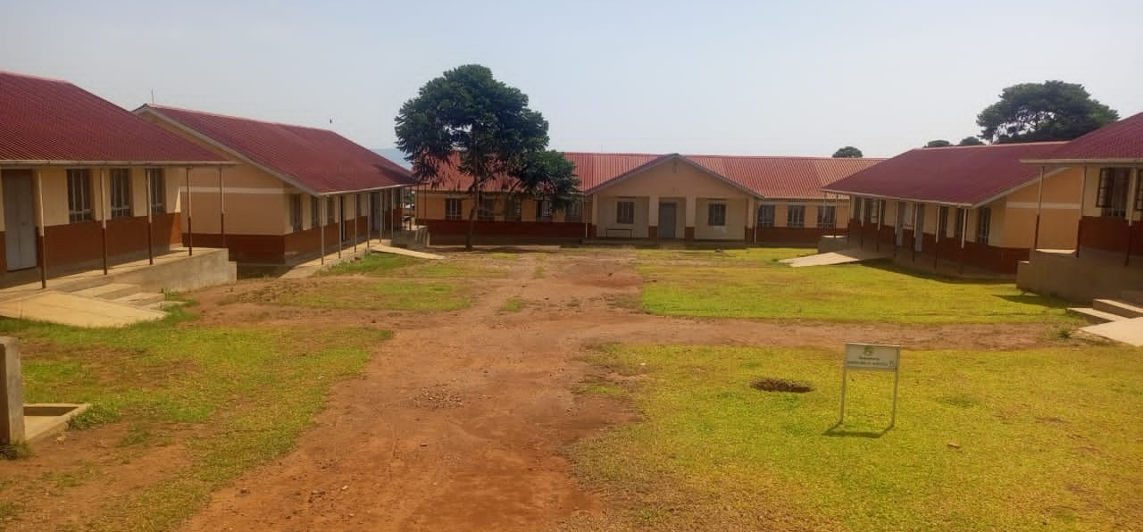  Figure 5: School buildings and courtyard at a seed secondary school, Buvuma District (Buganda) | 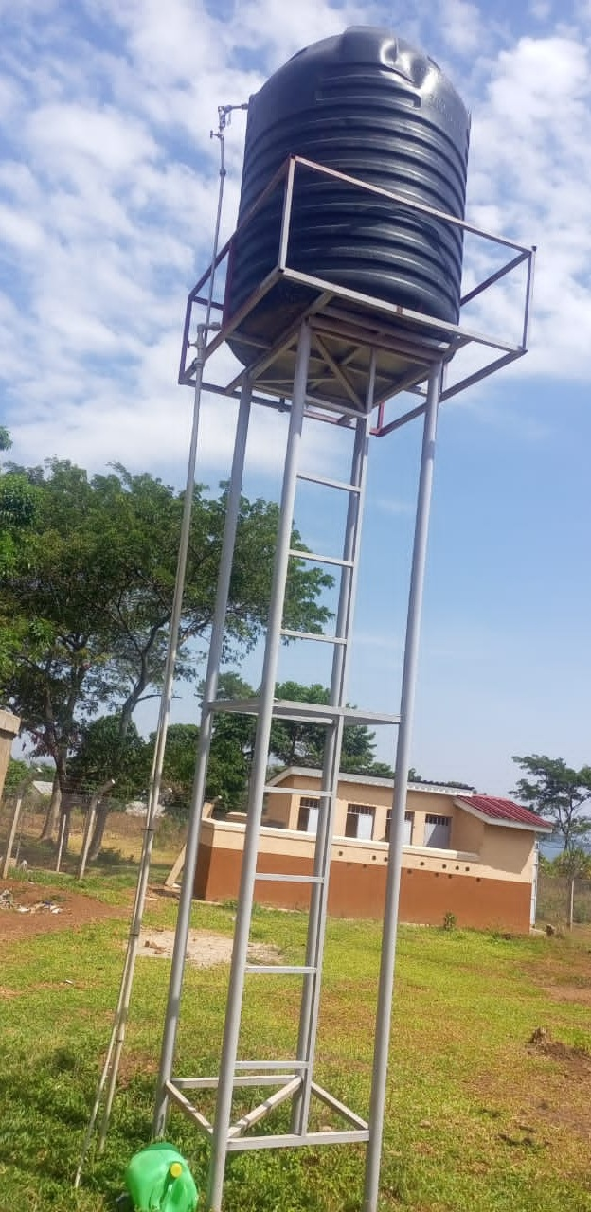  Figure 6: Raised water storage tank at a seed secondary school, Buvuma District (Buganda)

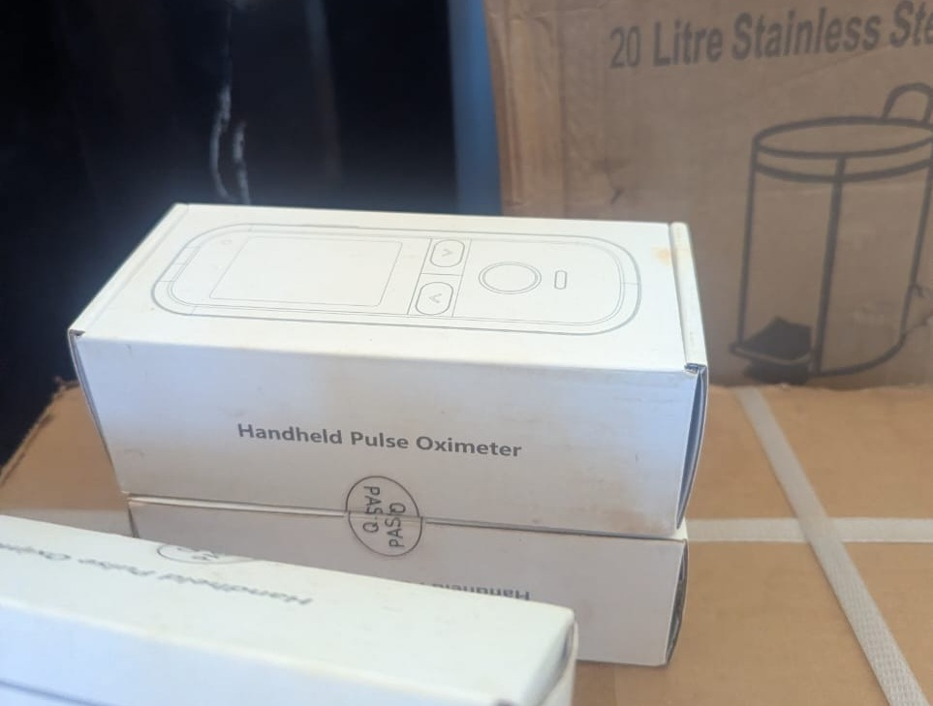  Figure 7: Boxed pulse oximeters at a health centre, Makindye-Ssabagabo Municipal Council (Buganda) | 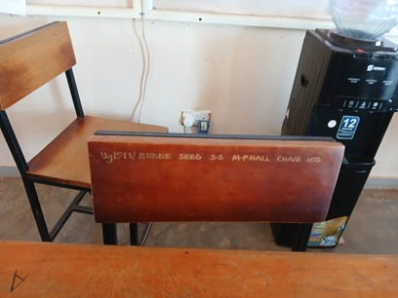  Figure 8: Programme and school engraving on a chair at Budde Seed Secondary School, Butambala District (Buganda)

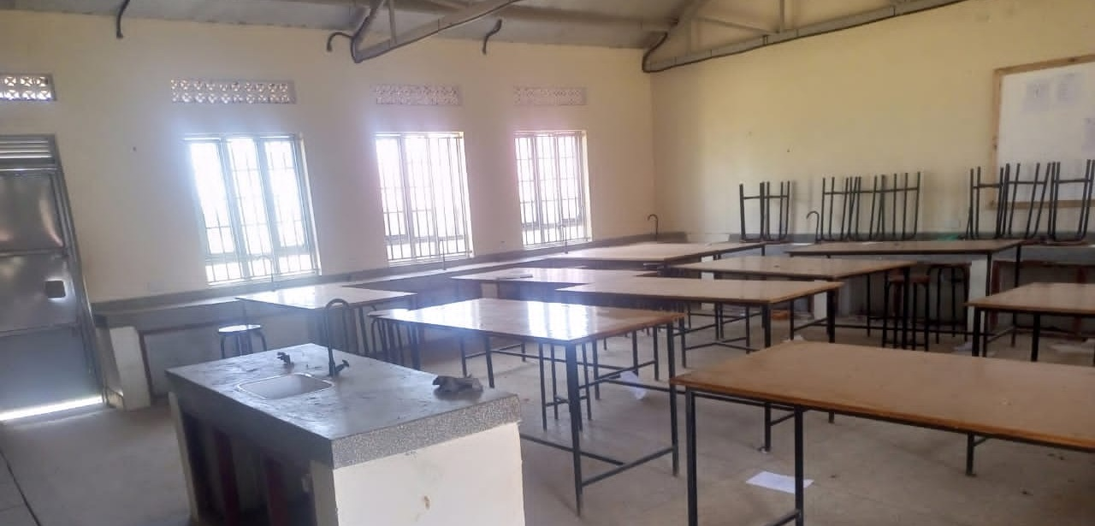  Figure 9: Laboratory benches and sinks at Bweema Seed Secondary School, Buvuma District (Buganda) | 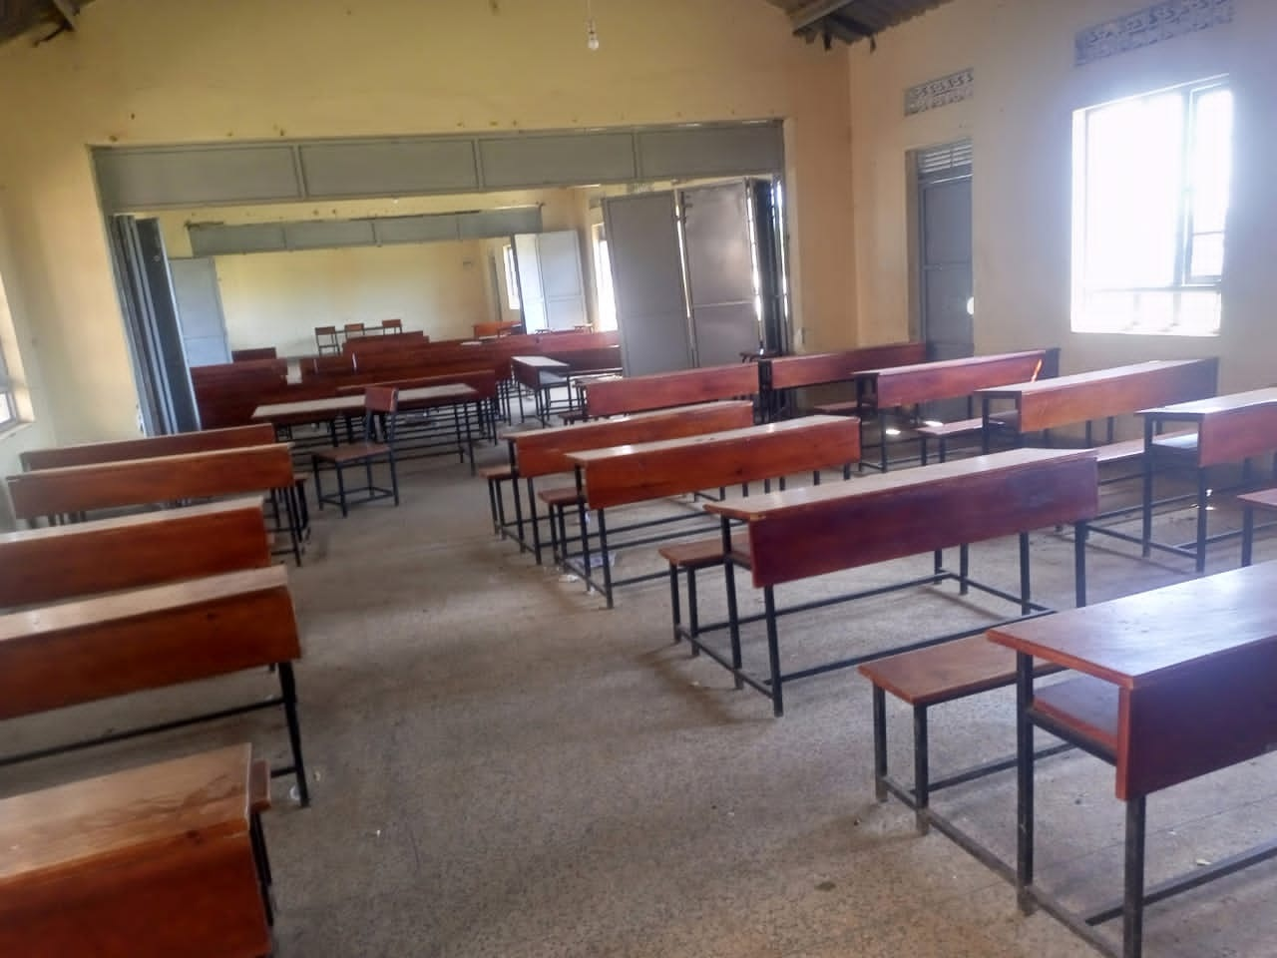  Figure 10: Classroom desks at Bweema Seed Secondary School, Buvuma District (Buganda)

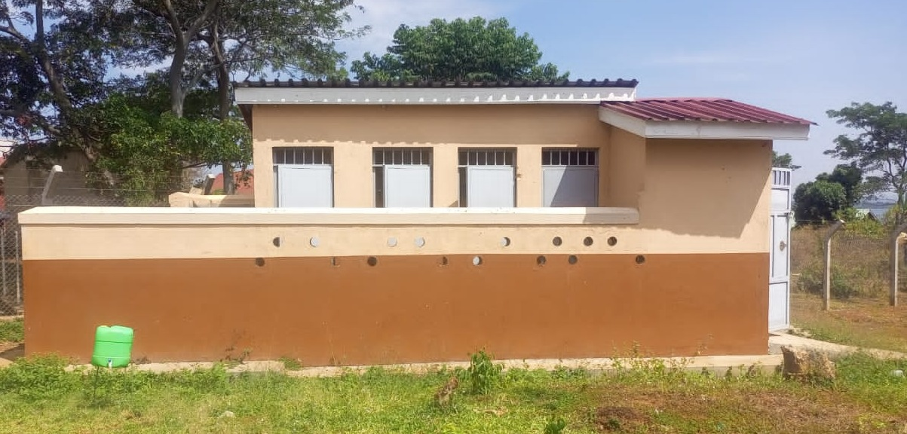  Figure 11: Sanitation block at Bweema Seed Secondary School, Buvuma District (Buganda) | 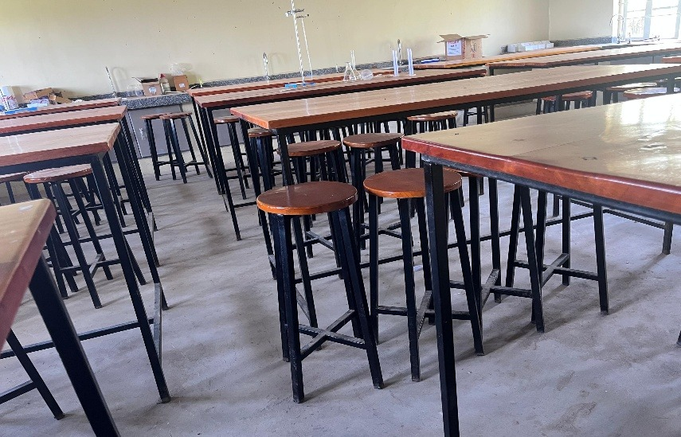  Figure 12: Science laboratory tables and stools at a seed secondary school, Kalangala District (Buganda)

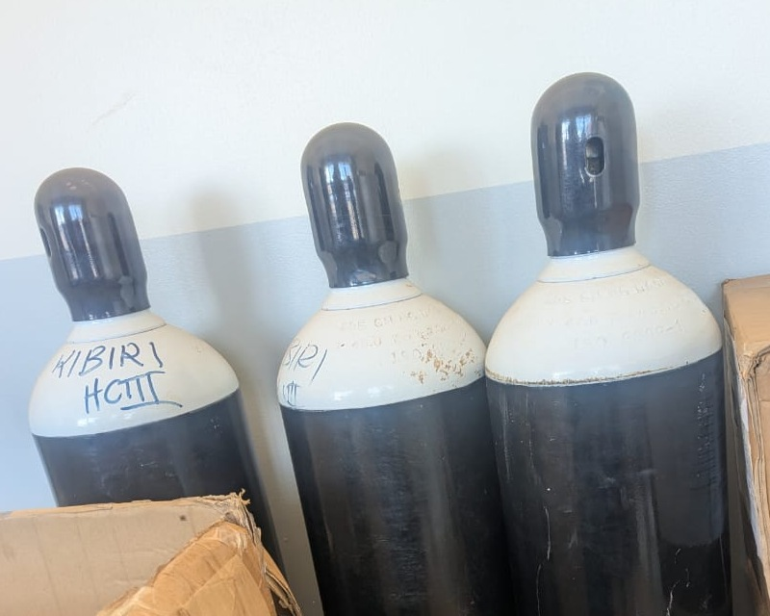  Figure 13: Oxygen cylinders at Kibiri HC III, Makindye-Ssabagabo Municipality (Buganda) | 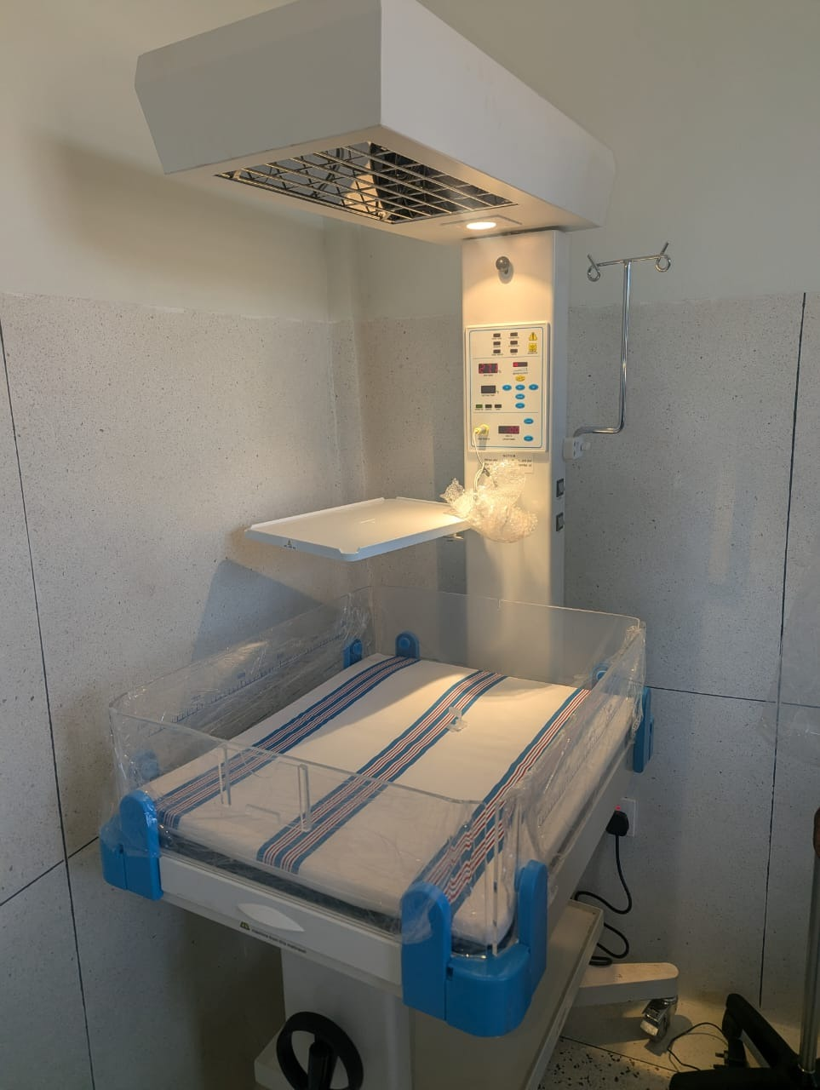  Figure 14: Infant radiant warmer at a health centre, Makindye-Ssabagabo Municipal Council (Buganda)

7.3.2 Eastern region
The Eastern region master list covered 93 health centres and 76 schools. The asset inventory covered 84,681 items. Of these, 19,992 were engraved and 64,689 were not engraved.

What was found
At Kagumba Health Centre III in Kamuli, staff linked the new maternity ward to increased use of delivery and antenatal services. The facility kept an asset condition book, but staff identified pressure on housing and a need for outpatient, laboratory, storage and kitchen space. These needs should be assessed against the services now provided at the facility.
Repairs had returned broken furniture to use at Kagumba Seed Secondary School during the second term. In contrast, Sikuda Seed Secondary School in Busia had broken desks and a cracked laboratory stool that was still being used. At Bubago Health Centre in Kamuli, staff needed training to operate and maintain an oxygen concentrator.
Equipment from Bumunji, Buwembe and Majanji health centres in Busia had been transferred to Masafu Hospital. The district should confirm the continuing service need at each location and keep responsibility for the transferred equipment clear. Repairing unsafe furniture and training the oxygen equipment users are immediate priorities.

Gaps and actions
Table 11: Eastern region: findings and recommended actions
Location | Expected position and field finding | Gap or service implication | Recommended action
Kagumba Health Centre III, Kamuli | Staff reported increased maternity and antenatal service use, and the facility kept an asset condition book. | Staff housing was under pressure; outpatient, laboratory, storage and kitchen space were identified as needs. | Assess the supporting space against patient demand and include the agreed works in the district health investment plan.
Kagumba Seed Secondary School, Kamuli | The school reported that broken furniture had been repaired during the second term. | Practice to sustain. | Continue condition checks and scheduled furniture repairs before each term.
Sikuda Seed Secondary School, Busia | Broken desks and a cracked laboratory stool were found. | The cracked stool was still in use. | Withdraw unsafe furniture from use and repair or replace it before returning it to classrooms or laboratories.
Bubago Health Centre, Kamuli | Staff identified difficulty operating and maintaining an oxygen concentrator. | Equipment use depended on stronger user and basic maintenance skills. | Arrange practical user training and a technical check, then demonstrate operation with the staff responsible for the equipment.
Bumunji, Buwembe and Majanji health centres; Masafu Hospital, Busia | Equipment had been transferred from the health centres to Masafu Hospital. | Allocation and custody require confirmation. | Confirm the receiving custodian, location and service need, and retain signed transfer and receipt documentation.
Nansanga Seed Secondary School, Budaka | Expected: The supplied desktop computers should be installed and available for teaching.  Found: The school lacked reliable power, and twenty-seven of its twenty-eight desktops remained packed. | Most of the supplied computer capacity had not reached classroom use because a basic operating requirement was unresolved. | Budaka District and the school should settle the power connection or suitable alternative, arrange installation and testing, and confirm the number of computers available to learners.
Muhula Seed Secondary School, Butaleja | Expected: The school should receive completed buildings and tested equipment before formal handover and operation.  Found: The contractor had not handed over the school, and it was not operating. Buildings showed cracks, an air conditioner remained boxed with a missing fan, and the installed water pump was not working. | Construction completion, equipment completeness and successful testing had not come together to make the school ready. | Butaleja District and the Ministry of Education and Sports should agree a defects and handover schedule with the contractor, rectify the works, complete the equipment and witness operational tests before handover.
Sop Sop Health Centre III, Tororo | Expected: Delivered equipment should be accompanied by the skills and accessories needed to use it.  Found: The facility reported that much of its equipment remained in store because staff did not know how to operate it. Oxygen equipment had arrived without cylinders. Tuberculosis testing and maternity services had nevertheless improved. | Equipment delivery had not been matched consistently with user training and a complete operating package. | Tororo District and the Ministry of Health should arrange practical training at the facility, confirm the required oxygen components, and check that trained staff can safely use each released item.
Bunamono Health Centre III, Bududa | Expected: The installed water system should supply the staff houses, and supplied clinical equipment should be ready for use.  Found: The water tank was not working and the solar pump was not connected, leaving the staff houses without water. A supplied laboratory stand remained boxed because staff could not assemble it, and a glucometer lacked test strips. | The facility needed installation, demonstration and consumables to turn delivered assets into usable services. | Bududa District should complete and test the water connection, arrange assembly and user demonstration for the laboratory stand, and establish a supply of compatible glucometer strips.
Table 12: Eastern assets and identification by category
Asset category | Assets | Engraved | Not engraved
Clinical equipment | 8,042 | 748 | 7,294
Clinical furniture | 6,871 | 936 | 5,935
Other assets | 14,006 | 1,410 | 12,596
Health centre ICT equipment | 107 | 4 | 103
Maternity ward equipment | 1,746 | 110 | 1,636
Building blocks | 2,975 | 217 | 2,758
School furniture | 45,693 | 15,486 | 30,207
School computers and related equipment | 4,462 | 983 | 3,479
School support equipment | 423 | 81 | 342
Other ICT equipment | 347 | 12 | 335
Vehicles and motorcycles | 9 | 5 | 4
Table 12 shows the assets covered and the outstanding identification work by category. Sub-region counts and condition classifications are in the appendices.

Field photographs from Eastern
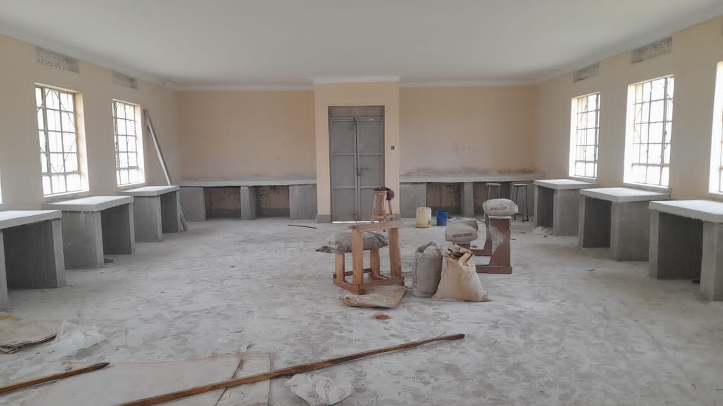  Figure 15: ICT laboratory interior under construction at Kitawoi Seed Secondary School, Kween District (Sebei) | 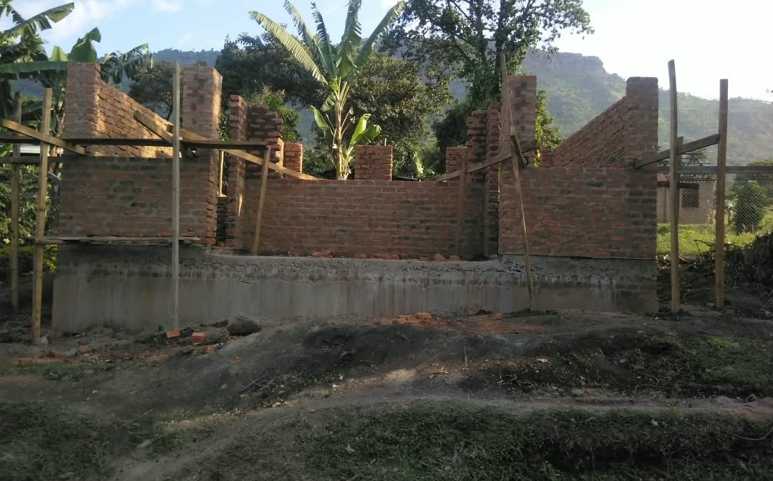  Figure 16: Unfinished laboratory building at a health centre, Sironko District (Bugisu)

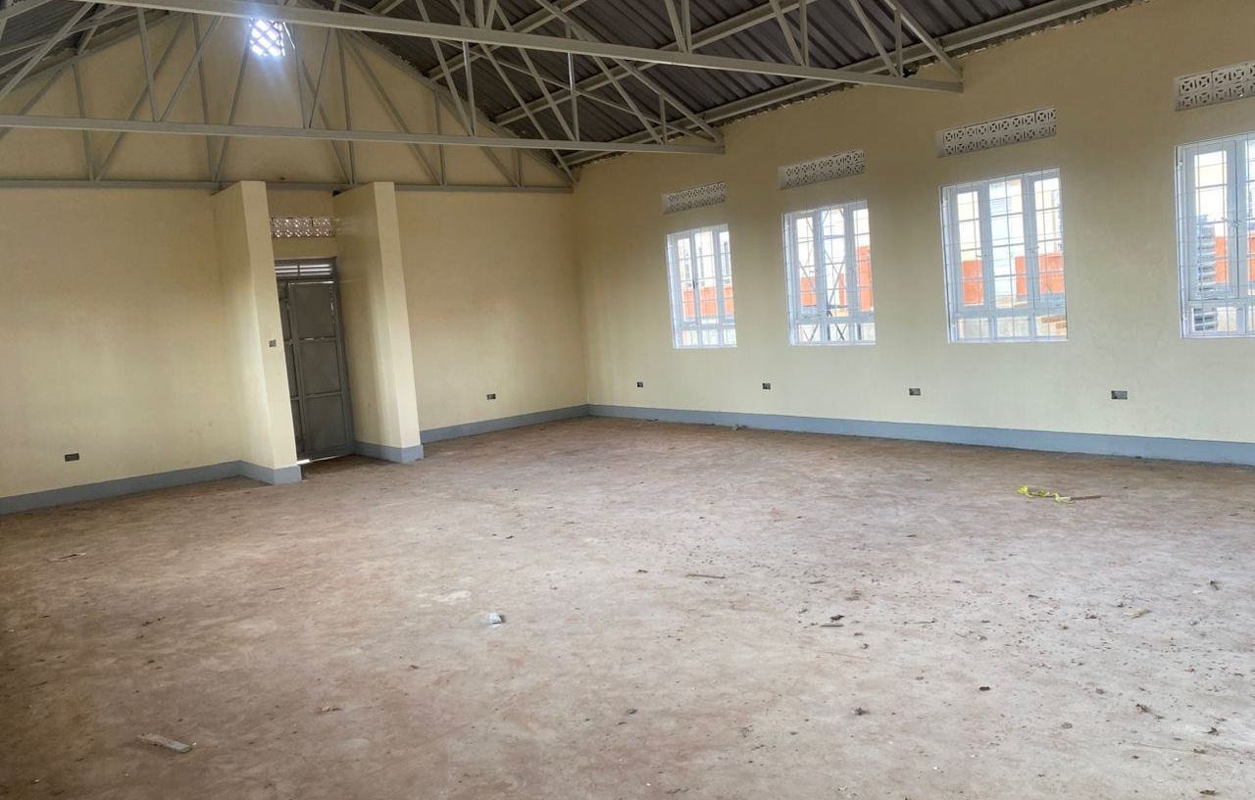  Figure 17: Empty computer laboratory at a seed secondary school, Kween District (Sebei) | 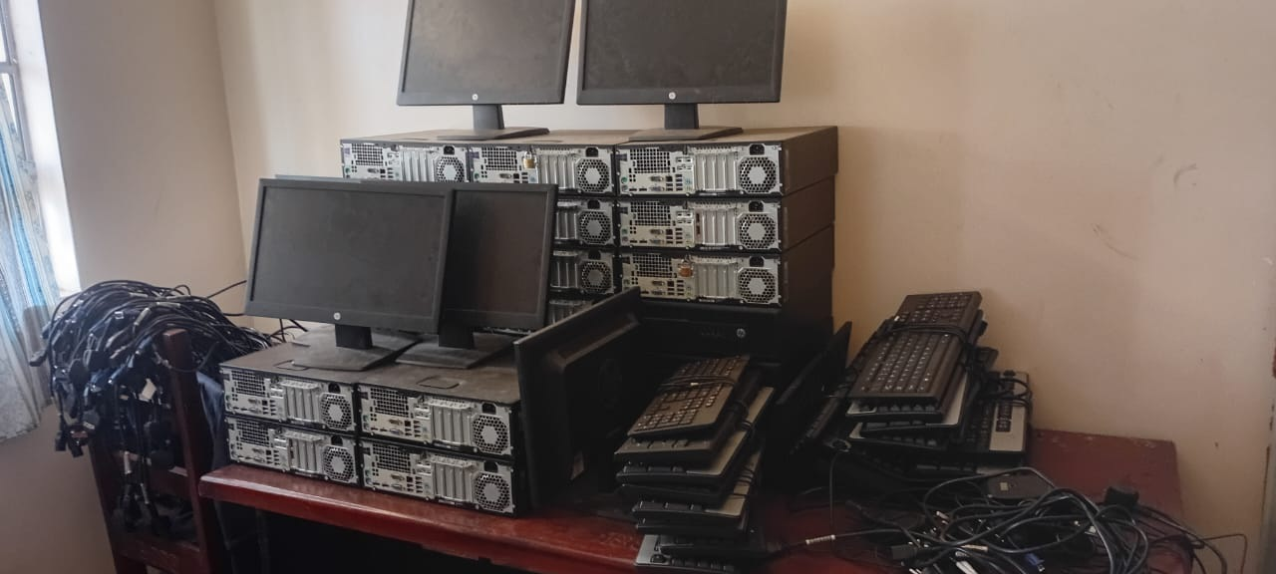  Figure 18: Computer sets stacked in a store at Bumufuni Seed Secondary School, Bulambuli District (Bugisu)

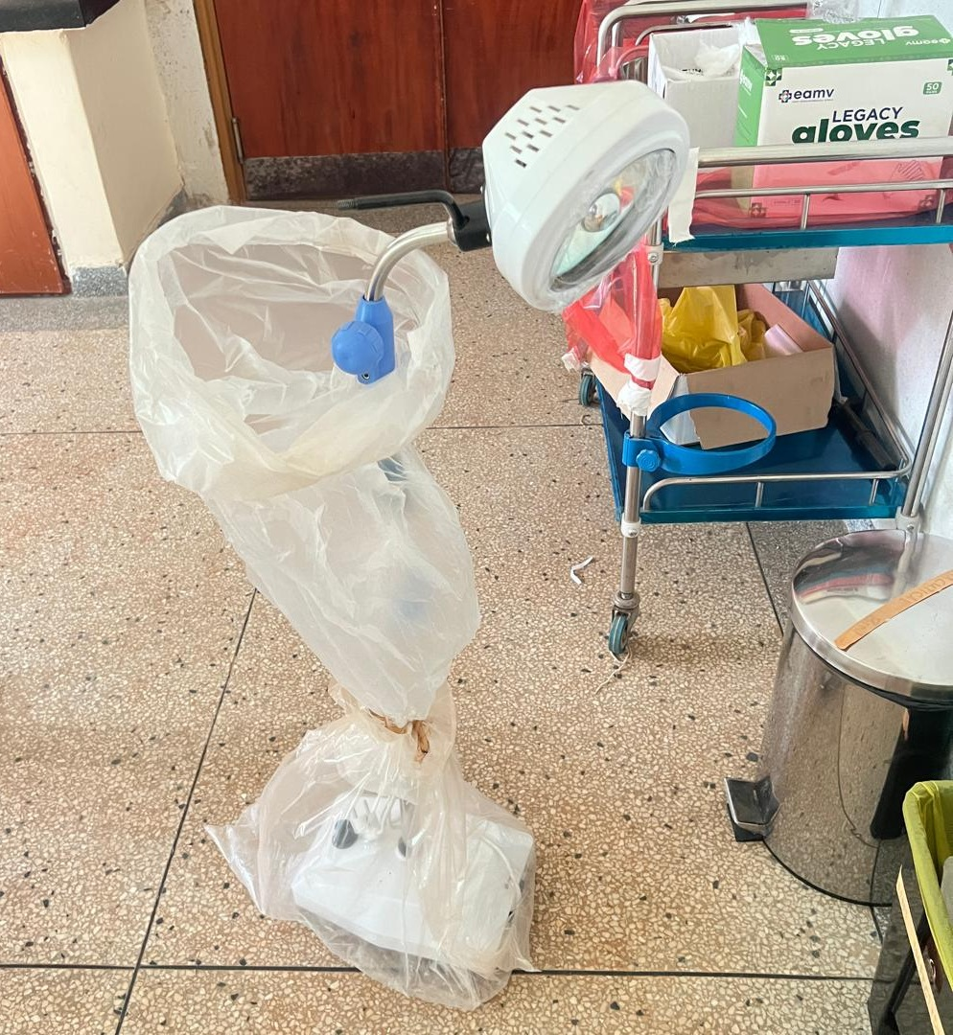  Figure 19: Examination lamp in protective wrapping at Buwumba HC III, Busia District (Bukedi) | 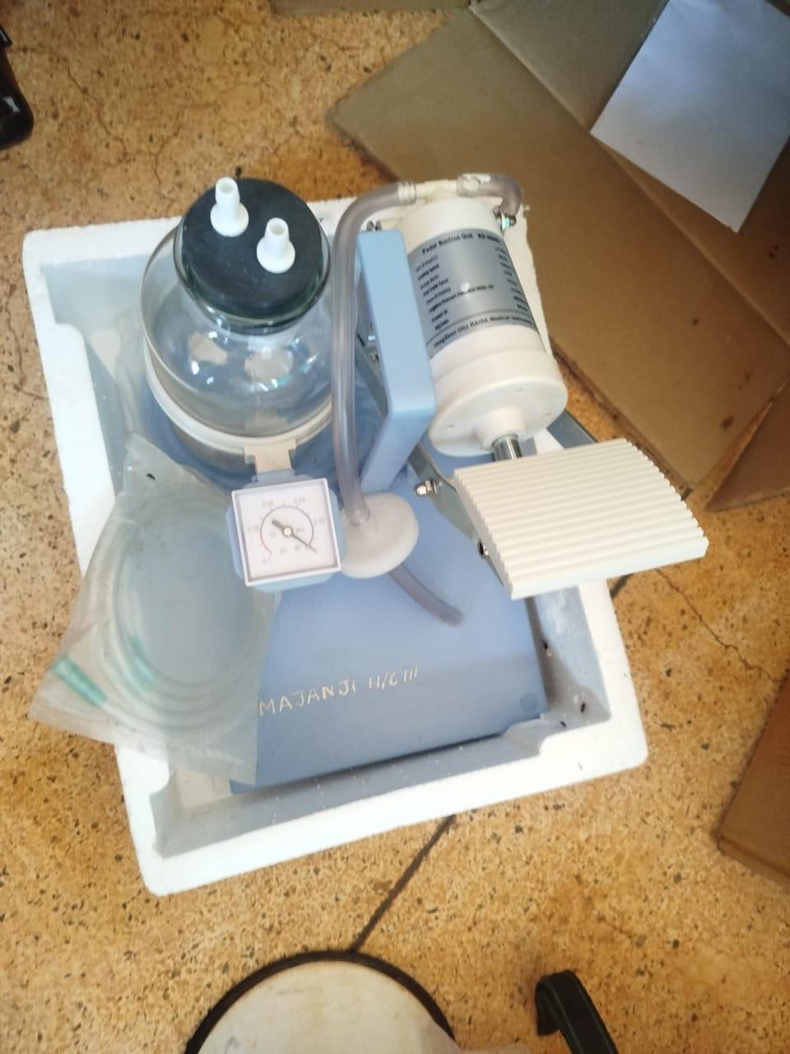  Figure 20: Pedal suction unit in packaging at Majanji HC III, Busia District (Bukedi)

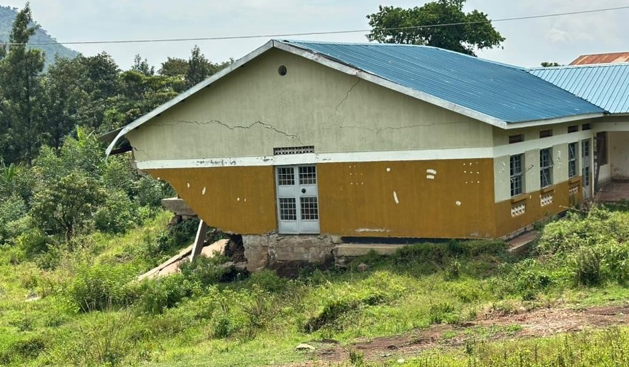
Figure 21: Cracked health centre block above collapsed ground, Bulambuli District (Bugisu)
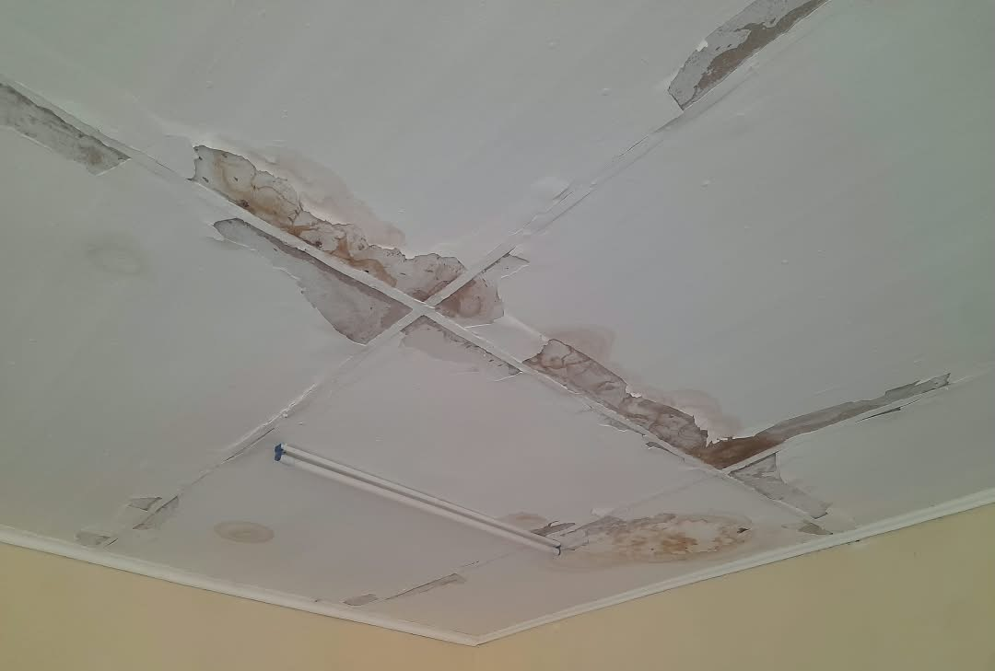  Figure 22: Stained and peeling ceiling at a health centre, Sironko District (Bugisu) | 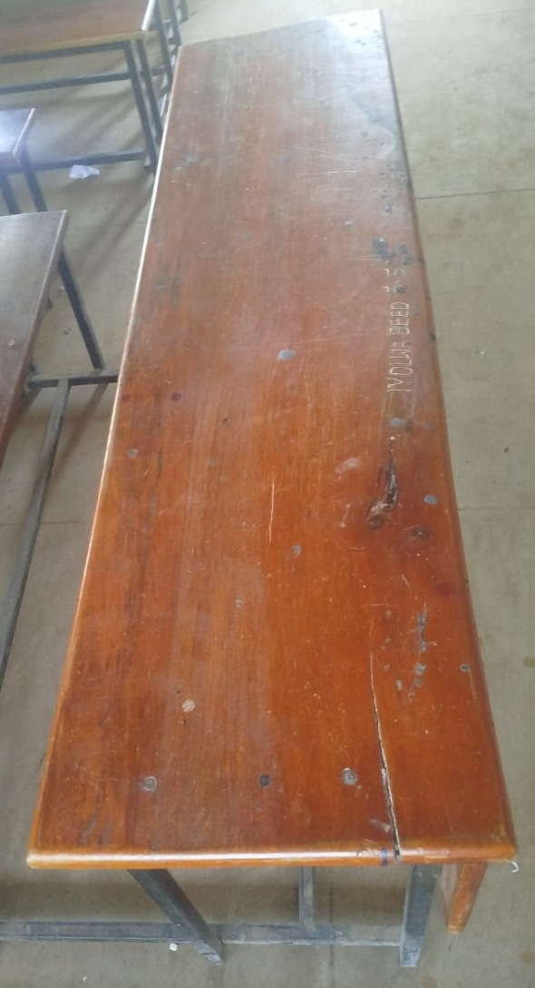  Figure 23: Cracked desk surface bearing a school marking, Tororo District (Bukedi)

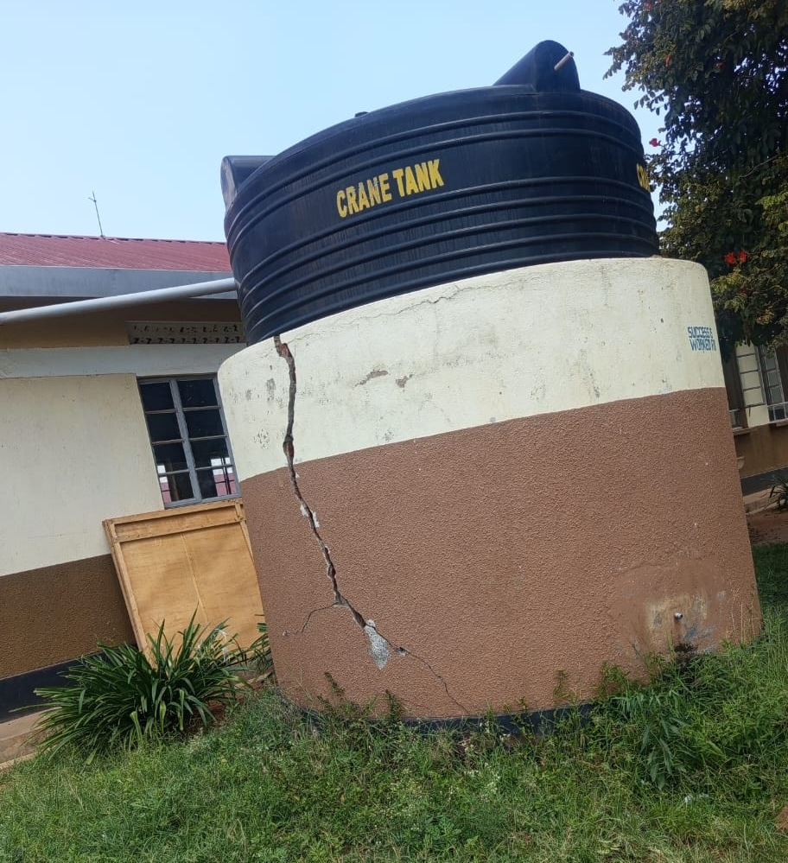  Figure 24: Water tank on a cracked base at a seed secondary school, Kibuku District (Bukedi) | 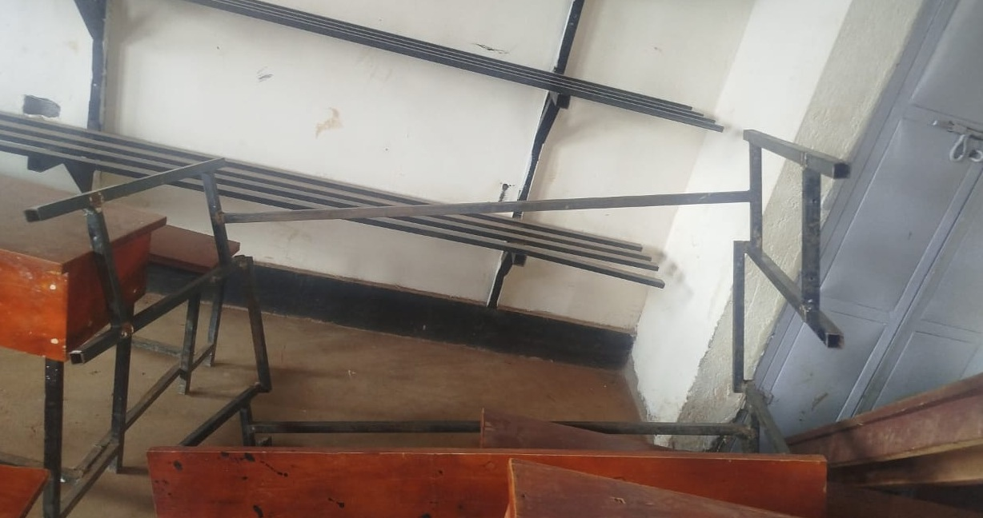  Figure 25: Broken desk frame at a seed secondary school, Namisindwa District (Bugisu)

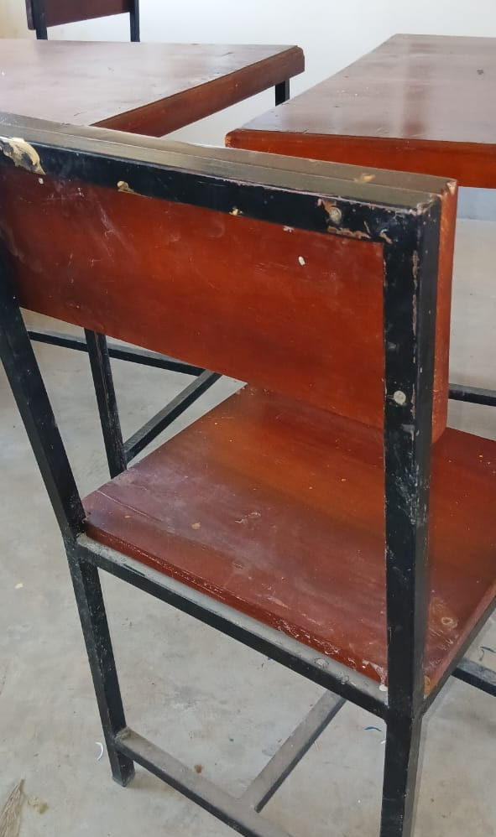  Figure 26: Damaged chair back joint at a seed secondary school, Budaka District (Bukedi) | 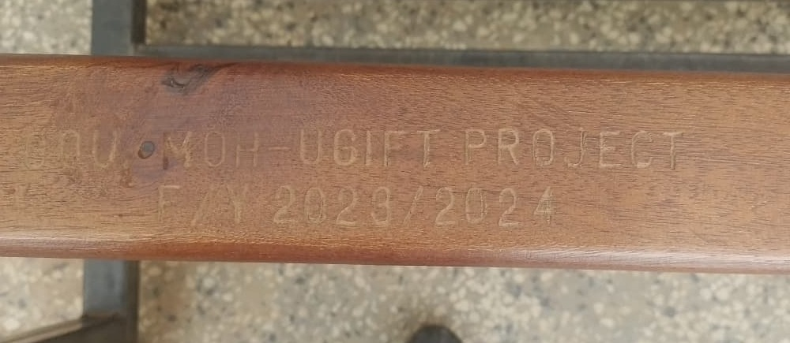  Figure 27: UgIFT engraving on a health centre bench, Bududa District (Bugisu)

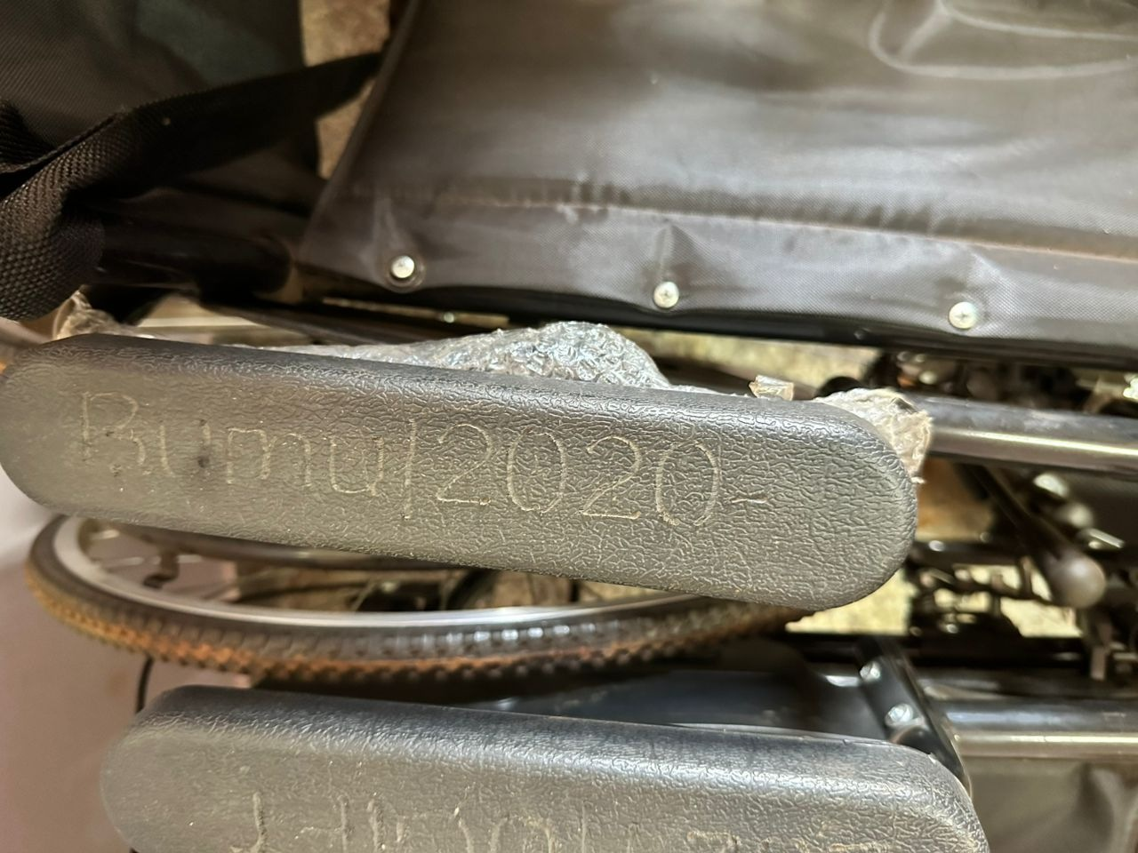  Figure 28: Engraving on a wheelchair armrest at Bumugibole HC III, Bulambuli District (Bugisu) | 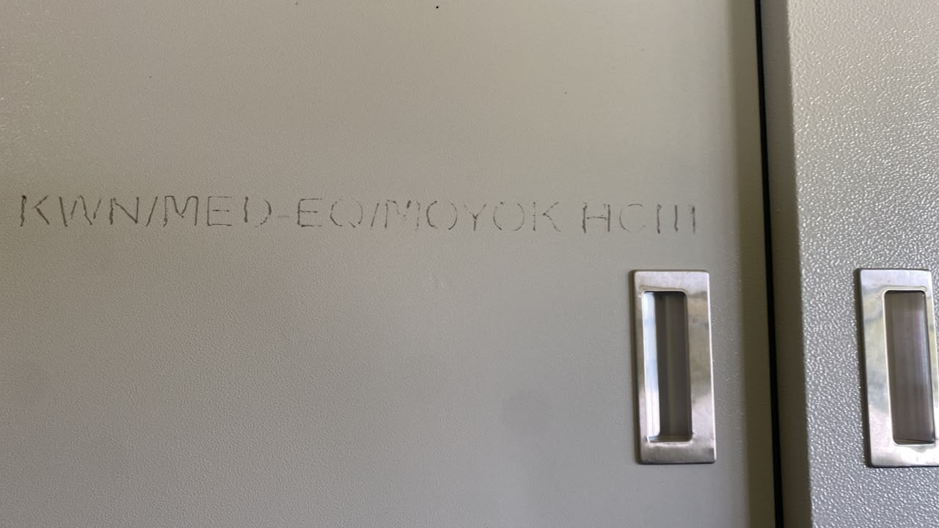  Figure 29: Institutional engraving on equipment at Moyok HC III, Kween District (Sebei)

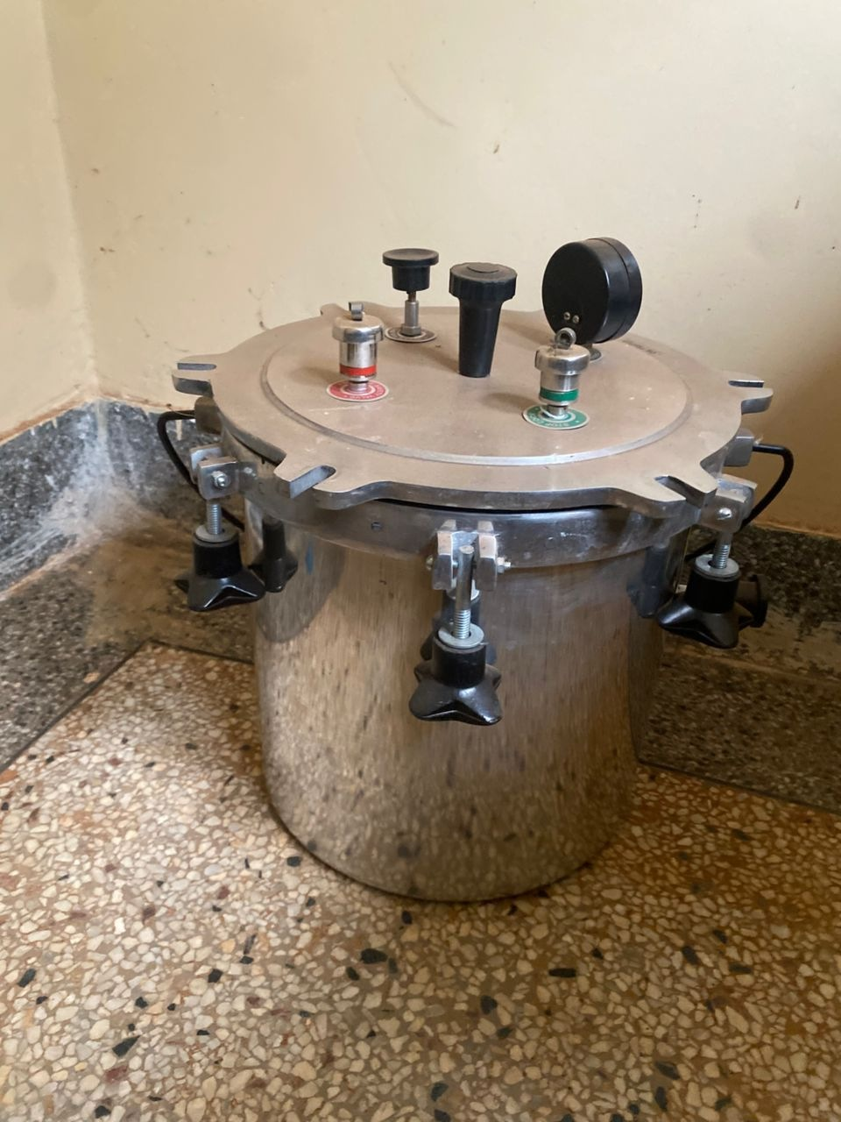  Figure 30: Autoclave at Atar HC III, Kween District (Sebei) | 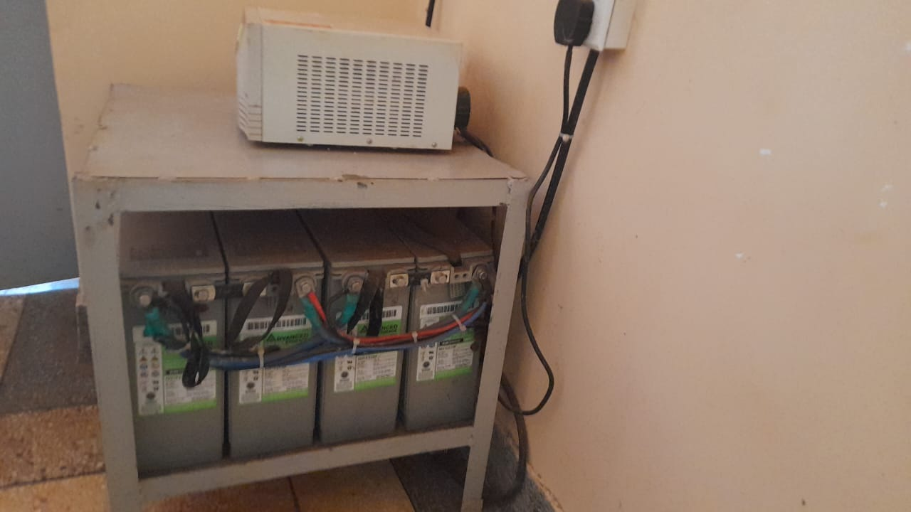  Figure 31: Solar batteries and control equipment at Atar HC III, Kween District (Sebei)

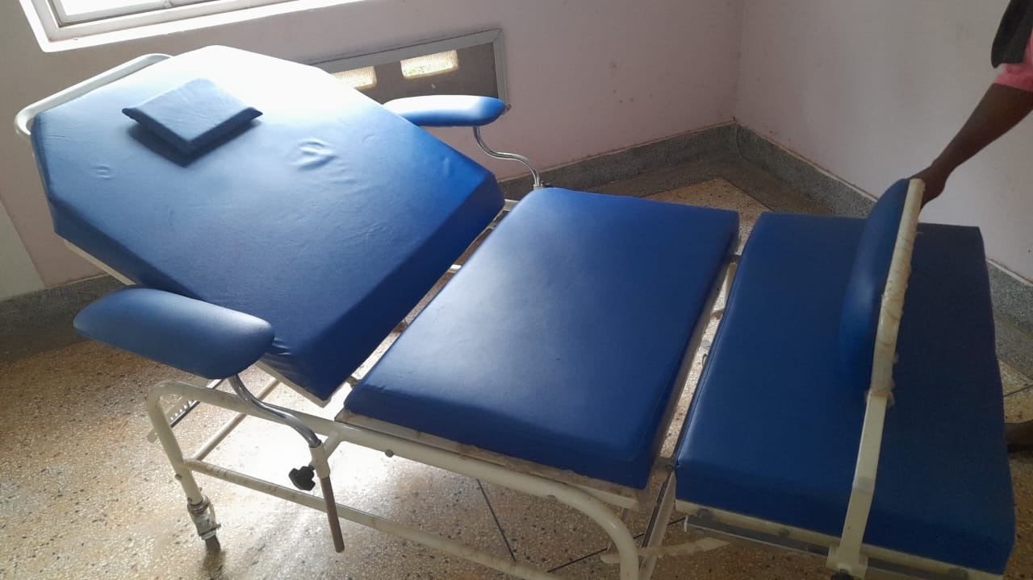  Figure 32: Kangaroo care chair at Atar HC III, Kween District (Sebei) | 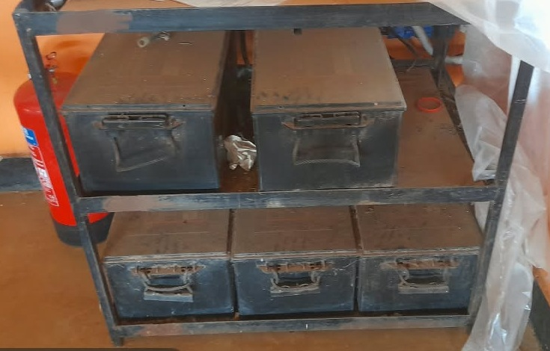  Figure 33: Solar batteries at Bunangaka HC III, Bulambuli District (Bugisu)

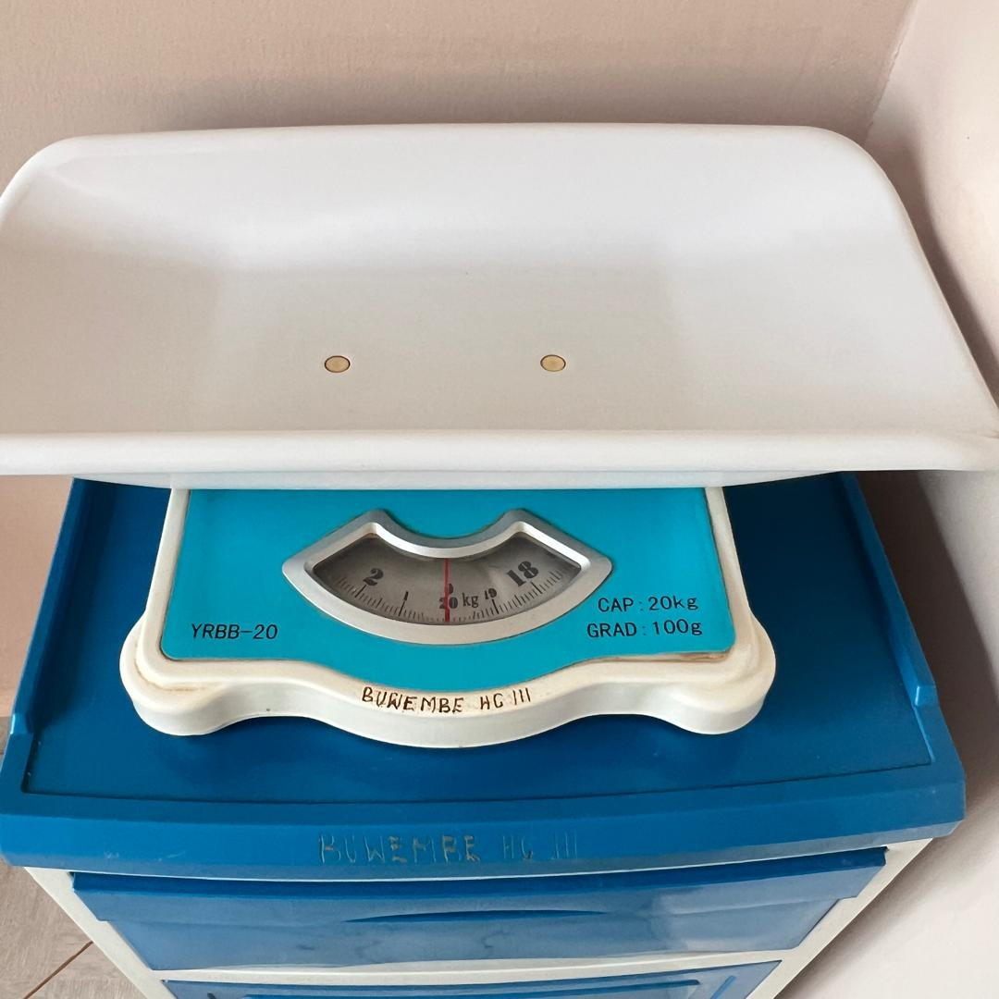  Figure 34: Infant weighing scale at Buwembe HC III, Busia District (Bukedi) | 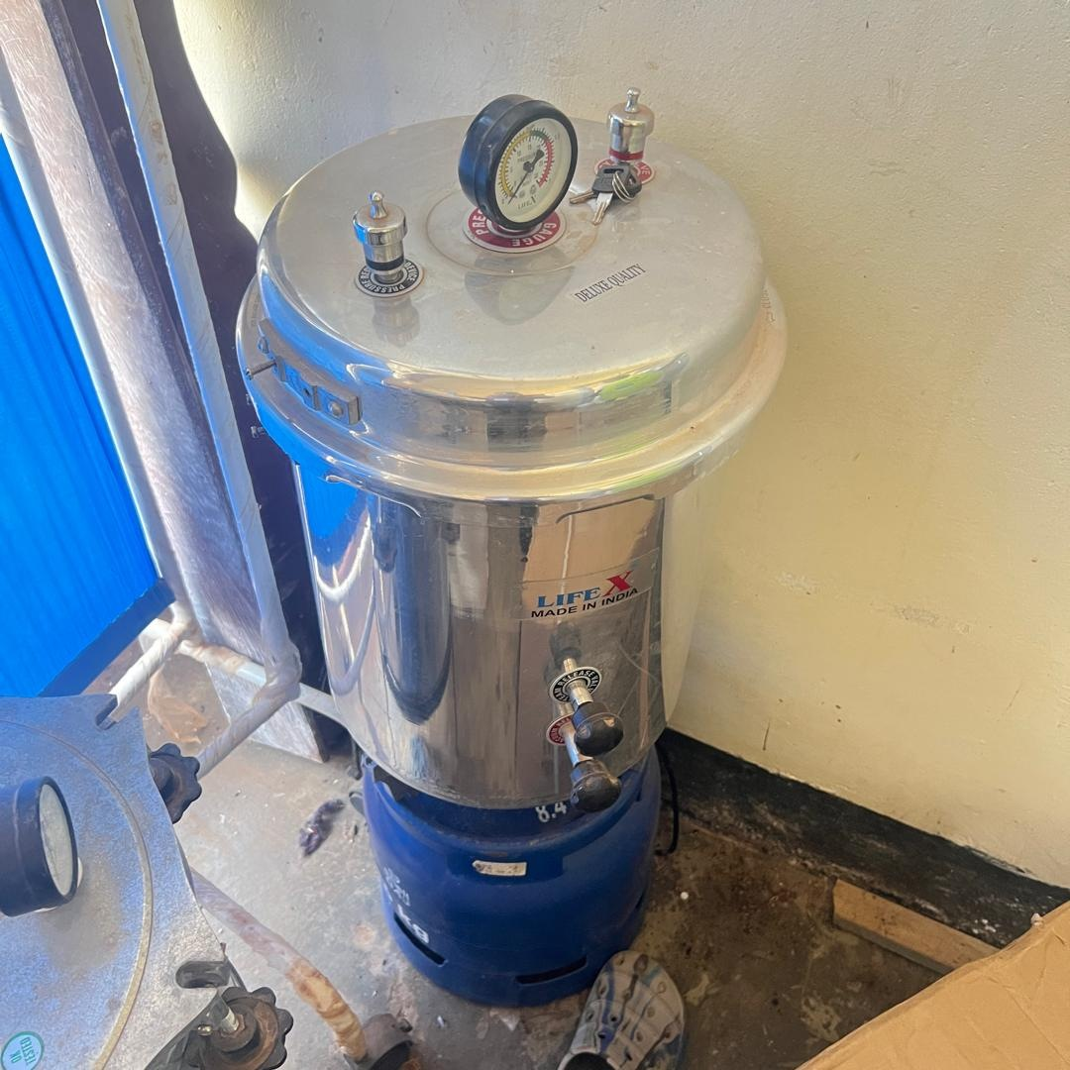  Figure 35: Autoclave above a gas cylinder at Buwembe HC III, Busia District (Bukedi)

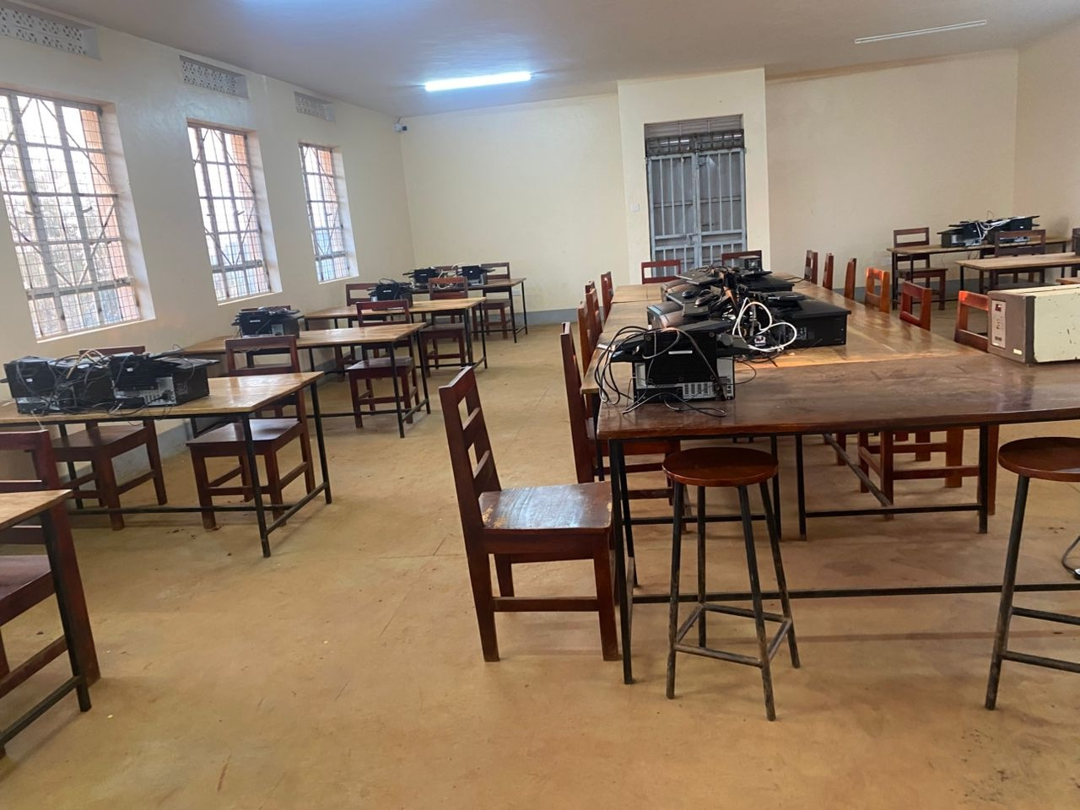  Figure 36: Computer equipment in the school ICT room at Kabeywa Seed Secondary School, Kapchorwa District (Sebei) | 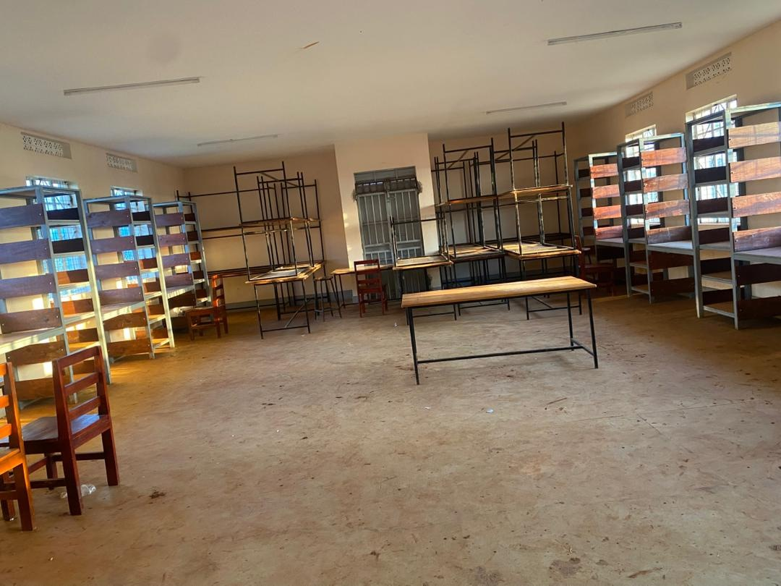  Figure 37: Library shelving and tables at Kabeywa Seed Secondary School, Kapchorwa District (Sebei)

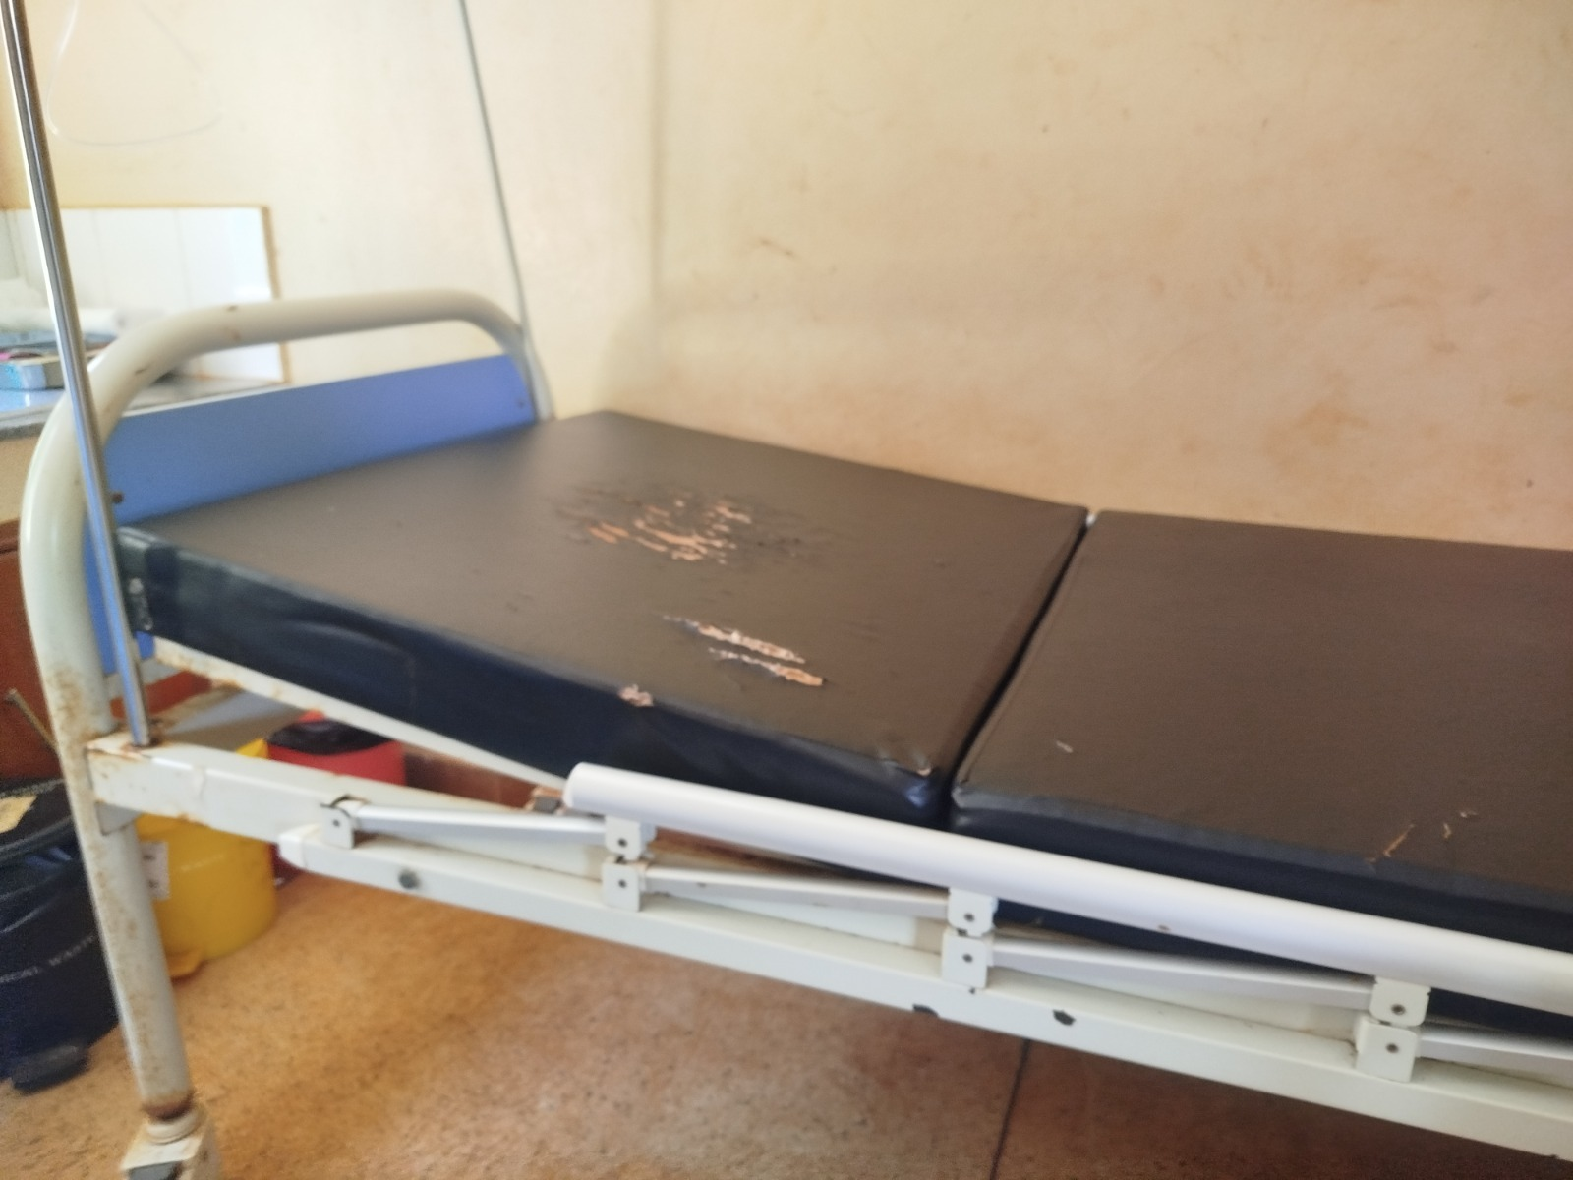  Figure 38: Delivery bed with a torn mattress cover at a health centre, Busia District (Bukedi) | 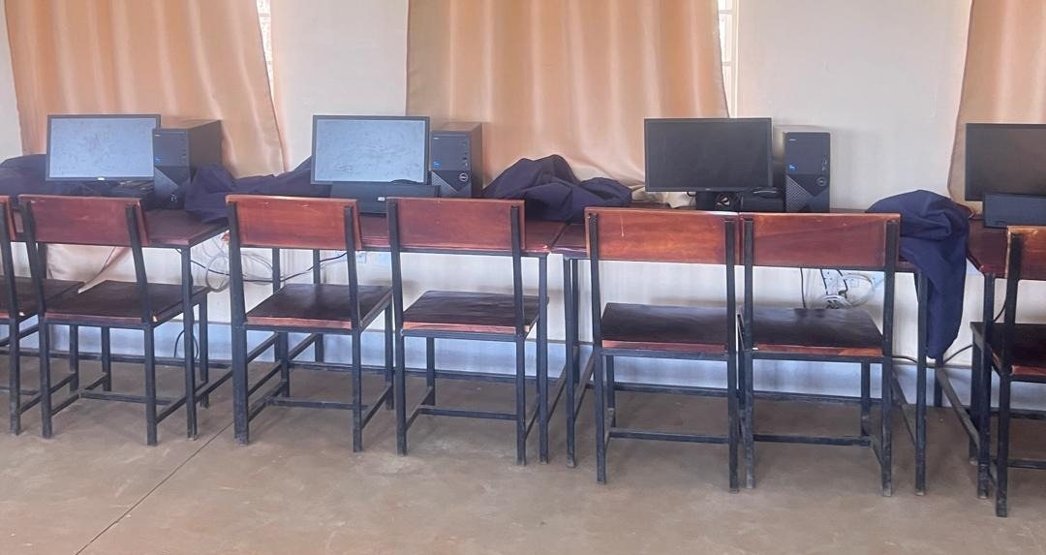  Figure 39: Desktop computers and classroom furniture at a seed secondary school, Busia District (Bukedi)

7.3.3 Northern region
The Northern region master list covered 92 health centres and 74 schools. The asset inventory covered 52,303 items. Of these, 12,064 were engraved and 40,239 were not engraved.

What was found
Unfinished construction delayed the use of delivered equipment at several schools. Got Apwoyo Seed Secondary School in Nwoya had not been commissioned; furniture was on site and computer equipment remained at district headquarters. At Ndhew and Mamba Seed Schools in Nebbi, unfinished buildings also delayed installation, with science equipment held at district headquarters. Mamba was using older structures to accommodate its computers.
Conditions differed within Nebbi. Atego Seed School was still under construction, but its computers were connected and working in older rooms. Staff reported power surges. This calls for completion of the planned facilities and a stable electricity supply while protecting the equipment already in use.
Power also restricted use of completed facilities. Lungulu Seed Secondary School in Nwoya kept computers and related equipment in storage pending a suitable power connection; the stored equipment included defective desktop units requiring separate attention. At Pamaka Health Centre III in Nebbi, a nonfunctional solar system and power constraints prevented use of oxygen equipment. Rupa Seed School in Moroto hired a generator for practical lessons and used the library and computer laboratory block as dormitories.
Some equipment had yet to be brought into use. Neonatal respiratory equipment at Kalemungole Health Centre III in Moroto remained in an unopened carton and treatment trolleys were still wrapped. Equipment intended for Todora Health Centre III in Nwoya had been sent to Paraa during construction and had not all been transferred back. Each case needs a clear decision on installation, allocation and custody.
Todora referred major medical equipment repairs through the District Health Officer to the Gulu Regional Referral Hospital technical team. Lungulu funded minor repairs from school revenue and sought district technical support. Its assets also required engraving. At Pamaka, staff reported greater community confidence and patient attendance, alongside pressure on staffing.

Gaps and actions
Table 13: Northern region: findings and recommended actions
Location | Expected position and field finding | Gap or service implication | Recommended action
Got Apwoyo Seed Secondary School, Nwoya | The school was under construction and had not been commissioned. Delivered furniture was on site and computer equipment was held at district headquarters. | Incomplete buildings prevented commissioning and installation. | Agree a costed completion and handover plan, then move and install the equipment when the rooms and utilities are ready.
Ndhew Seed School, Nebbi | Buildings were incomplete, with computer and science equipment held at district headquarters and furniture not yet installed. | Delivery of equipment had not translated into an equipped school. | Complete the outstanding works and sanitation facilities and coordinate furniture and equipment installation with handover.
Mamba Seed School, Nebbi | Construction was incomplete. Computers were temporarily accommodated in older structures, while science equipment remained at district headquarters. | The planned laboratory and computer spaces were not ready for full installation. | Complete and commission the buildings, install the equipment and confirm safe operation before formal handover.
Atego Seed School, Nebbi | Computers were connected and working in older rooms while construction continued. | Staff reported power surges and the planned facilities were not fully commissioned. | Stabilise the power supply, protect the installed computers and finish the remaining works.
Lungulu Seed Secondary School, Nwoya | The school funded minor repairs and kept breakdown information, but computers remained in storage pending power. | The stored equipment included defective desktop units, and the assets were not engraved. | Provide a suitable power connection, repair defective units, install the usable equipment and apply asset identification markings.
Todora and Paraa Health Centres III, Nwoya | Todora used the regional technical maintenance team, while some equipment originally intended for Todora remained at Paraa after redirection during construction. | Equipment location and final allocation required a district decision. | Confirm the service need at both facilities, formally allocate or transfer the equipment and update the named custodians.
Pamaka Health Centre III, Nebbi | Staff reported increased attendance and community confidence. | The solar system was not working, oxygen equipment could not be used because of power constraints, and staffing was under pressure. | Restore reliable power and demonstrate oxygen equipment operation; review staffing against patient demand.
Kalemungole Health Centre III, Moroto | Neonatal respiratory equipment remained in an unopened carton and treatment trolleys were still wrapped. | Delivered items had not been brought into routine use. | Check the equipment, confirm the room and staff requirements, and arrange installation and user orientation.
Rupa Seed School, Moroto | The school hired a generator for practical lessons and used its library and computer laboratory block as dormitories. | The intended learning spaces and a permanent power connection were unavailable for their planned use. | Agree a room-use plan and power solution that restores the library and computer laboratory functions.
Alwi Seed Secondary School, Pakwach | Expected: The computer laboratory and security equipment should support teaching and school operation.  Found: The school reported power surges. Nine monitors and ten system units were not working, as were the server power-backup unit and twenty other power-backup units. Only one of thirteen security cameras was functional. | The loss of working computer stations and power protection reduced the usable laboratory capacity and left much of the camera system unavailable. | Pakwach District and the school should first assess the electrical supply and protection, then repair or replace failed equipment and test the whole laboratory and camera system before acceptance.
Wadelai Seed Secondary School, Pakwach | Expected: The school should be able to use its computer laboratory reliably and keep water storage structures safe.  Found: Twenty desktop computers were recorded as working and in use, but the school reported a solar fault that interrupted use of electrical equipment. One water-tank stand was broken and presented a threat to students. | Usable equipment remained dependent on an unreliable power supply, and the damaged tank support required immediate attention. | The school and Pakwach District should restrict access around the damaged tank support pending an engineering assessment, repair the support, and restore and test the solar system.
Table 14: Northern assets and identification by category
Asset category | Assets | Engraved | Not engraved
Clinical equipment | 5,874 | 438 | 5,436
Clinical furniture | 5,795 | 1,164 | 4,631
Other assets | 4,117 | 249 | 3,868
Building blocks | 2,555 | 34 | 2,521
Maternity ward equipment | 2,211 | 28 | 2,183
Health centre ICT equipment | 205 | 137 | 68
School furniture | 28,922 | 9,145 | 19,777
School computers and related equipment | 2,316 | 832 | 1,484
Other ICT equipment | 102 | 12 | 90
School support equipment | 201 | 23 | 178
Vehicles and motorcycles | 5 | 2 | 3
Table 14 shows the assets covered and the outstanding identification work by category. Sub-region counts and condition classifications are in the appendices.

Field photographs from Northern
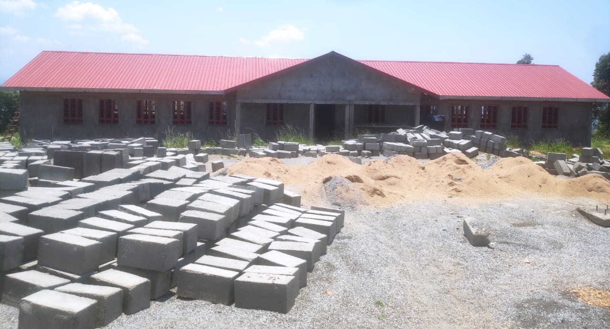  Figure 40: Building works and construction materials at Ndhew Seed Secondary School, Nebbi District (West Nile) | 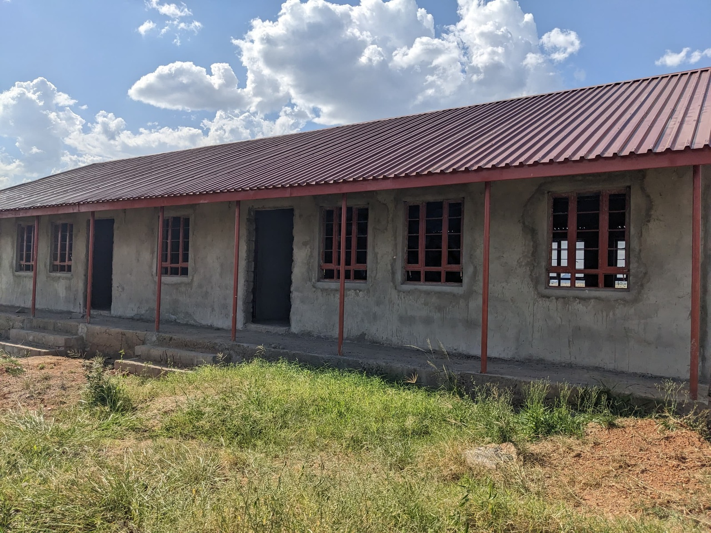  Figure 41: Unfinished classroom block at Sidok Seed Secondary School, Kaabong District (Karamoja)

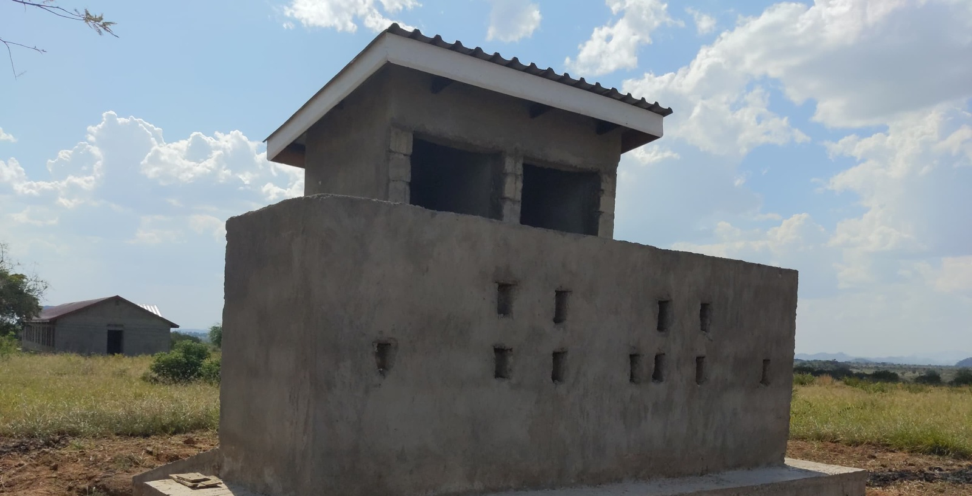  Figure 42: Latrine block under construction at Sidok Seed Secondary School, Kaabong District (Karamoja) | 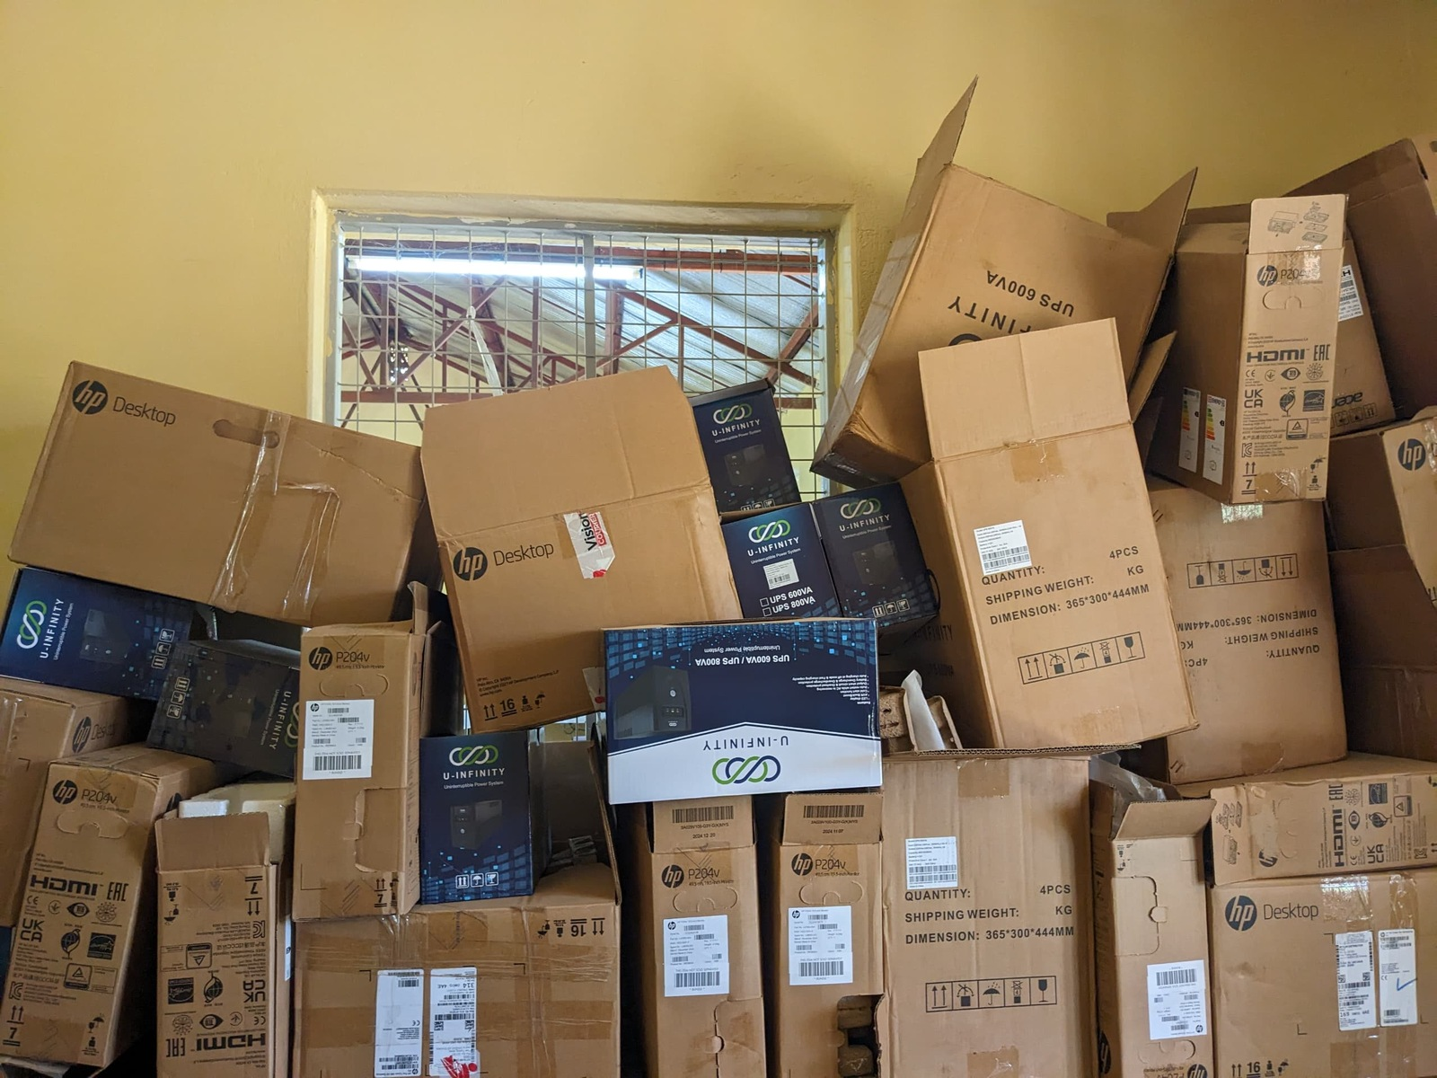  Figure 43: Boxed desktop computers at Alerek Seed Secondary School, Abim District (Karamoja)

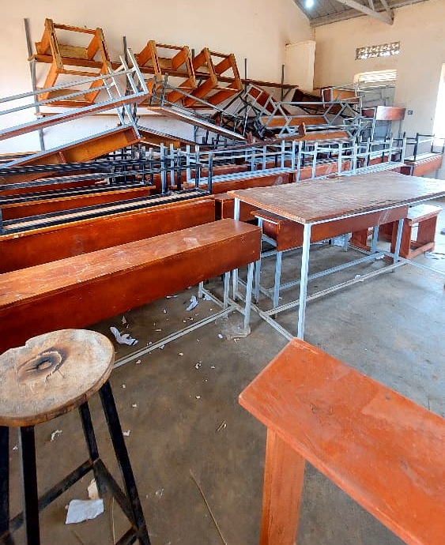  Figure 44: Stacked desks, chairs and stools at a seed secondary school, Napak District (Karamoja) | 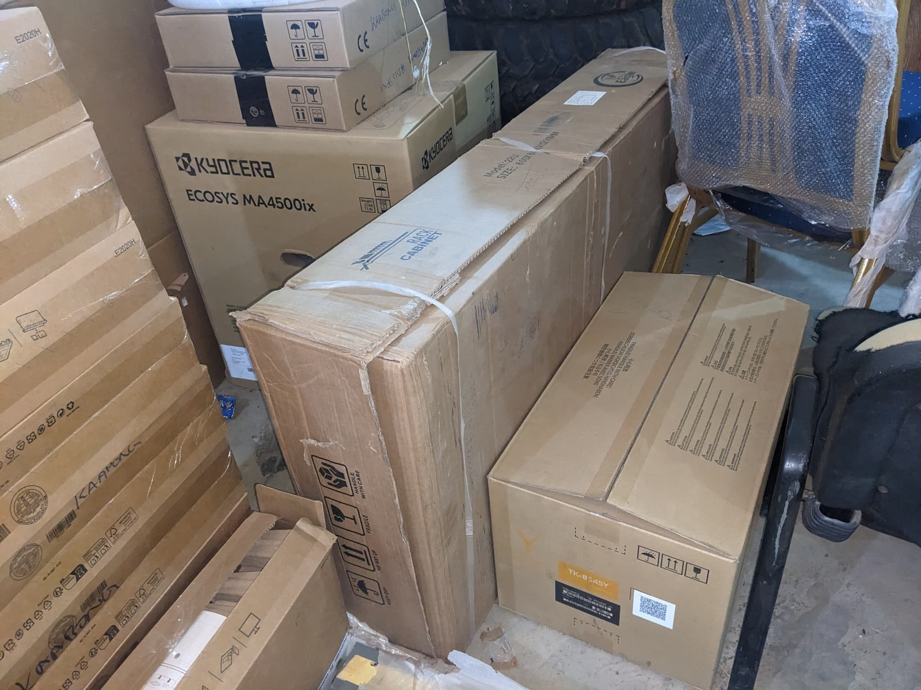  Figure 45: Boxed printer and equipment at Sidok Seed Secondary School, Kaabong District (Karamoja)

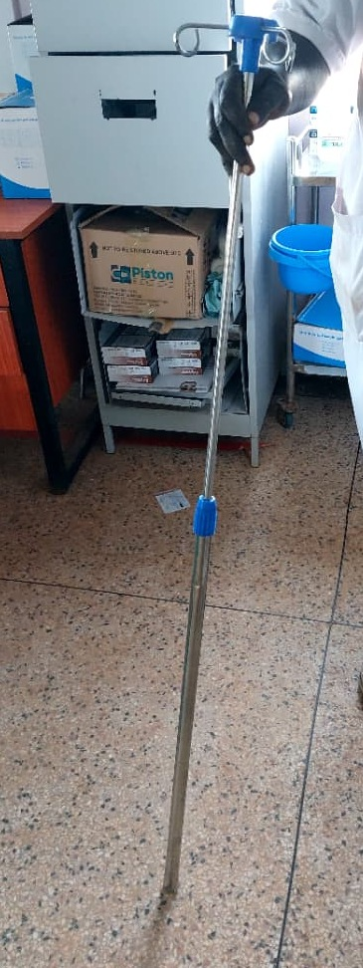  Figure 46: Damaged drip stand at a health centre, Moroto District (Karamoja) | 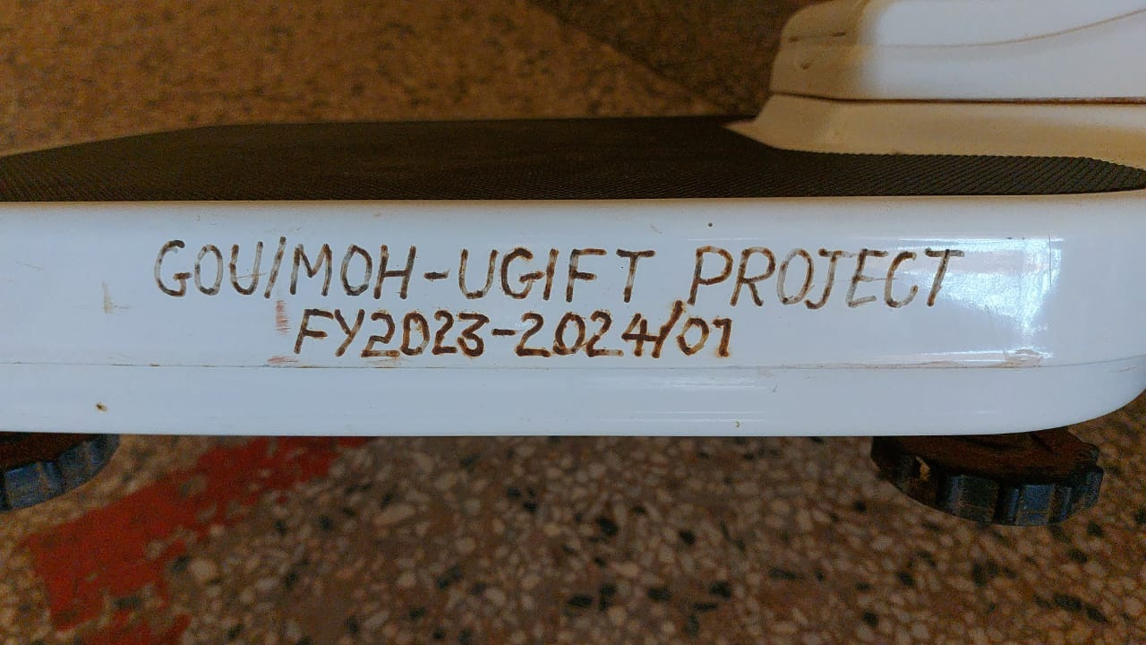  Figure 47: Programme engraving on a weighing scale at Kalemungole HC III, Moroto District (Karamoja)

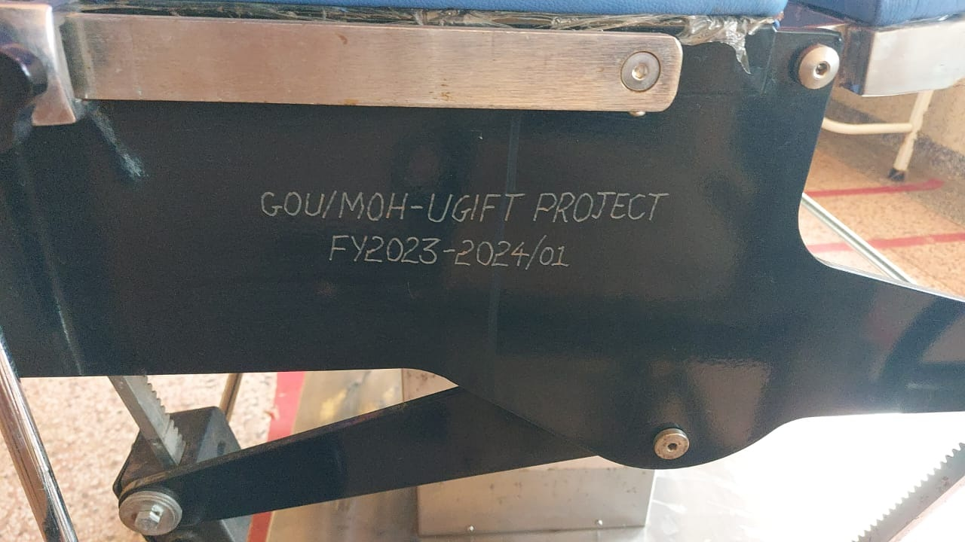  Figure 48: Programme engraving on a delivery bed at Kalemungole HC III, Moroto District (Karamoja) | 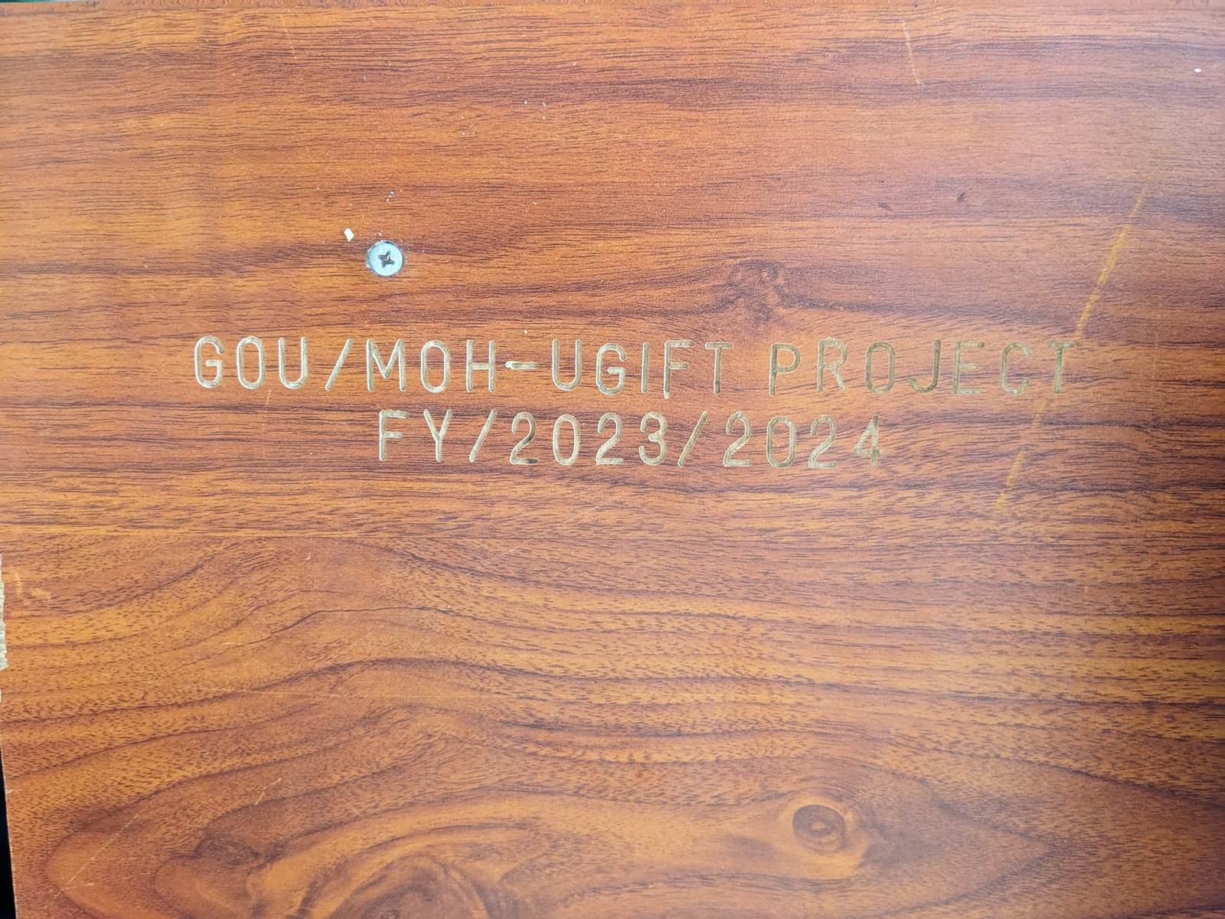  Figure 49: Programme engraving on a table at Kamoru HC III, Kotido District (Karamoja)

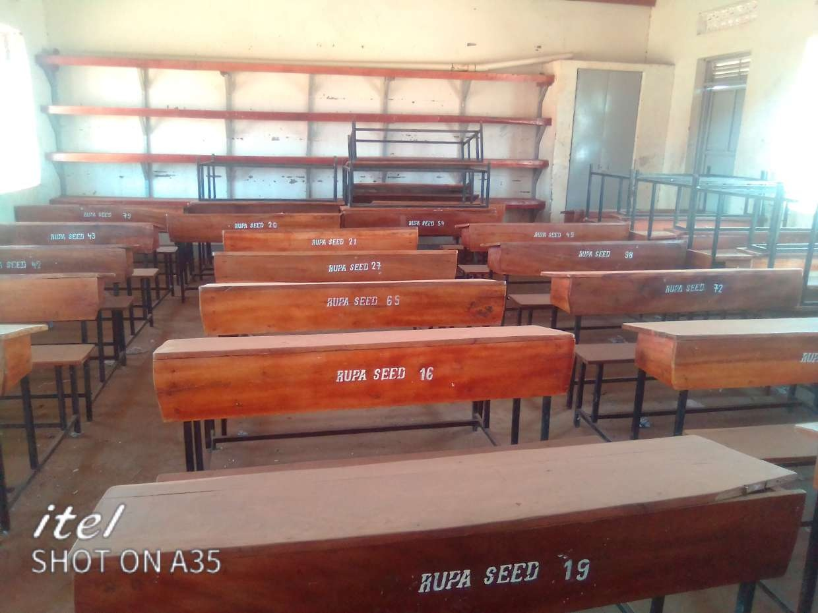  Figure 50: Classroom furniture with school markings at Rupa Seed School, Moroto District (Karamoja) | 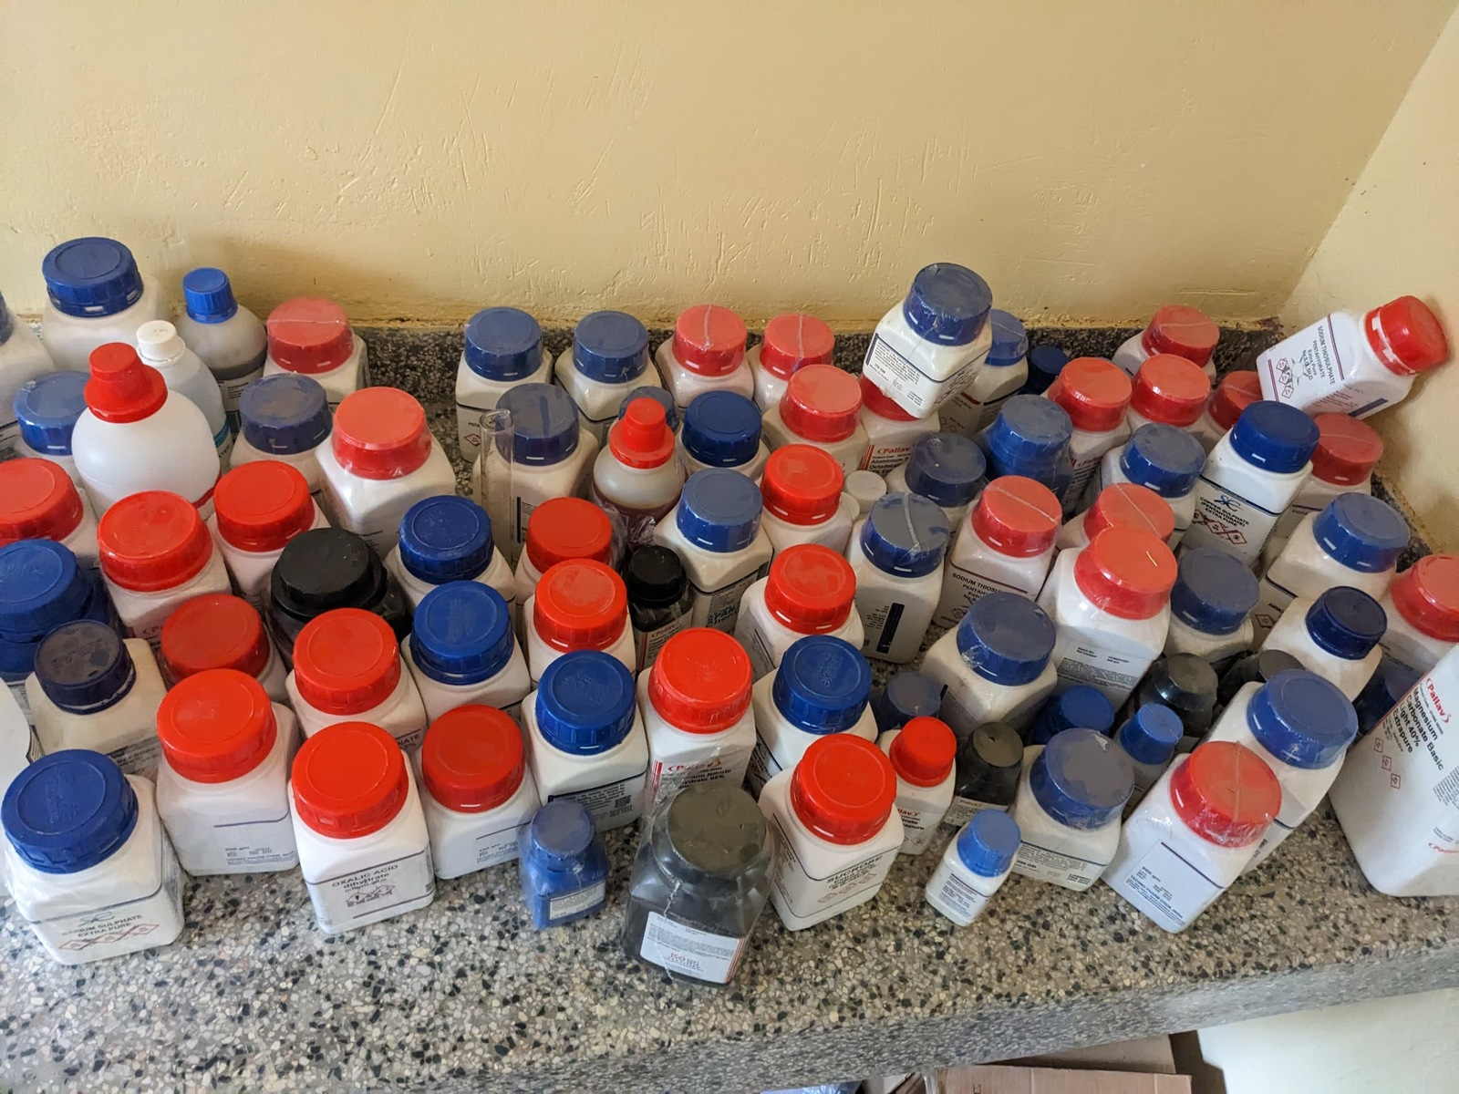  Figure 51: Laboratory reagent containers at Alerek Seed Secondary School, Abim District (Karamoja)

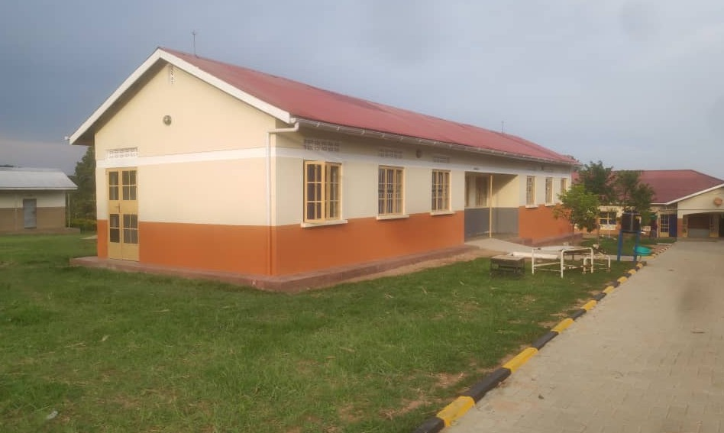  Figure 52: Health centre building, Nwoya District (Acholi) | 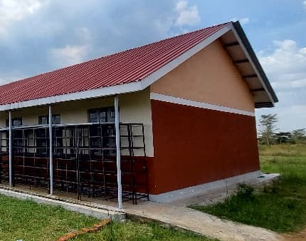  Figure 53: Section of the science laboratory exterior at Iriiri Seed Secondary School, Napak District (Karamoja)

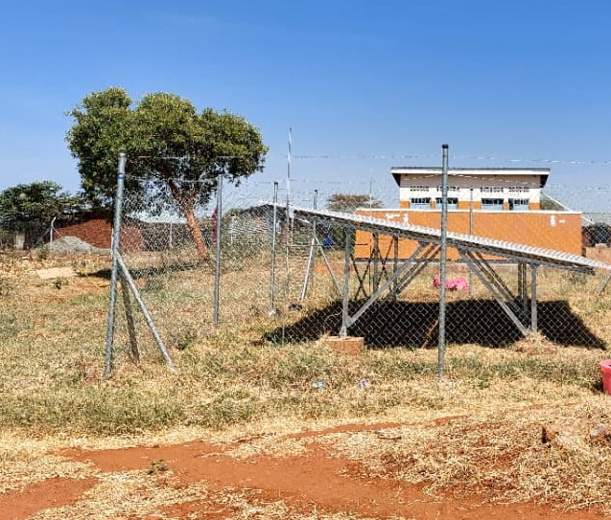  Figure 54: Solar panels at Kalemungole HC III, Moroto District (Karamoja) | 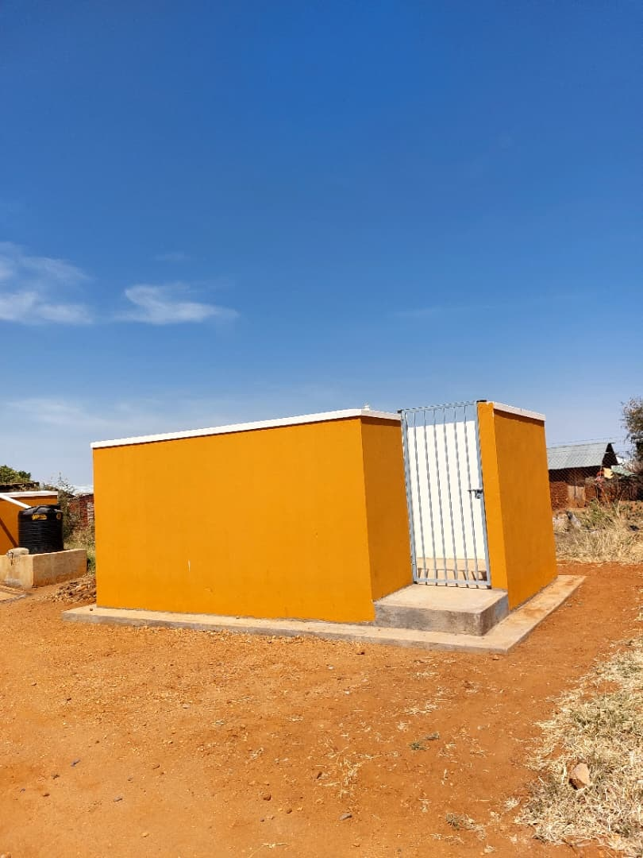  Figure 55: Patient toilet block at Kalemungole HC III, Moroto District (Karamoja)

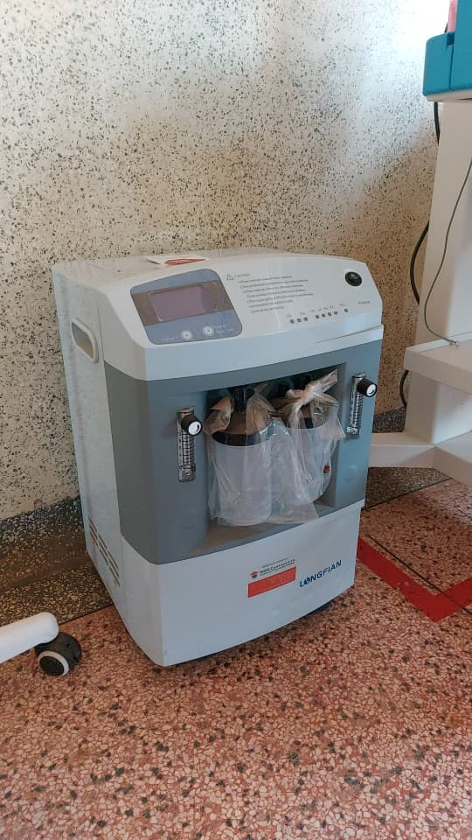  Figure 56: Oxygen concentrator at Kalemungole HC III, Moroto District (Karamoja) | 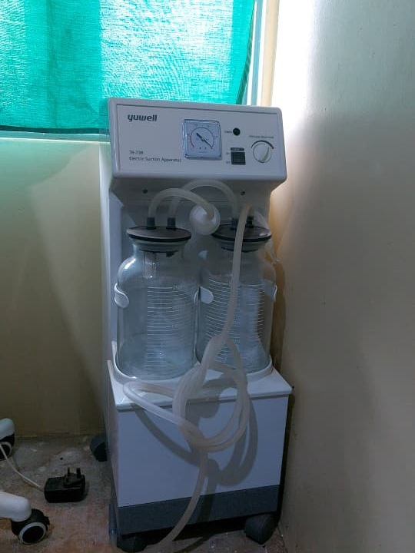  Figure 57: Suction apparatus at Kalemungole HC III, Moroto District (Karamoja)

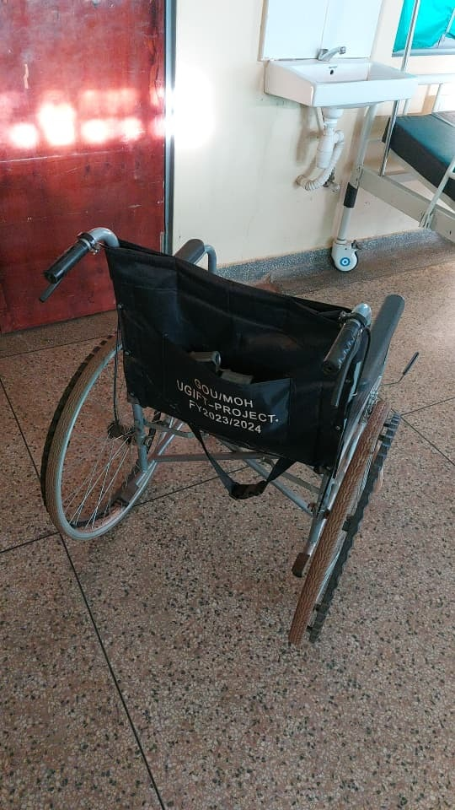  Figure 58: Wheelchair with programme marking at Kalemungole HC III, Moroto District (Karamoja) | 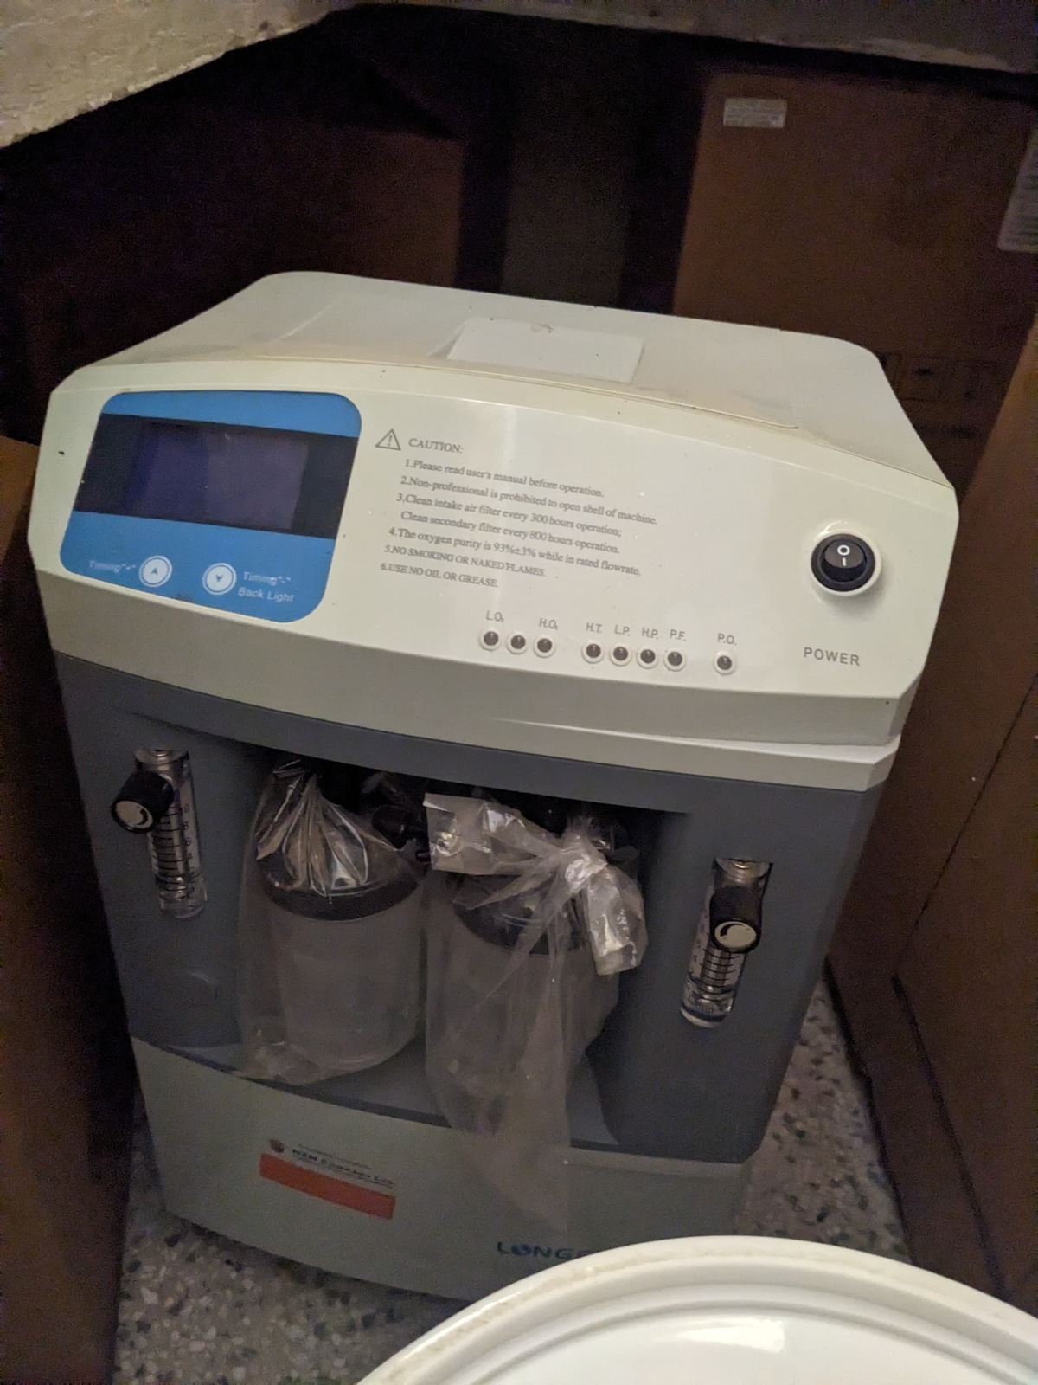  Figure 59: Oxygen concentrator at Kamoru HC III, Kotido District (Karamoja)

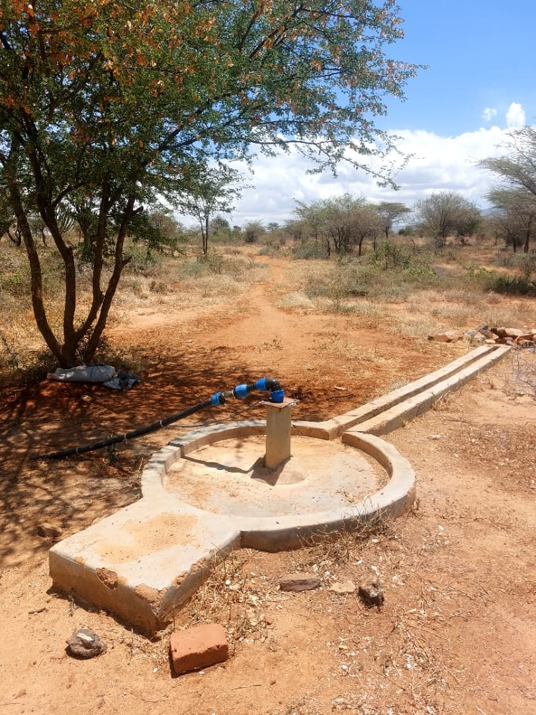  Figure 60: Borehole apron and pipework at Katikekire Seed School, Moroto District (Karamoja) | 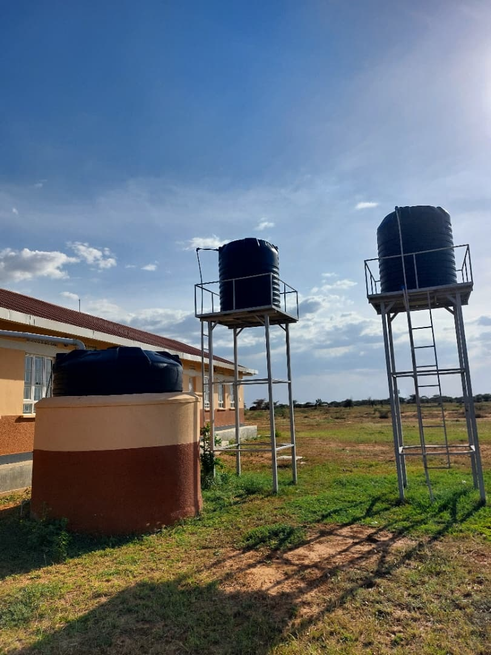  Figure 61: Water storage tanks at Lopei Seed Secondary School, Napak District (Karamoja)

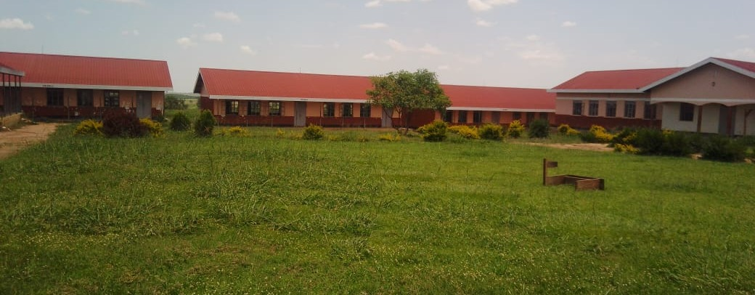  Figure 62: Buildings at a seed secondary school, Nwoya District (Acholi) | 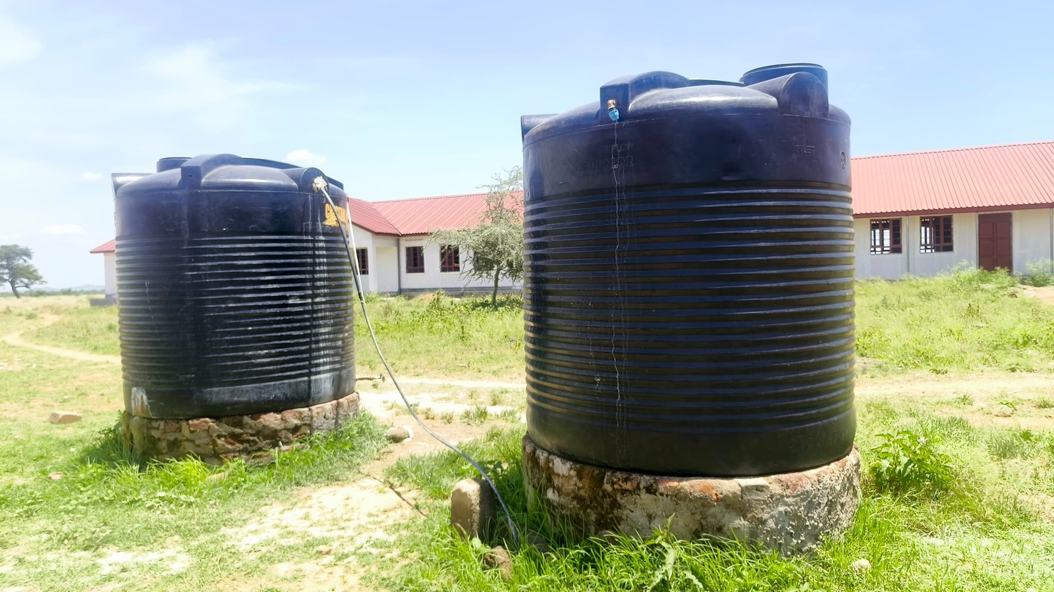  Figure 63: Water storage tanks at Rengen Seed School, Kotido District (Karamoja)

7.3.4 Western region
The Western region master list covered 124 health centres and 71 schools. The asset inventory covered 44,164 items. Of these, 6,951 were engraved and 37,213 were not engraved.

What was found
Repair needs affected buildings as well as equipment. At Nyamarunda Health Centre III in Kibaale, staff raised concerns about staff-quarter workmanship, electrical installation, drainage, water security and storage space. The facility recorded broken items, set them aside and referred them to the District Health Officer. A technical inspection should establish the repairs needed and their order of priority.
Avogera Health Centre III in Buliisa carried out some repairs locally and received support from Hoima Regional Referral Hospital. Items that could not be repaired remained in storage, and staff identified a need for technical skills, user orientation and more storage space. Kyankaramata Health Centre III in Kyenjojo funded minor repairs from Primary Health Care funds, but the cost of major repairs was a constraint.
There were practical maintenance arrangements to continue. Ngwedo Seed Secondary School in Buliisa engaged a caretaker monthly and used the Directorate of Industrial Training for furniture repairs. Bundimulangya Health Centre III in Bundibugyo referred maintenance needs to the District Health Officer, who sent a team; staff said the power house and solar installation supported continued operation.
Butungama Seed School in Ntoroko remained under construction. At Kigorobya Seed Secondary School in Hoima, classrooms, the computer room and chemistry laboratory supported teaching, while staffing and study materials remained constraints. These findings call for completion of outstanding works and operating support alongside the assets already supplied.

Gaps and actions
Table 15: Western region: findings and recommended actions
Location | Expected position and field finding | Gap or service implication | Recommended action
Nyamarunda Health Centre III, Kibaale | The facility identified and set aside broken items and referred them to the District Health Officer. | Staff raised concerns about staff-quarter workmanship, electrical installation, drainage, water security and storage. | Carry out a joint engineering and health inspection, make unsafe installations safe and complete the agreed repairs.
Avogera Health Centre III, Buliisa | The facility carried out local repairs and received technical support from Hoima Regional Referral Hospital. | Items that could not be repaired remained stored; staff identified technical skills, user orientation and storage needs. | Assess the stored items for repair, give practical user training and agree a suitable storage arrangement.
Ngwedo Seed Secondary School, Buliisa | A caretaker attended monthly for repairs, and the Directorate of Industrial Training repaired furniture. | Practice to sustain. | Continue the repair schedule and record the items returned to use.
Bundimulangya Health Centre III, Bundibugyo | The District Health Officer arranged maintenance support, and staff said the power house and solar installation supported continued operation. | Practice to sustain. | Keep the technical referral arrangement active and include the power and solar systems in routine servicing.
Kyankaramata Health Centre III, Kyenjojo | Primary Health Care funds paid for minor repairs. | Major repair costs were a constraint. | Prepare costed technical referrals for major repairs and agree district funding and follow-up.
Kigorobya Seed Secondary School, Hoima | Equipped classrooms, the computer room and chemistry laboratory supported teaching; the school and ministry shared maintenance work. | Staffing and study materials constrained use of the improved facilities. | Review teaching staff and materials alongside the maintenance plan.
Butungama Seed School, Ntoroko | The school was still under construction at the time of the interview. | The construction works required completion. | Confirm the outstanding works with the district engineer and agree the completion and handover sequence.
Butiaba Health Centre III, Buliisa | The hydraulic delivery bed was not in use because staff needed operating guidance. Staff also reported difficulty obtaining test strips for the supplied glucometers. | Equipment use depended on practical training and access to compatible consumables. | Demonstrate safe operation of the delivery bed with its users and arrange a reliable supply of compatible glucometer strips.
Kihungya Seed Secondary School, Buliisa | Expected: The school investment should provide usable science and computer laboratories, staff accommodation, water and secure premises.  Found: The science block, computer laboratory and library were still under construction, and staff quarters were incomplete. The school reported no electricity for computer sessions, no water for sanitation and no perimeter fence. Its administration block was already in use. | The school was partly in use while essential teaching spaces, utilities and security remained unfinished. | Buliisa District and the Ministry of Education and Sports should use one completion plan for the laboratories, staff housing, electricity, water and security, with separate testing and handover of each finished element.
Kihungya Health Centre III, Buliisa | Expected: Expanded buildings and equipment should support care at the health centre, with responsibility clear for any items kept elsewhere.  Found: Staff reported more room for patients, easier working arrangements through staff accommodation, and electricity from the new solar power house. Buildings were in use. A gas stove, electric suction apparatus, laboratory stool and electric centrifuge were recorded at the subcounty rather than the health centre. | The building and power investment was supporting care, but the intended use and custody of equipment held away from the facility needed confirmation. | Buliisa District and facility management should preserve the working building and solar arrangements, confirm who holds the off-site equipment, and agree whether it should be deployed to the health centre or remain at its present location.
Table 16: Western assets and identification by category
Asset category | Assets | Engraved | Not engraved
Clinical equipment | 6,207 | 712 | 5,495
Clinical furniture | 4,524 | 805 | 3,719
Other assets | 7,013 | 271 | 6,742
Health centre ICT equipment | 79 | 7 | 72
Maternity ward equipment | 2,088 | 898 | 1,190
Building blocks | 3,503 | 191 | 3,312
School furniture | 18,481 | 3,755 | 14,726
School support equipment | 216 | 26 | 190
Other ICT equipment | 58 | 3 | 55
School computers and related equipment | 1,994 | 283 | 1,711
Vehicles and motorcycles | 1 | 0 | 1
Table 16 shows the assets covered and the outstanding identification work by category. Sub-region counts and condition classifications are in the appendices.

Field photographs from Western
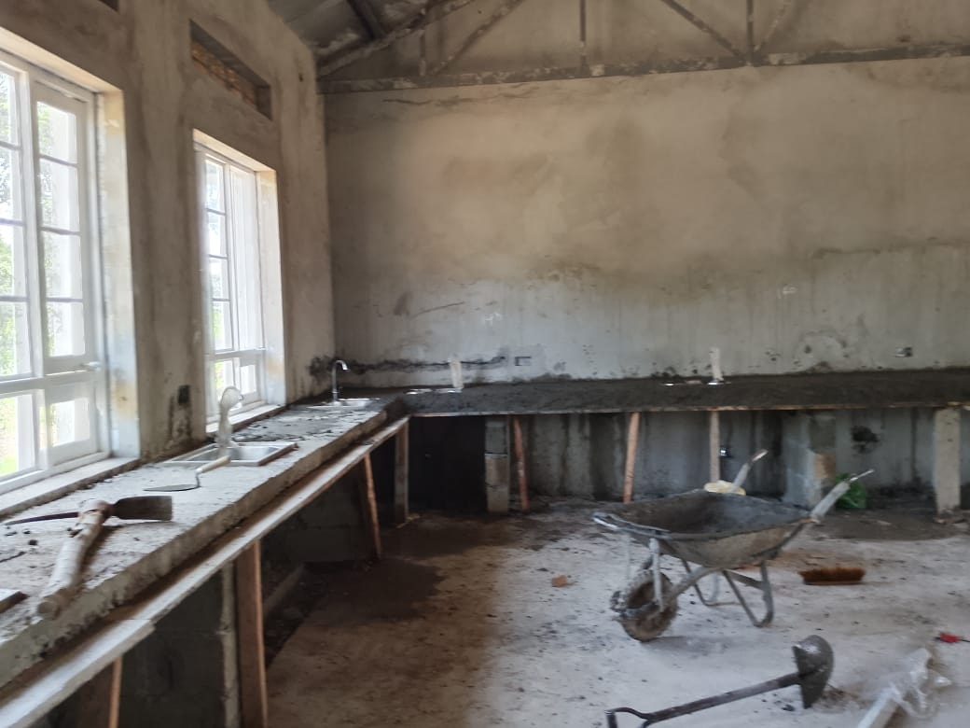  Figure 64: Biology laboratory under construction at a seed secondary school, Buliisa District (Bunyoro) | 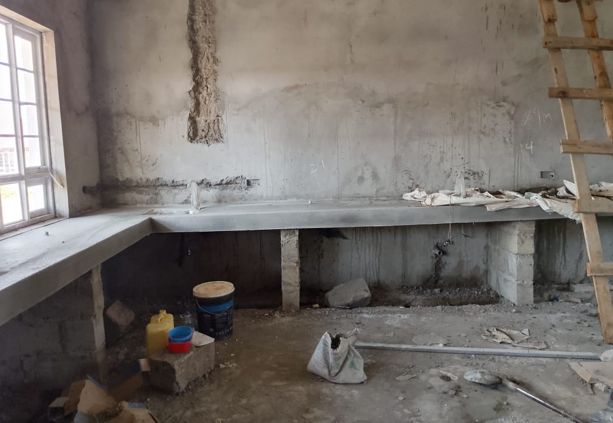  Figure 65: Unfinished laboratory interior at Kihungya Seed Secondary School, Buliisa District (Bunyoro)

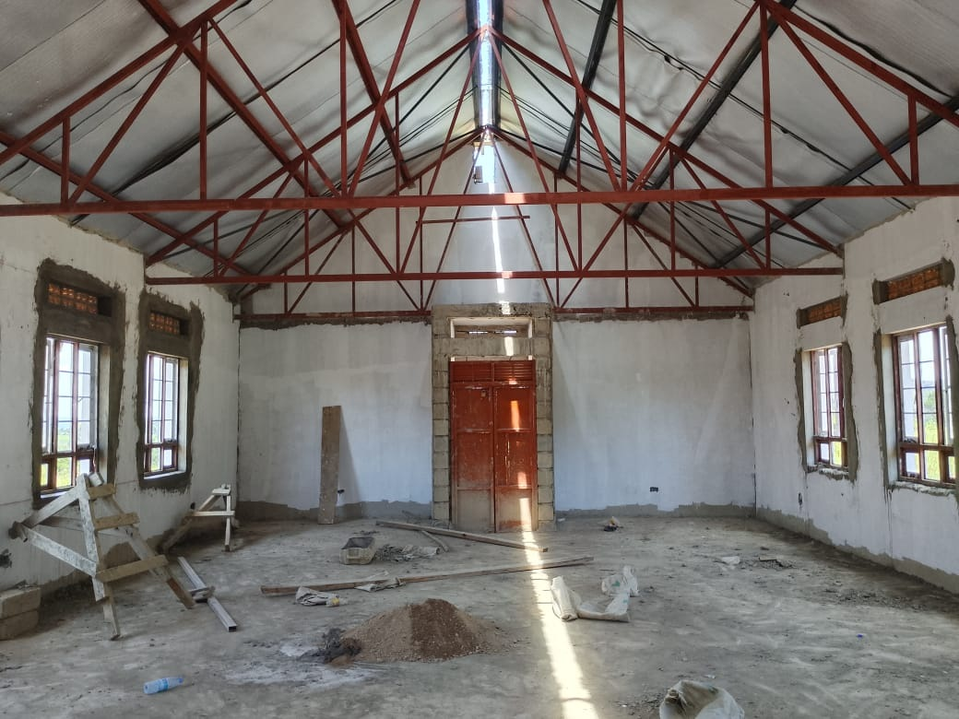  Figure 66: Library interior under construction at Kihungya Seed Secondary School, Buliisa District (Bunyoro) | 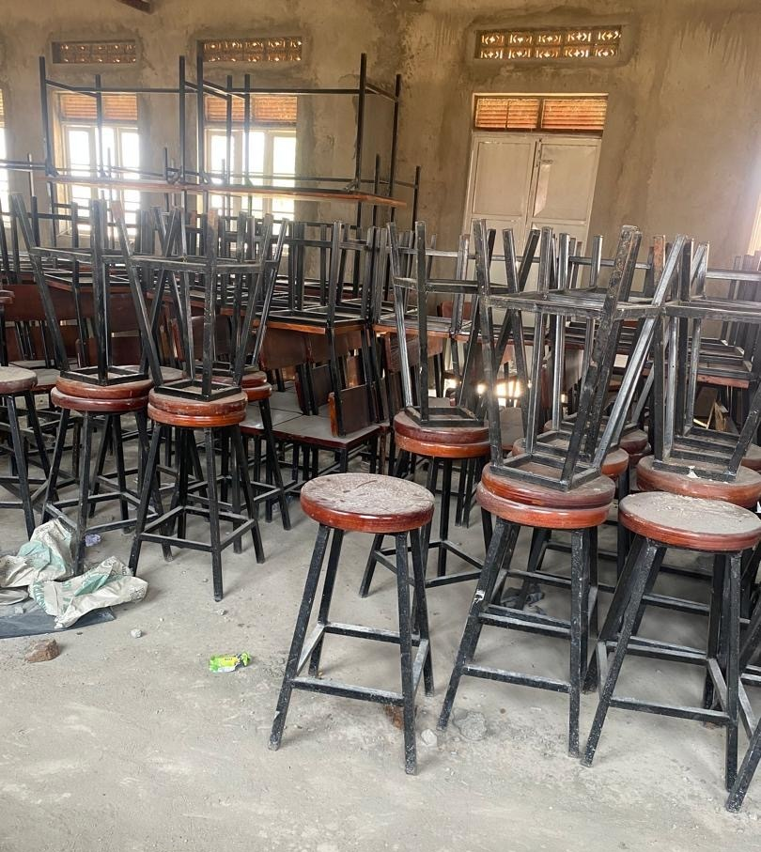  Figure 67: Laboratory stools and other school furniture in storage, Ntoroko District (Tooro)

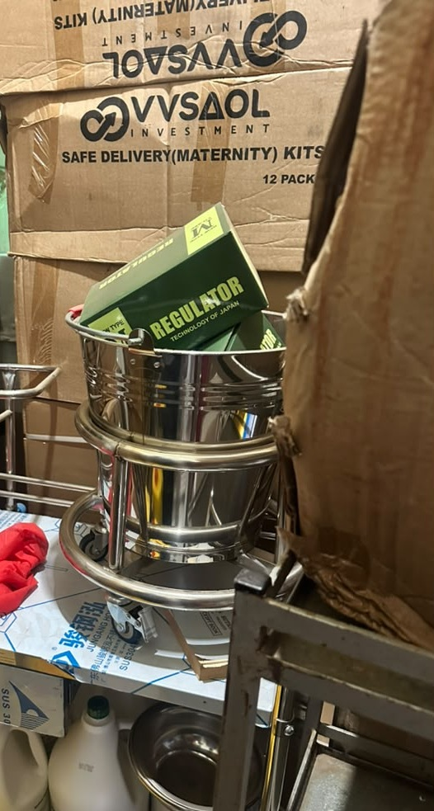  Figure 68: Clinical equipment packed among cartons at a health centre, Hoima City (Bunyoro) | 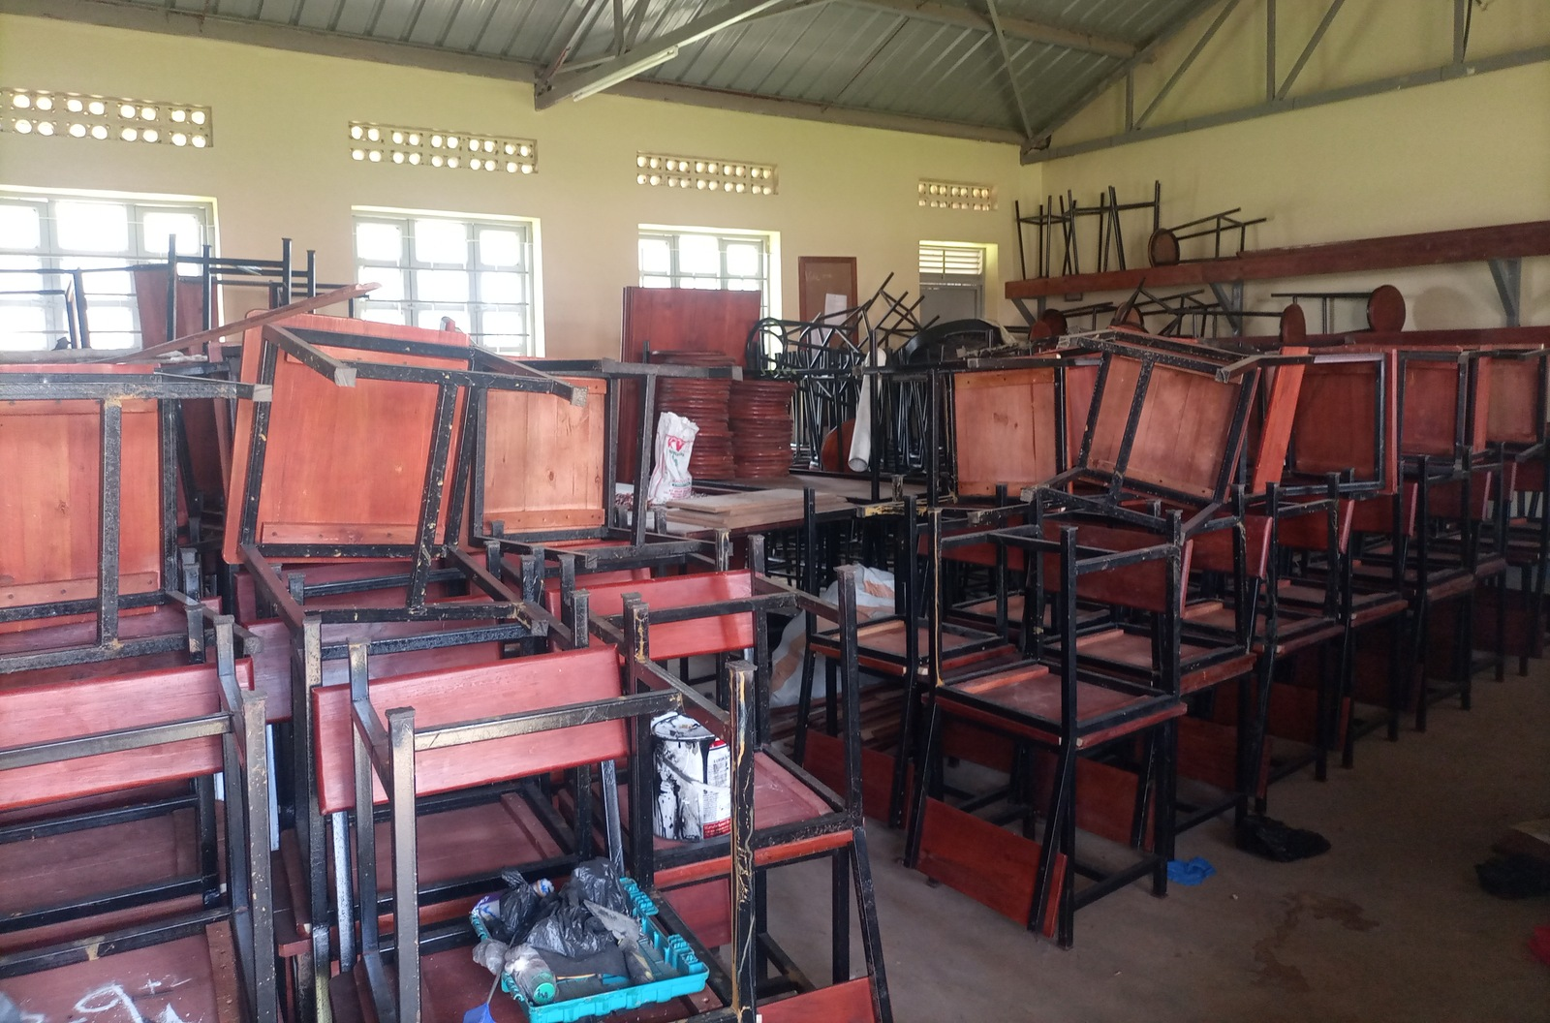  Figure 69: Stacked classroom furniture at King Solomon Seed Secondary School, Kagadi District (Bunyoro)

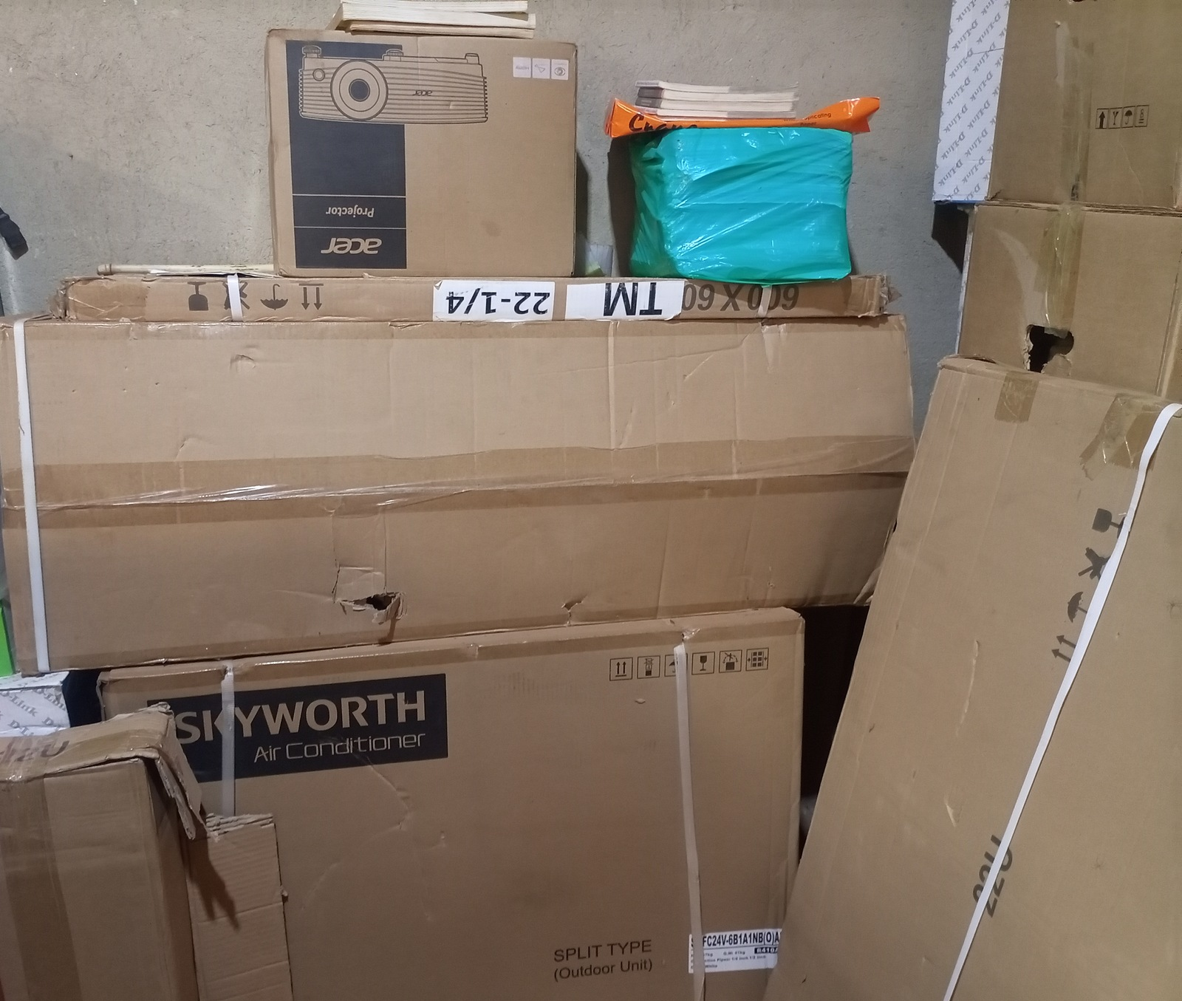  Figure 70: Boxed projector and other equipment at King Solomon Seed Secondary School, Kagadi District (Bunyoro) | 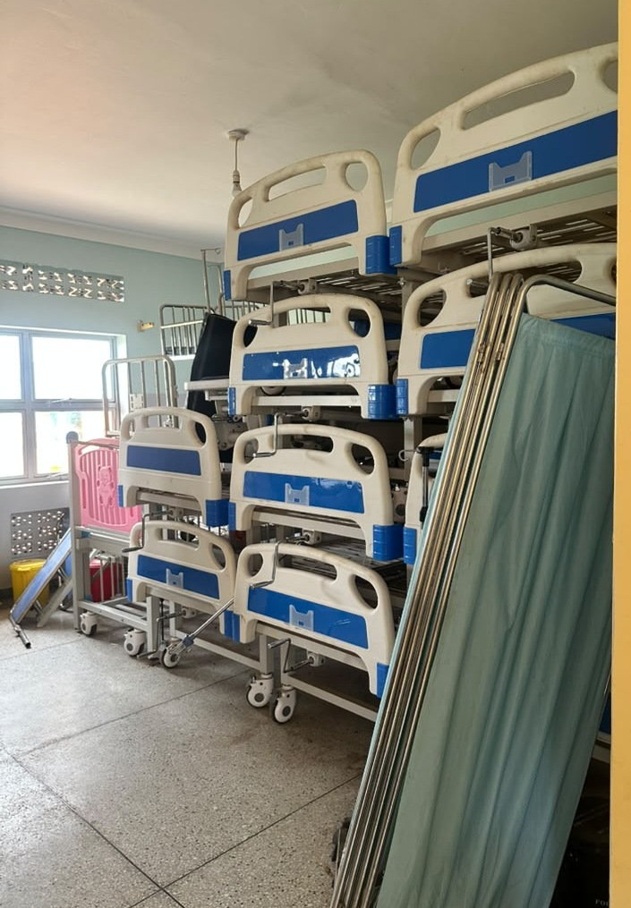  Figure 71: Hospital beds and screens stacked in storage at a health centre, Kagadi District (Bunyoro)

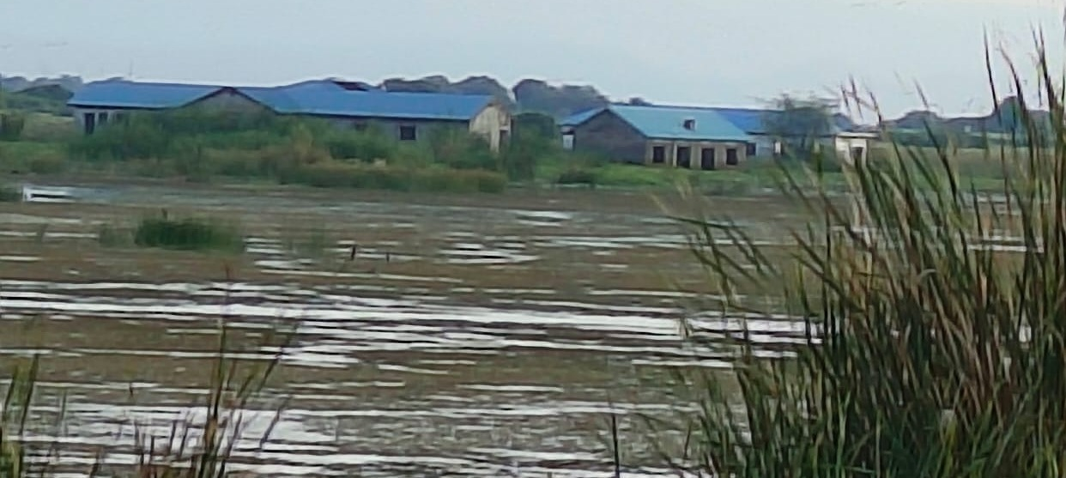
Figure 72: Flood-affected older health facility at Butiaba, Buliisa District (Bunyoro)
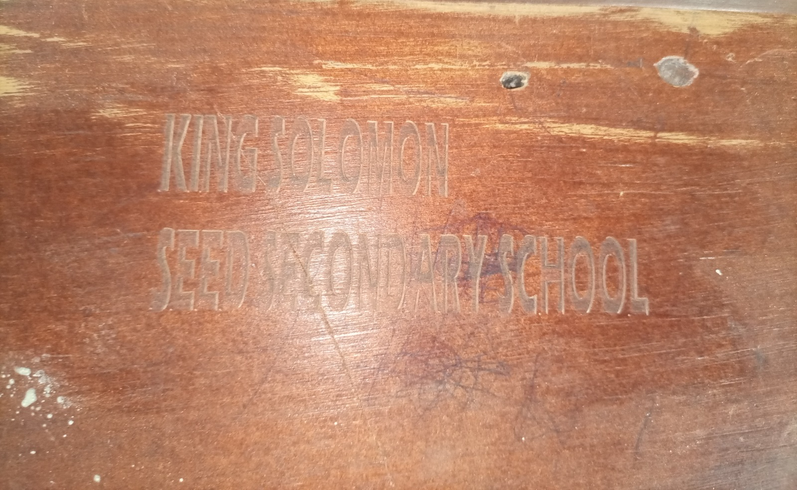  Figure 73: School engraving on wooden furniture at King Solomon Seed Secondary School, Kagadi District (Bunyoro) | 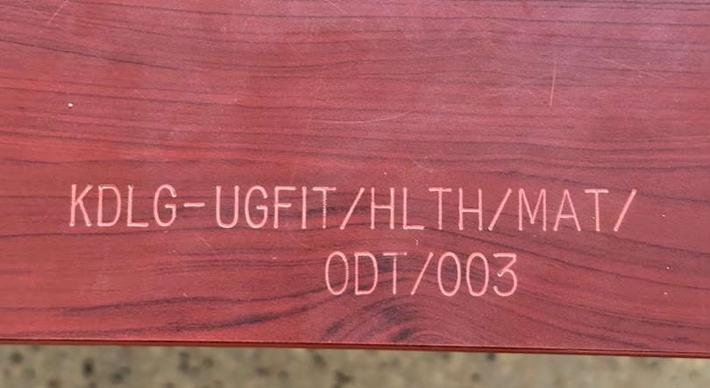  Figure 74: Programme engraving on a table at Kyabasara HC III, Kagadi District (Bunyoro)

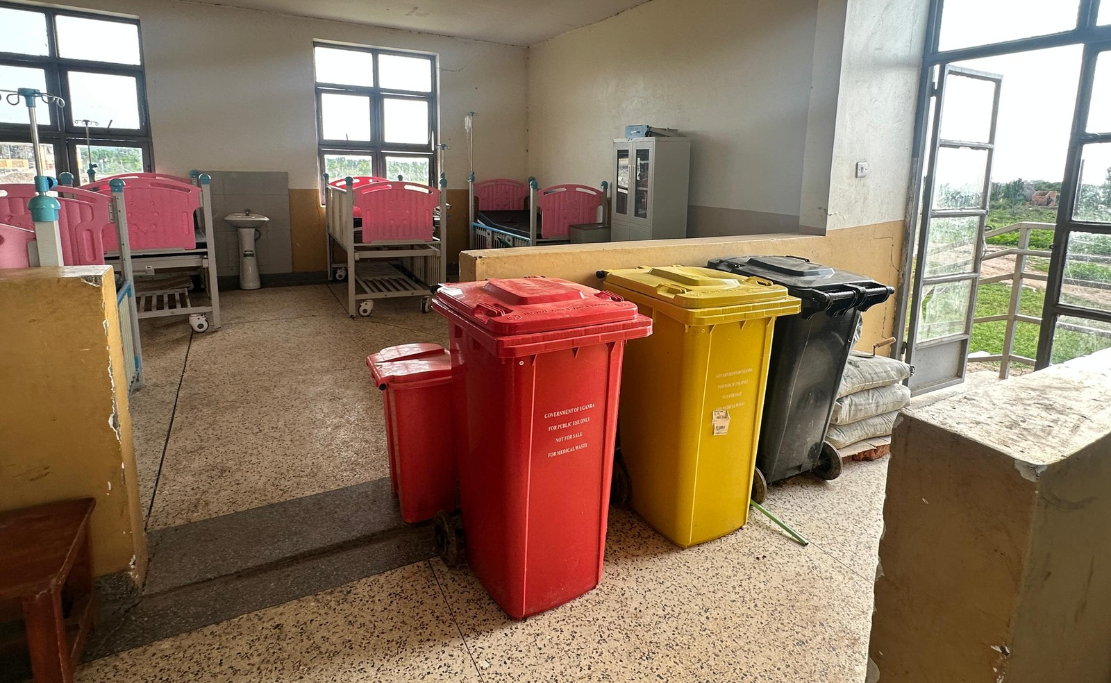  Figure 75: Medical-waste bins and ward beds at Butiaba HC III, Buliisa District (Bunyoro) | 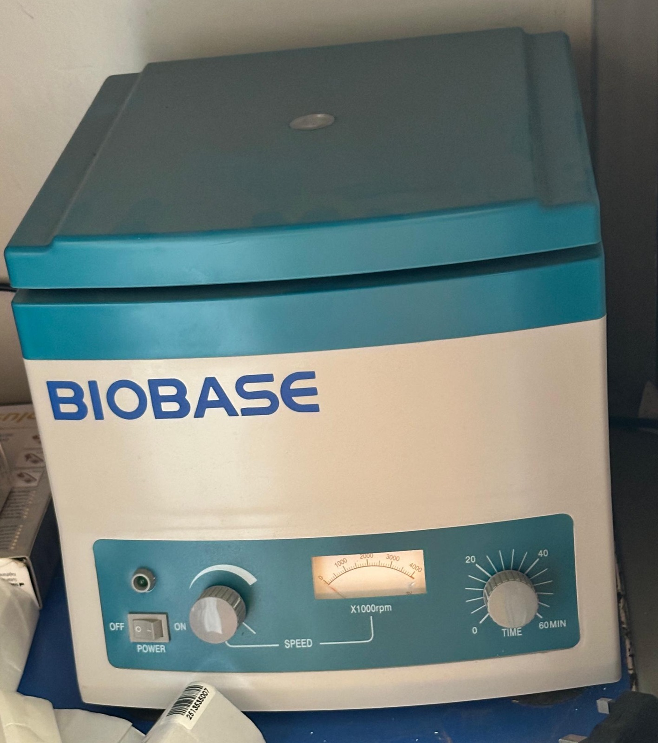  Figure 76: Laboratory centrifuge at Butiaba HC III, Buliisa District (Bunyoro)

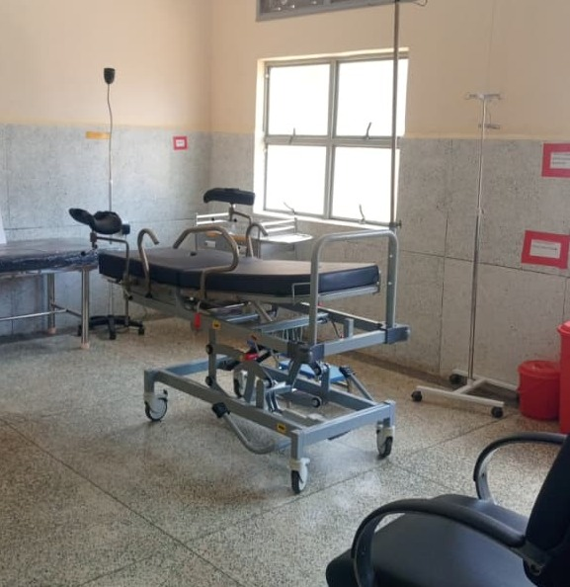  Figure 77: Delivery bed and clinical furniture at a health centre, Kabarole District (Tooro) | 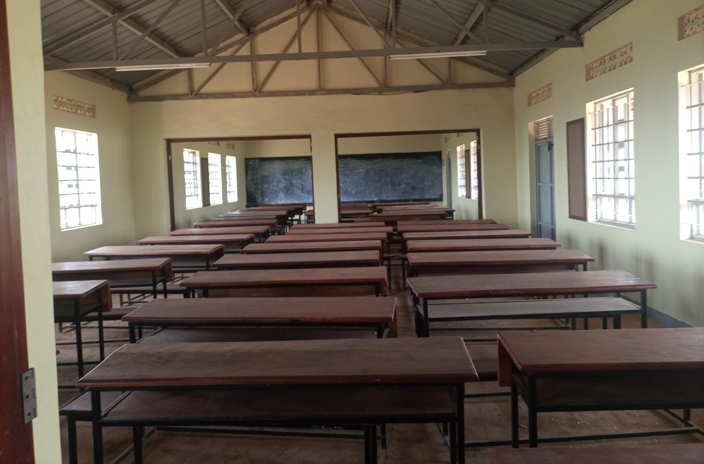  Figure 78: Classroom desks at King Solomon Seed Secondary School, Kagadi District (Bunyoro)

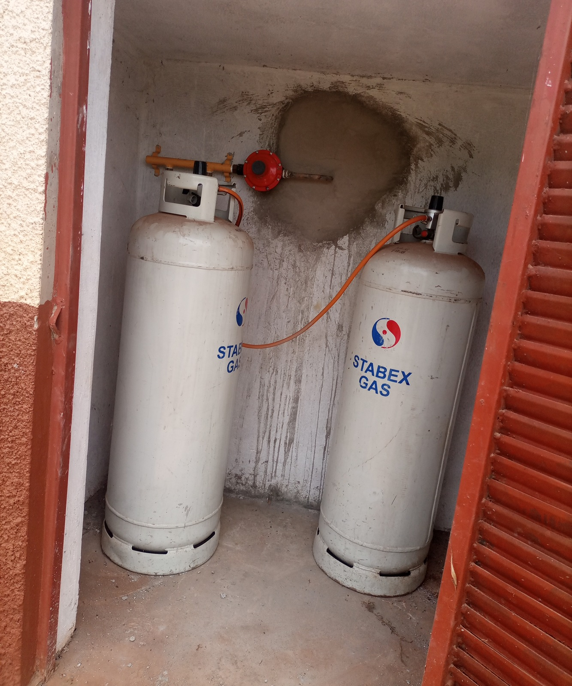  Figure 79: Gas cylinders and pipework at King Solomon Seed Secondary School, Kagadi District (Bunyoro) | 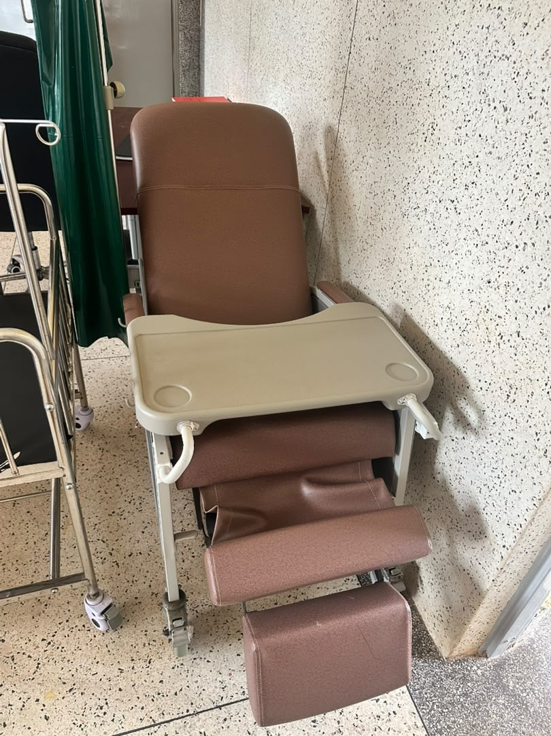  Figure 80: Kangaroo care chair at Kyabasara HC III, Kagadi District (Bunyoro)

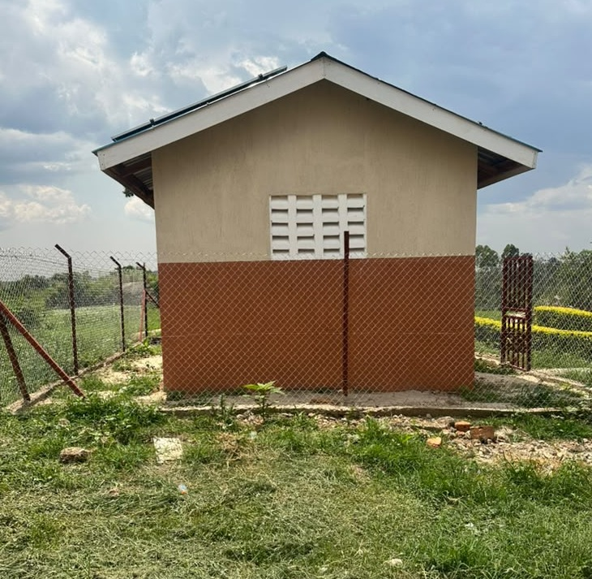  Figure 81: Power house at Kyabasara HC III, Kagadi District (Bunyoro) | 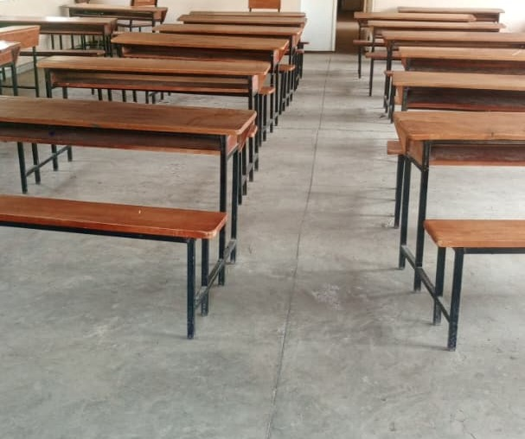  Figure 82: Classroom desks at a seed secondary school, Ntoroko District (Tooro)

7.4 Condition and use of assets

7.4.1 Equipment in use and items awaiting action
The visits showed why availability, condition and use need to be considered together. At Lungulu Seed Secondary School, a power connection was needed before stored computers could be installed. At Kalemungole Health Centre III, equipment remained boxed or wrapped. At Sikuda Seed Secondary School, a damaged stool was still being used.
Among assets recorded as out of use, 2,569 had damage, fault or repair remarks, while 483 were stored and described as good or new. These groups require different action: damaged items need technical assessment, while usable stored items need the conditions for safe installation and use.

7.4.2 Complete the setting in which equipment will work
At Got Apwoyo, Ndhew and Mamba seed schools, unfinished buildings delayed the use or installation of equipment. At Rupa Seed School, the library and computer laboratory block had been put to another use. Completion plans should bring buildings, electricity, furniture, equipment and staffing together so that handover leads to an operating service.
At Atego Seed School, equipment was already working in older rooms while construction continued. Completion should protect this use while the planned facilities are finished and the power supply is stabilised.

7.5 Asset management practices, gaps and actions

7.5.1 Identification and custody
Across the programme, 50,211 assets carried identification markings, representing 22.3% of the 225,133 entries. Of these, 21,023 had UgIFT marking and 29,188 had other markings. Lungulu Seed Secondary School provided a specific example of assets requiring engraving.
Marking should identify the asset and the institution responsible for it. Where assets have moved, custody needs to move with them: equipment from three Busia health centres had gone to Masafu Hospital, while equipment intended for Todora in Nwoya had gone to Paraa during construction. The district should confirm the continuing allocation and retain signed handover or transfer documentation.
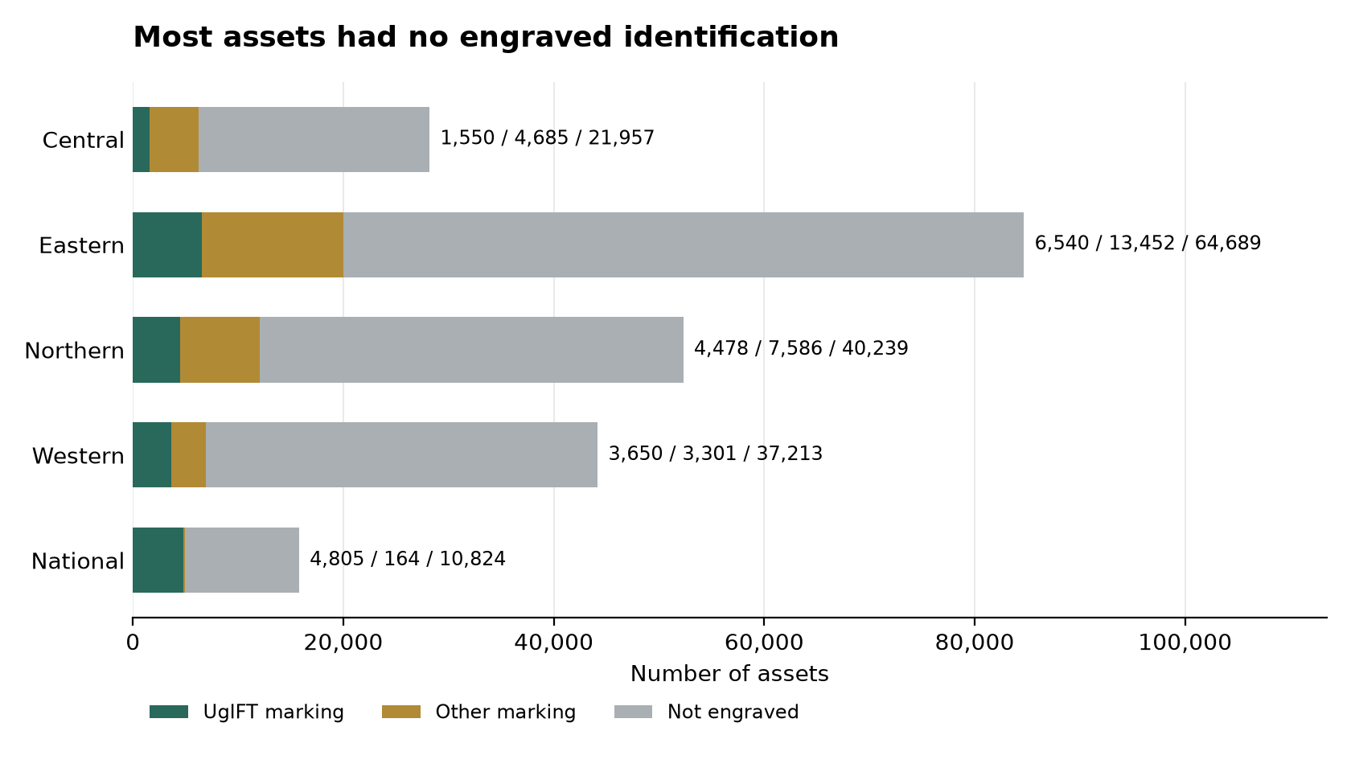
Figure 83: Most assets had no engraved identification
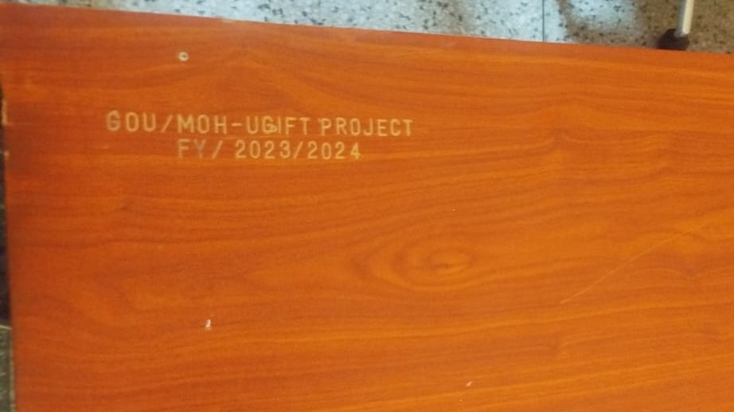
Figure 84: UgIFT identification on a desk at a seed school, Tororo District (Bukedi)

7.5.2 Maintenance and repairs
Facilities used several practical arrangements. Busaale Health Centre III reviewed condition quarterly and used Primary Health Care funds for repairs. Kagumba Health Centre III kept a condition book, and Kagumba Seed Secondary School had repaired broken furniture during the second term. Ngwedo Seed Secondary School used a monthly caretaker visit and specialist furniture repair support.
Major medical equipment repairs depended on technical support beyond the facility. Todora worked through the District Health Officer and Gulu Regional Referral Hospital; Avogera received support from Hoima Regional Referral Hospital; Bundimulangya obtained a team through the District Health Officer. At Kyankaramata, the cost of major repairs constrained what the facility could do.
Each facility should keep a short list of items requiring action, the responsible person and the agreed completion date. District health and education offices should review unresolved repairs and arrange technical assistance. Completion should mean that the item has been checked and returned to safe use, or formally assigned another outcome.

7.5.3 Storage, installation and user skills
Stored equipment needs a plan for use. Lungulu needed power, Got Apwoyo needed completed buildings, and Avogera needed repair support for items it could not restore locally. Kalemungole had unopened and wrapped equipment requiring a check of readiness for installation and use.
Training should accompany installation. Bubago Health Centre identified limited capacity to operate and maintain an oxygen concentrator, while Avogera asked for user orientation and technical skills. Equipment should be handed over with a practical demonstration to the staff who will use it and a clear route for technical support.
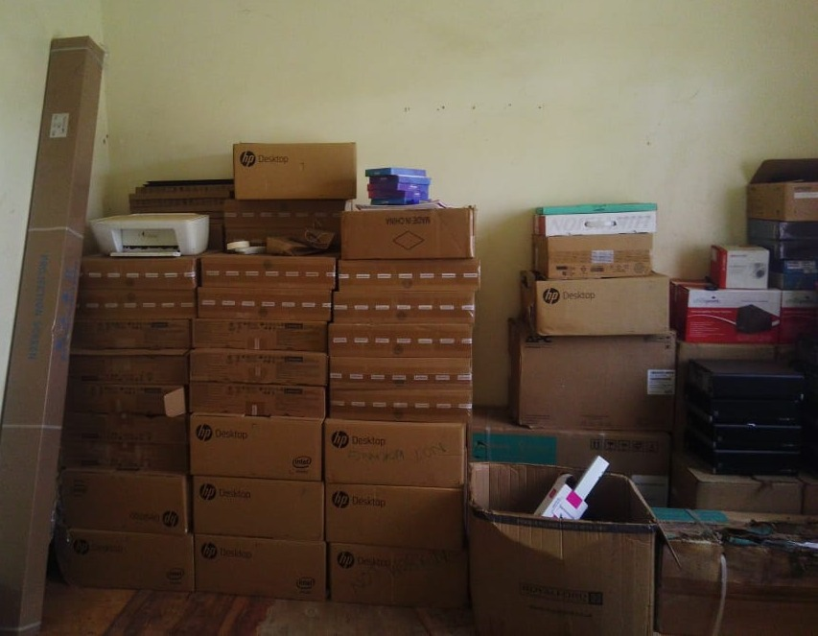
Figure 85: Boxed computers and related equipment in a seed school store, Nwoya District (Acholi)

7.5.4 Priorities for follow-up
The first priority is to make unsafe items and installations safe and restore equipment needed for care and teaching. The next is to complete works, provide utilities and install assets that can then be used. Marking, custody checks and routine servicing should form part of the same follow-up, with responsibility assigned to the institution and its supervising office.
Future delivery plans should confirm the room, power, water, storage and staff requirements before equipment arrives. Facility managers should take part in that planning, as recommended at Kyankaramata and Avogera. The action schedule sets out proposed owners, timing and evidence of completion.

Priority action plan
The following timeframes are proposed from acceptance of this report. Accounting Officers should assign responsible staff and track each action to completion.
Table 17: Priority actions to protect assets and restore service
Priority | Action | Responsible institution | Proposed timing | Evidence of completion
1 | Withdraw damaged furniture that presents a safety concern, inspect the electrical concerns at Nyamarunda, and assess the failed solar and oxygen equipment arrangements at Pamaka. | Facility managers, district health and education officers, district engineers and regional medical equipment technical teams | inspect within 30 days of report approval; complete minor corrective work within 60 days. | Unsafe items withdrawn; signed technical assessment; repair record and demonstration of safe operation.
2 | Agree completion plans for Got Apwoyo, Ndhew, Mamba and Butungama seed schools. Coordinate the remaining works, utilities, furniture and equipment installation; protect ongoing equipment use at Atego. | District Accounting Officers, district engineers, district education officers, contractors and Ministry of Education and Sports | agree site-specific completion plans within 30 days; track progress monthly against the approved dates. | Outstanding-works schedule; approved completion dates; inspection and handover documents; classrooms or laboratories opened for their intended use.
3 | Provide the power required at Lungulu, assess and install the boxed equipment at Kalemungole, and assess the repair needs of stored items at Avogera. Keep damaged and usable stored items on separate action lists. | District health and education officers, facility managers, electrical contractors and regional technical teams | confirm readiness and actions within 30 days; complete installation within 90 days where rooms and utilities are ready. | Equipment location check; power and installation sign-off; named custodian; practical demonstration and date first used.
4 | Repair the roof, doors and solar system at Busaale, arrange the major repair support needed at Kyankaramata and assess damaged laptops at the Office of the Prime Minister. | Facility managers, district health officers, district engineers and the responsible national institution asset managers | agree priority work within 30 days and complete funded repairs within 90 days. | Approved repair list; work orders; repairs checked and assets returned to use or assigned a formal disposal decision.
5 | Provide practical operation and basic maintenance training for oxygen equipment users at Bubago and the staff requiring equipment orientation at Avogera. | District health officers, facility in-charges, suppliers and regional medical equipment technical teams | complete initial training within 60 days and review use after a further 30 days. | Training attendance by role; practical demonstration of equipment use; named technical support contact.
6 | Mark eligible unengraved assets, starting with the identified Lungulu holdings, and confirm the final allocation of transferred equipment at Todora, Paraa and Masafu. | Institution asset managers, facility managers and district finance, health and education offices | confirm allocation within 30 days and complete priority marking and custody checks within 90 days. | Readable identification; item-to-custodian match; signed transfer or receipt and agreed final location.
7 | Retain the functioning local and regional repair arrangements and prepare annual maintenance plans that separate minor repairs from specialist work. Review unresolved faults each quarter. | Facility managers, school governing bodies, district health and education officers and national institution Accounting Officers | prepare plans within 90 days, include costs in the next budget cycle and review quarterly. | Funded maintenance plan; fault list with responsible roles and due dates; service history and closed repair actions.
8 | Review supporting clinical space and staffing at Kagumba and Pamaka, teaching staff and materials at Kigorobya, and attendance barriers at Musiitwa. Include operating needs in future asset planning. | District health and education officers, facility managers and the relevant sector ministries | complete service-needs reviews within 90 days and include agreed measures in the next planning and budget cycle. | Agreed staffing and space priorities; service or teaching plan; funded actions and periodic review of use.

7.6 UgIFT support to service delivery

7.6.1 Benefits described by facilities
Staff at Lukale Health Centre III in Buvuma said women could give birth locally instead of crossing water and had greater privacy. Kagumba Health Centre III in Kamuli reported greater use of maternity and antenatal services. At Pamaka Health Centre III in Nebbi, staff described increased attendance and community confidence.
Schools also described practical gains. Musiitwa Seed Secondary School used the irrigation system for teaching and food production and provided secondary education closer to surrounding communities. Kigorobya Seed Secondary School used its classrooms, computer room and chemistry laboratory to support teaching.

7.6.2 Constraints to the intended service
Equipment could not deliver its intended benefit where buildings, utilities or user skills were not ready. Power restricted oxygen equipment at Pamaka and computer installation at Lungulu. At Rupa, teaching spaces served as dormitories and practical lessons depended on a hired generator.
Demand also brought pressure on staff and space. Kagumba identified needs for staff housing and supporting clinical facilities. Pamaka reported staffing pressure, and Kigorobya identified teaching staff and study-material constraints. Musiitwa's attendance concerns required attention alongside investment in buildings and equipment.

7.6.3 Actions to sustain the benefits
Districts and sector ministries should direct the first round of follow-up to actions that restore or expand a service using assets already supplied. These include reliable electricity, completion of classrooms and laboratories, repair of maternity buildings, practical equipment training and return of damaged furniture to safe use.
Facility managers should report progress in terms of use: rooms opened, equipment installed and demonstrated, repairs completed and staff able to operate the equipment. Future investment should provide for staffing, operating funds and maintenance alongside buildings and equipment.

8 Appendices

8.1 Full summary count schedule
The summary schedule brings the asset counts, facility coverage and reconciliation outcomes together. Asset measures count register rows. The national column contains national institutional holdings, and the whole programme column includes all register rows.
Table 18: Whole programme and regional summary counts
Measure | Central | Eastern | Northern | Western | National | Programme
Asset register rows | 28,192 | 84,681 | 52,303 | 44,164 | 15,793 | 225,133
Assets engraved | 6,235 | 19,992 | 12,064 | 6,951 | 4,969 | 50,211
Engraved with UgIFT marking | 1,550 | 6,540 | 4,478 | 3,650 | 4,805 | 21,023
Engraved with other marking | 4,685 | 13,452 | 7,586 | 3,301 | 164 | 29,188
Not engraved | 21,957 | 64,689 | 40,239 | 37,213 | 10,824 | 174,922
Use flag YES | 27,028 | 78,939 | 49,052 | 40,821 | 15,773 | 211,613
Use flag NO with damage wording | 89 | 1,536 | 524 | 417 | 3 | 2,569
Not in use, stored and explicitly good or new | 2 | 300 | 66 | 115 | 0 | 483
Functional classification | 27,028 | 78,939 | 49,052 | 40,821 | 15,773 | 211,613
Faulty classification | 1,164 | 5,742 | 3,251 | 3,343 | 20 | 13,520
Facilities sharing or holding assets elsewhere | 2 | 11 | 12 | 17 | 0 | 42
Ground-return identities outside master names | 3 | 2 | 10 | 9 | 0 | 24
Does not exist or was not constructed under the programme | 1 | 3 | 5 | 1 | 0 | 10
Replaced by another facility | 0 | 0 | 3 | 1 | 0 | 4
Operates under another name | 9 | 8 | 0 | 13 | 0 | 30
Not a UgIFT beneficiary | 0 | 1 | 1 | 1 | 0 | 3
Assets relocated to another facility or held at district | 0 | 0 | 3 | 0 | 0 | 3
Exists with no UgIFT assets | 0 | 0 | 1 | 4 | 0 | 5
Health centre master-list entries | 62 | 93 | 92 | 124 | 0 | 371
School master-list entries | 37 | 76 | 74 | 71 | 0 | 258
Health centre asset rows | 10,153 | 21,250 | 16,991 | 15,565 | 14 | 63,973
School asset rows | 18,037 | 63,431 | 35,310 | 28,599 | 0 | 145,377
MDA asset rows | 0 | 0 | 0 | 0 | 7,520 | 7,520
Hospital asset rows | 0 | 0 | 0 | 0 | 8,101 | 8,101
Blood bank asset rows | 0 | 0 | 0 | 0 | 158 | 158
Local government office asset rows | 2 | 0 | 2 | 0 | 0 | 4
Table 18 gives the full summary schedule. Report-category and register-class totals continue in Appendix 8.2. Reconciled operating names may also hold verification materials, so reconciliation reasons are not additive to master-list coverage.

8.2 Asset totals by report category and register class
Table 19: Asset rows by report category and region
Report category | Central | Eastern | Northern | Western | National | Programme
Building blocks | 1,247 | 2,975 | 2,555 | 3,503 | 95 | 10,375
Clinical equipment | 3,820 | 8,042 | 5,874 | 6,207 | 0 | 23,943
Clinical furniture | 2,965 | 6,871 | 5,795 | 4,524 | 0 | 20,155
Health centre ICT equipment | 32 | 107 | 205 | 79 | 8 | 431
Maternity ward equipment | 1,369 | 1,746 | 2,211 | 2,088 | 0 | 7,414
Other ICT equipment | 80 | 347 | 102 | 58 | 5,719 | 6,306
Other assets | 3,509 | 14,006 | 4,117 | 7,013 | 9,656 | 38,301
Other furniture | 0 | 0 | 0 | 0 | 242 | 242
School computers and related equipment | 1,365 | 4,462 | 2,316 | 1,994 | 0 | 10,137
School furniture | 13,726 | 45,693 | 28,922 | 18,481 | 0 | 106,822
School support equipment | 76 | 423 | 201 | 216 | 0 | 916
Vehicles and motorcycles | 3 | 9 | 5 | 1 | 73 | 91
Table 19 reconciles the report categories to the programme asset count.
Table 20: Asset rows by register class and region
Register class | Central | Eastern | Northern | Western | National | Programme
Other recorded items | 3,097 | 9,295 | 3,400 | 5,532 | 1,830 | 23,154
Computer Software | 0 | 0 | 19 | 2 | 30 | 51
Cycles | 1 | 4 | 2 | 0 | 47 | 54
Electrical Machinery | 141 | 1,560 | 217 | 260 | 224 | 2,402
Furniture And Fittings | 16,097 | 50,785 | 33,694 | 21,982 | 242 | 122,800
Heavy ICT Hardware | 7 | 121 | 101 | 38 | 14 | 281
ICT Network Lines | 0 | 12 | 16 | 3 | 0 | 31
Land | 1 | 5 | 0 | 11 | 0 | 17
Light ICT Hardware | 1,462 | 4,889 | 2,566 | 2,147 | 5,707 | 16,771
Light Vehicles | 2 | 5 | 3 | 1 | 26 | 37
Med Lab Research Appliances | 5,978 | 14,260 | 9,537 | 10,270 | 7,493 | 47,538
Musical Instruments | 1 | 1 | 0 | 0 | 0 | 2
Non Residential Buildings | 927 | 2,006 | 2,086 | 2,971 | 0 | 7,990
Office Equipment | 0 | 0 | 0 | 0 | 7 | 7
Other ICT Equipment | 82 | 329 | 157 | 160 | 6 | 734
Other Structures | 147 | 562 | 192 | 213 | 95 | 1,209
Plant Machinery | 45 | 202 | 24 | 72 | 72 | 415
Precision Optical Instruments | 26 | 246 | 18 | 172 | 0 | 462
Residential Buildings | 171 | 386 | 255 | 309 | 0 | 1,121
Road Furniture | 2 | 1 | 0 | 0 | 0 | 3
Roads And Bridges | 2 | 4 | 2 | 3 | 0 | 11
Sports Equipment | 3 | 3 | 10 | 14 | 0 | 30
Water Supply Systems | 0 | 5 | 4 | 4 | 0 | 13
Table 20 preserves the register class distribution alongside the report categories.

8.3 Condition tables behind the charts
The consolidated asset inventory classifies each entry as Functional or Faulty. Functional includes working, available, verified and new items together with the register's default classification; Faulty includes defective items and items recorded as stored or otherwise out of use. The percentages in this appendix describe these register classifications. The separate use analysis retains the stated reasons for damage and storage.
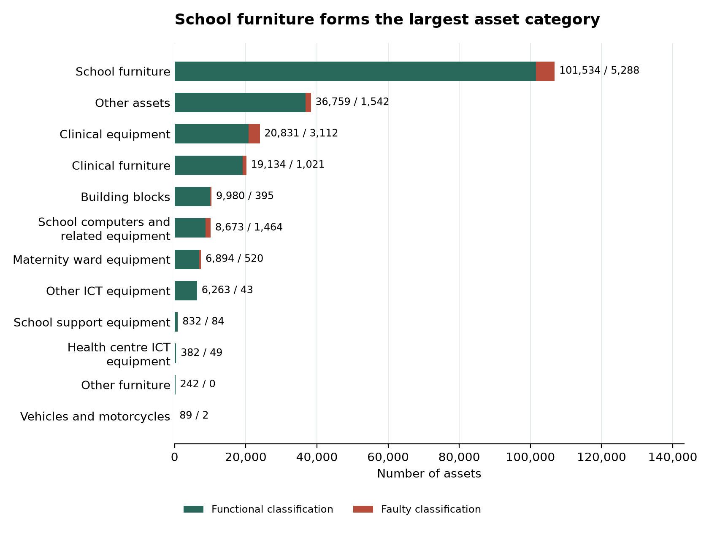
Figure 86: School furniture forms the largest asset category
Table 21: Condition classifications by report category
Category | Functional | Faulty | Total
Clinical equipment | 20,831 | 3,112 | 23,943
Clinical furniture | 19,134 | 1,021 | 20,155
Other assets | 36,759 | 1,542 | 38,301
Health centre ICT equipment | 382 | 49 | 431
Maternity ward equipment | 6,894 | 520 | 7,414
Building blocks | 9,980 | 395 | 10,375
School furniture | 101,534 | 5,288 | 106,822
School support equipment | 832 | 84 | 916
Other ICT equipment | 6,263 | 43 | 6,306
School computers and related equipment | 8,673 | 1,464 | 10,137
Vehicles and motorcycles | 89 | 2 | 91
Other furniture | 242 | 0 | 242
Table 21 supplies the data for the corresponding condition chart in this appendix.
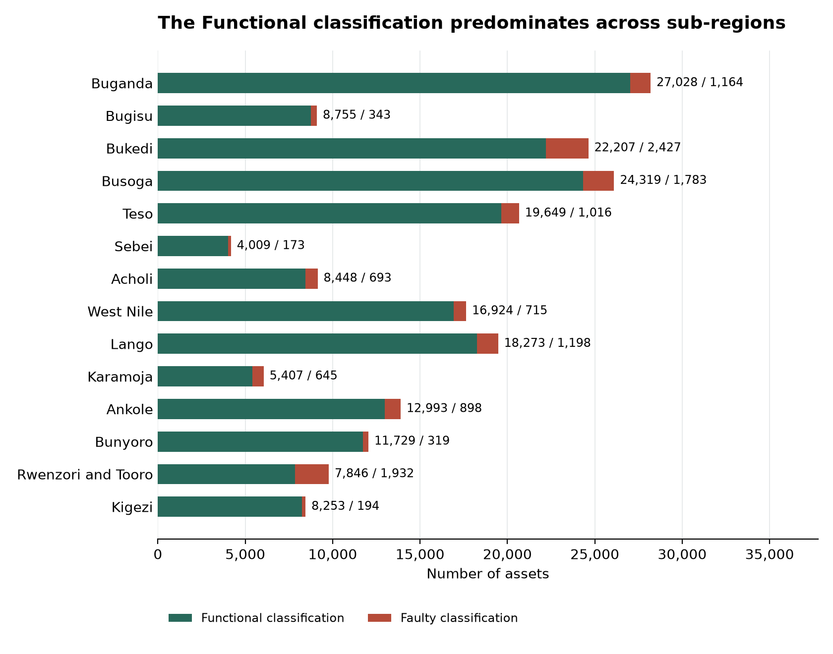
Figure 87: The Functional classification predominates across sub-regions
Table 22: Condition classifications by sub-region
Subregion | Functional | Faulty | Total
Buganda | 27,028 | 1,164 | 28,192
Rwenzori and Tooro | 7,846 | 1,932 | 9,778
Bunyoro | 11,729 | 319 | 12,048
Busoga | 24,319 | 1,783 | 26,102
West Nile | 16,924 | 715 | 17,639
Acholi | 8,448 | 693 | 9,141
Ankole | 12,993 | 898 | 13,891
Lango | 18,273 | 1,198 | 19,471
Teso | 19,649 | 1,016 | 20,665
Bukedi | 22,207 | 2,427 | 24,634
Karamoja | 5,407 | 645 | 6,052
Bugisu | 8,755 | 343 | 9,098
Sebei | 4,009 | 173 | 4,182
Kigezi | 8,253 | 194 | 8,447
Table 22 supplies the data for the corresponding condition chart in this appendix.

8.4 Recorded value and net book value schedules
The programme assets have a total recorded value of UGX 986,778,303,394, accumulated depreciation of UGX 177,319,698,579 and net book value of UGX 809,473,130,826 at 30 September 2026. These amounts support the financial handover and are presented separately from the field findings.
Recognition followed sections 3.2.1 and 3.3.3 of the Government of Uganda Asset Accounting Policies and Guidelines 2023. Recorded values combine facility prices with programme unit-cost comparisons by item, local government, period and asset class, including zero carrying amounts for unit costs below UGX 10,000.
The useful lives and commencement dates follow the register and the asset-class framework in Annex 1. Depreciation is straight line with nil residual value under sections 5.5 and 5.7; capital work in progress is not depreciated. Net book value is calculated for each asset as cost less accumulated depreciation, with a minimum of zero, before amounts are totalled.
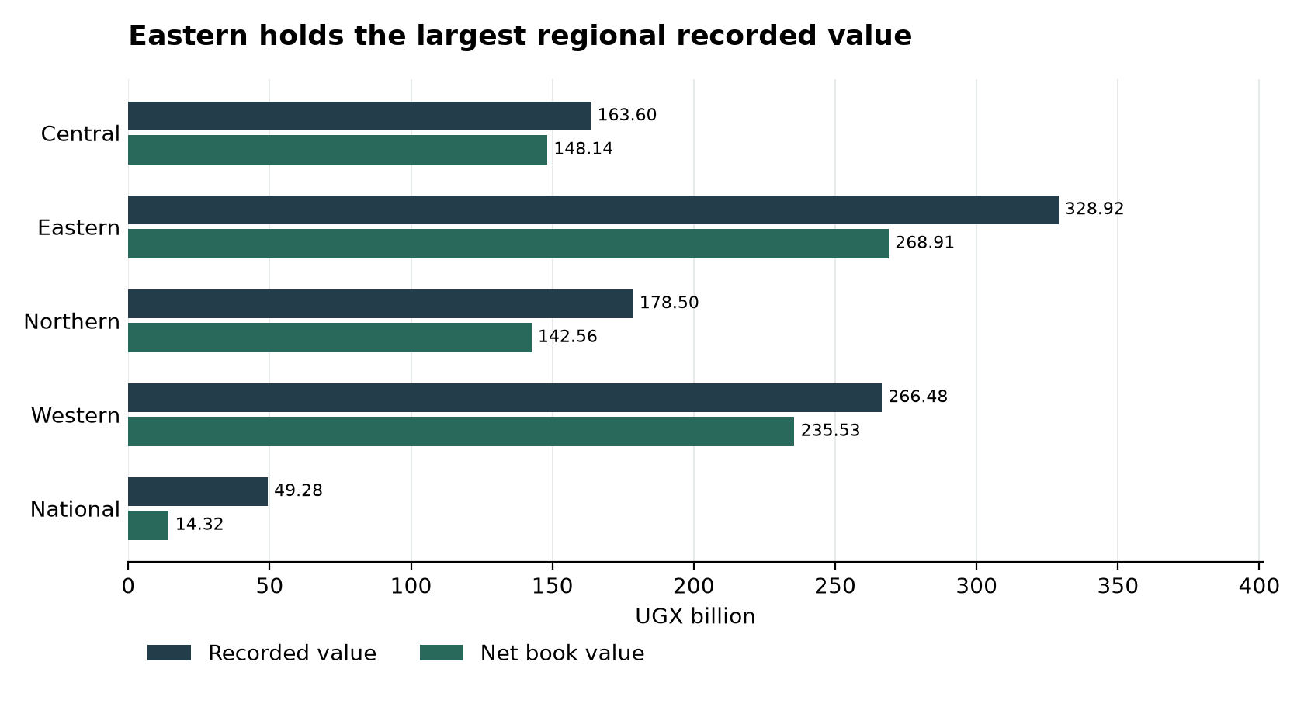
Figure 88: Eastern holds the largest regional recorded value
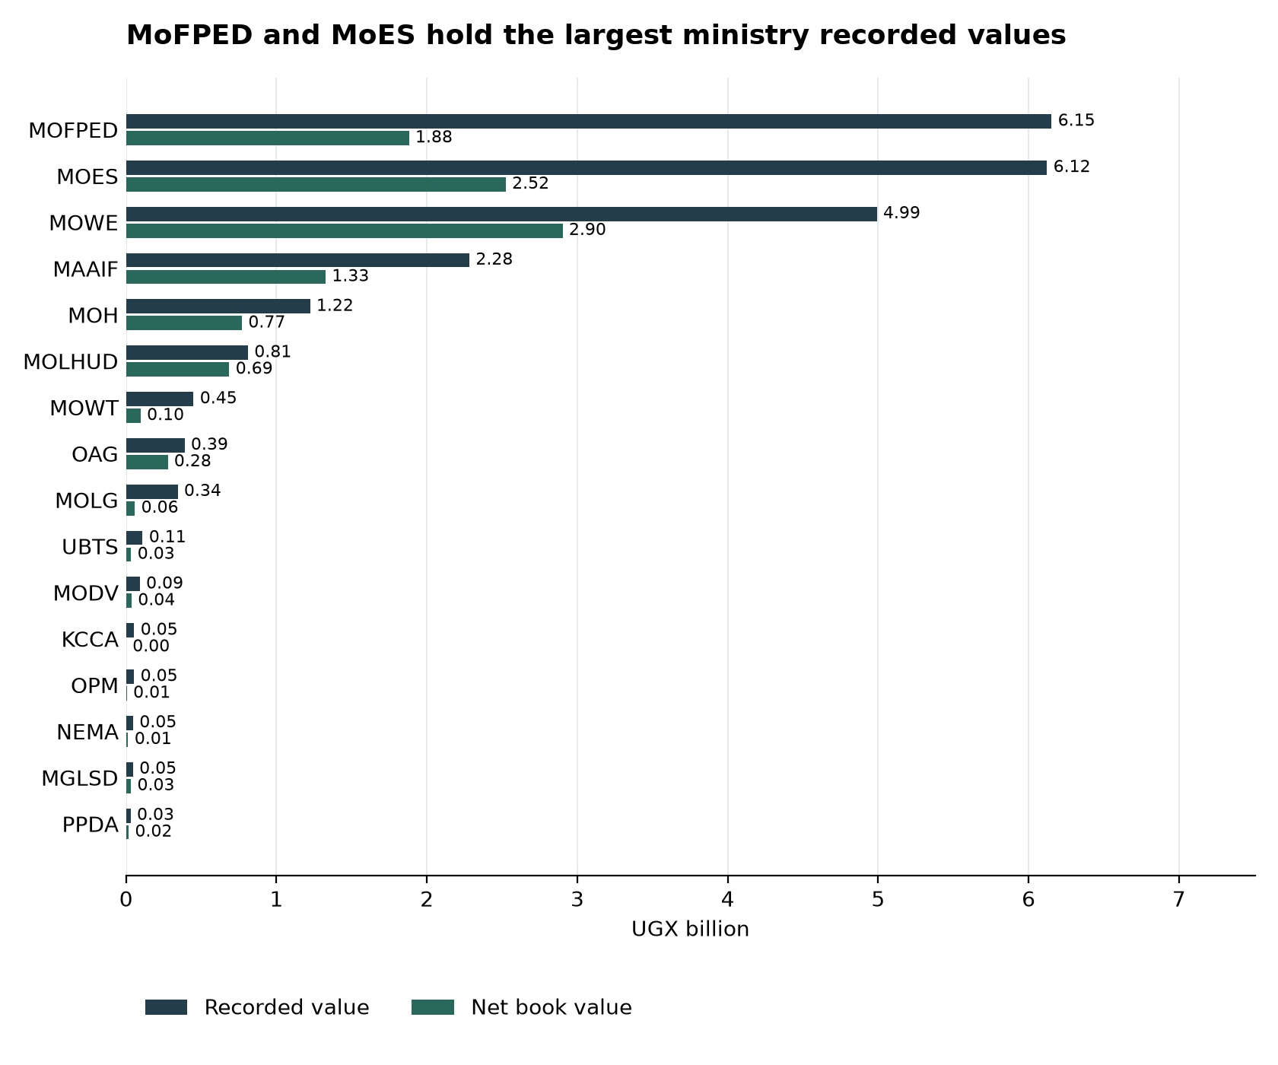
Figure 89: MoFPED and MoES hold the largest ministry recorded values
Table 23: Recorded value and net book value by region
Region | Recorded value UGX | Depreciation UGX | Net book value UGX
Central | 163,598,168,583 | 15,455,528,014 | 148,142,640,569
Eastern | 328,917,243,224 | 60,006,413,998 | 268,910,829,237
Northern | 178,501,289,749 | 35,951,101,557 | 142,564,714,192
Western | 266,480,769,152 | 30,945,792,264 | 235,534,976,888
National | 49,280,832,686 | 34,960,862,746 | 14,319,969,940
Programme | 986,778,303,394 | 177,319,698,579 | 809,473,130,826
Table 23 gives the data behind the regional value chart. The net book value floor applies to each individual row before aggregation.
Table 24: National ministry and agency value schedule
Vote or group | Qty | Recorded value UGX | Depreciation UGX | Net book value UGX
MOFPED | 458 | 6,152,854,000 | 4,272,041,257 | 1,880,812,743
MOES | 1,371 | 6,122,415,903 | 3,598,574,311 | 2,523,841,592
MOWE | 2,939 | 4,990,929,297 | 2,088,701,634 | 2,902,227,663
MAAIF | 1,975 | 2,282,355,629 | 955,929,429 | 1,326,426,200
MOH | 264 | 1,222,996,178 | 452,722,710 | 770,273,468
MOLHUD | 26 | 810,399,998 | 124,320,000 | 686,079,998
MOWT | 88 | 448,639,007 | 352,204,285 | 96,434,722
OAG | 20 | 388,773,680 | 111,591,545 | 277,182,135
MOLG | 13 | 343,320,450 | 284,804,160 | 58,516,290
UBTS | 273 | 109,987,849 | 76,107,195 | 33,880,654
MODV | 183 | 91,162,979 | 54,612,464 | 36,550,515
KCCA | 51 | 54,024,515 | 53,024,515 | 1,000,000
OPM | 10 | 53,535,300 | 48,181,770 | 5,353,530
NEMA | 6 | 46,824,409 | 32,841,273 | 13,983,136
MGLSD | 10 | 46,180,000 | 13,660,000 | 32,520,000
PPDA | 5 | 30,153,500 | 13,066,516 | 17,086,984
Hospital holdings | 8,101 | 26,086,279,992 | 22,428,479,682 | 3,657,800,310
Table 24 supplies the ministry and agency chart data and retains the national health groups in the account. Vote codes are the register identifiers.

8.5 Use and engraving schedules
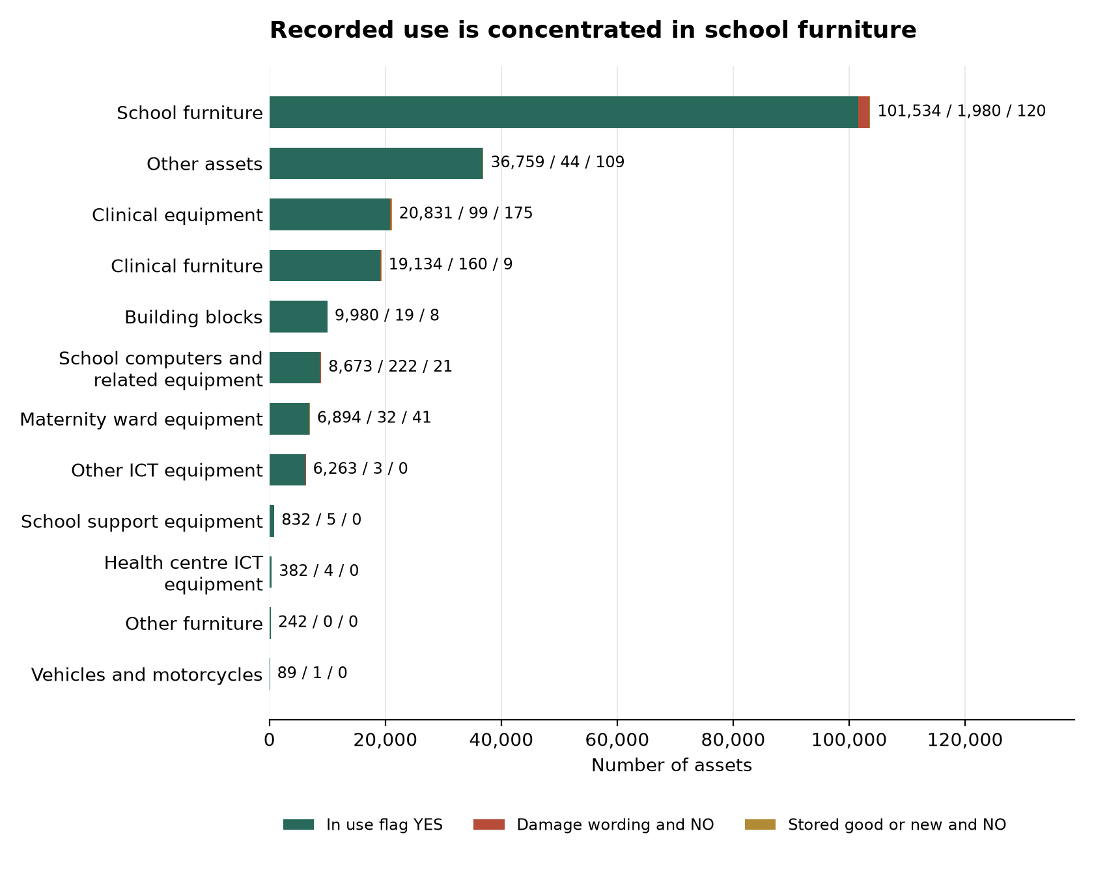
Figure 90: Recorded use is concentrated in school furniture
Table 25: Use flags and recorded reasons by report category
Category | Use flag YES | NO with damage wording | NO with stored or new wording
Clinical equipment | 20,831 | 99 | 175
Clinical furniture | 19,134 | 160 | 9
Other assets | 36,759 | 44 | 109
Health centre ICT equipment | 382 | 4 | 0
Maternity ward equipment | 6,894 | 32 | 41
Building blocks | 9,980 | 19 | 8
School furniture | 101,534 | 1,980 | 120
School support equipment | 832 | 5 | 0
Other ICT equipment | 6,263 | 3 | 0
School computers and related equipment | 8,673 | 222 | 21
Vehicles and motorcycles | 89 | 1 | 0
Other furniture | 242 | 0 | 0
Table 25 contains the data behind the use chart. The reason groups identify the wording recorded for the asset and do not form a separate condition assessment.
Table 26: Engraving by region
Region | UgIFT marking | Other marking | Not engraved | Total
Central | 1,550 | 4,685 | 21,957 | 28,192
Eastern | 6,540 | 13,452 | 64,689 | 84,681
Northern | 4,478 | 7,586 | 40,239 | 52,303
Western | 3,650 | 3,301 | 37,213 | 44,164
National | 4,805 | 164 | 10,824 | 15,793
Table 26 contains the data behind the engraving chart.

8.6 Master-list reconciliation and ground-return identities
Each master-list entry below retains its original identity, local government, final supported outcome. Names used by receiving facilities and operating institutions remain within the same reconciliation account.
Table 27: Master-list entries accounted for through reconciliation
Master-list entry | Local government | Reconciled outcome
H010 Butoloogo HC II | Kasanda  Central | The master-list entry Butoloogo HC II does not exist under the programme.
S065 Maddu Seed School | Gomba  Central | The submitted Kyayi Seed School return was reconciled to the master-list Maddu Seed School.
S066 Bufumira Seed School | Kalangala  Central | The master-list entry Bufumira Seed School was reconciled to Nekemiya Memorial Seed Secondary School.
H015 Kyakatebe HC II | Kasanda  Central | The master-list entry Kyakatebe HC II was reconciled to Namabaale Health Centre III.
H027 Kagganda HC II | Lwengo  Central | The master-list entry Kagganda HC II was reconciled to Mbirizi Seed Secondary School.
S081 Mpumudde seed school | Lyantonde  Central | The master-list entry Mpumudde seed school was reconciled to Rwamabara Seed Secondary School.
S084 Kiringente Seed School | Mpigi  Central | The master-list entry Kiringente Seed School was reconciled to Wamatovu Seed Secondary School.
H036 Kabbo | Mubende  Central | The master-list entry Kabbo was reconciled to Nakawala Health Centre III.
S086 Kimenyedde Seed School | Mukono  Central | The master-list entry Kimenyedde Seed School was reconciled to St Andrews Ndwaddemutwe Seed Secondary School.
H054 Bussi HC II | Wakiso  Central | Bussi is the village name for Zinga Health Centre III; the Zinga return is counted once on H052.
H070 Busia Eastern Division | Busia MC  Eastern | The master-list entry Busia Eastern Division does not exist under the programme.
S012 Central Division | Jinja City  Eastern | The master-list entry Central Division does not exist under the programme.
S010 Eastern Division | Tororo MC  Eastern | The master-list entry Eastern Division does not exist under the programme.
H086 Buyinda HC II | Kaliro  Eastern | Buyinda HC II is not a UgIFT beneficiary.
S011 Igombe | Bugweri  Eastern | The master-list entry Igombe was reconciled to Mpiita Seed Secondary School.
H125 Kocheka HC II | Bukedea  Eastern | The master-list entry Kocheka HC II was reconciled to Kangole / Kocheka Health Centre III.
S127 Bunambutye Seed School | Bulambuli  Eastern | The master-list entry Bunambutye Seed School was reconciled to Bumufuni Seed Secondary School.
H065 Dabani | Busia  Eastern | The master-list entry Dabani was reconciled to Buwumba Health Centre III.
S112 Butagaya | Jinja  Eastern | The master-list entry Butagaya was reconciled to Buwala Seed Secondary School.
S122 Mwema Seed School | Namayingo  Eastern | The master-list entry Mwema Seed School was reconciled to Mutumba Seed Secondary School.
S103 Pallisa | Pallisa  Eastern | The master-list entry Pallisa was reconciled to Akadot Seed Secondary School.
S167 Kadungulu Seed School | Serere  Eastern | The master-list entry Kadungulu Seed School was reconciled to Kagwara Seed Secondary School.
H231 Alangi | Zombo  Northern | The UgIFT assets for Alangi were relocated to Amwonyo Health Centre III.
H233 Ther-uru HC II | Zombo  Northern | The UgIFT assets for Ther-uru HC II were relocated to Atyak Health Centre III.
S208 Abanga | Zombo  Northern | The UgIFT assets for Abanga were relocated to Kango Seed Secondary School.
H190 Alik HCII | Lira  Northern | The master-list entry Alik HCII does not exist under the programme.
H195 Acokara HCII | Oyam  Northern | The master-list entry Acokara HCII does not exist under the programme.
H197 Acimi HC II | Oyam  Northern | The master-list entry Acimi HC II does not exist under the programme.
H200 Ariba HC II | Oyam  Northern | The master-list entry Ariba HC II does not exist under the programme.
H205 Olok HC II | Pader  Northern | Olok Health Centre III was not constructed under the programme.
H149 Pandwong HC II | Kitgum MC  Northern | Pandwong HC II exists with no UgIFT assets.
H193 Alira HCII | Oyam  Northern | Alira HCII is not a UgIFT beneficiary.
H150 Ngomoromo HC II | Lamwo  Northern | The master-list entry Ngomoromo HC II was replaced by Pangira Health Centre III.
H213 Loinya HC II | Maracha  Northern | The master-list entry Loinya HC II was replaced by Liko Health Centre III (H212).
H218 Oweko HC II | Nebbi  Northern | The master-list entry Oweko HC II was replaced by Pamaka Health Centre III.
S216 Kishangara seed school | Ibanda  Western | The master-list entry Kishangara seed school does not exist under the programme.
S214 Bumbaire Seed School | Bushenyi  Western | Bumbaire Seed School exists with no UgIFT assets.
S215 Kyamuhunga | Bushenyi  Western | Kyamuhunga exists with no UgIFT assets.
S221 Kashenshero | Mitooma  Western | Kashenshero exists with no UgIFT assets.
H282 Rwamujojo HC II | Sheema MC  Western | Rwamujojo HC II exists with no UgIFT assets.
S237 Kiziranfumbi Seed School | Kikuube  Western | Kiziranfumbi Seed School is not a UgIFT beneficiary.
S213 Nsiika T/C | Buhweju  Western | The master-list entry Nsiika T/C was reconciled to Ndibarema Memorial Seed Secondary School.
H318 Mantoroba HC II | Bundibugyo  Western | The master-list entry Mantoroba HC II was reconciled to Busanga Health Centre III.
S056 Kabonero | Bunyangabu  Western | The master-list entry Kabonero was reconciled to Katugunda Seed Secondary School.
S057 Kyamukube Town Council | Bunyangabu  Western | The master-list entry Kyamukube Town Council was reconciled to Nsuura Seed Secondary School.
S230 Buhanika | Hoima  Western | The master-list entry Buhanika was reconciled to Kidukuru Seed Secondary School.
H329 Kidubuli HC II | Kabarole  Western | The master-list entry Kidubuli HC II was reconciled to Iruhura Health Centre III.
H332 Nyabuswa HC II | Kabarole  Western | The master-list entry Nyabuswa HC II was reconciled to Nyambuusa Health Centre III.
S252 Kasenda Seed School | Kabarole  Western | The master-list entry Kasenda Seed School was reconciled to St Paul Nyabweya Seed Secondary School.
S048 Kagadi | Kagadi  Western | The master-list entry Kagadi was reconciled to King Solomon Seed Secondary School.
S049 Ruteete | Kagadi  Western | The master-list entry Ruteete was reconciled to Kitegwa Community Seed Secondary School.
S232 Kiryanga Seed School | Kagadi  Western | The master-list entry Kiryanga Seed School was reconciled to St Catherine Kicucura Seed Secondary School.
H292 Kikoola | Kakumiro  Western | The master-list entry Kikoola was reconciled to Mukoora Health Centre III.
S235 Mugarama( new facilities for St Mugagga S.S) | Kibaale  Western | The master-list entry Mugarama( new facilities for St Mugagga S.S) was reconciled to St Mugagga Vocational Seed Secondary School.
H354 Musandama HC II | Ntoroko  Western | The master-list entry Musandama HC II was replaced by Butungama Health Centre III.
Table 27 provides the facility-level detail supporting section 7.1.
Table 28: Ground-return identities outside master-list names
ID | Name in ground return | Local government | Region
X013 | Amei Seed Secondary School | Zombo | Northern
X016 | Odupiri HC III | Maracha | Northern
X901 | Ekaligo Health Centre III | Yumbe | Northern
X902 | Liko Health Centre III | Yumbe | Northern
X017 | Lobe HC III | Yumbe | Northern
X018 | Nyori HC III | Yumbe | Northern
X019 | Onywako HC III | Lira | Northern
X020 | Arocha HC III | Apac | Northern
X021 | Rupa Seed Secondary School | Moroto | Northern
X022 | Lokori Seed Secondary School | Karenga | Northern
X900 | Sofia Health Centre III | Busia MC | Eastern
X024 | Simu Pondo HC III | Sironko | Eastern
X003 | Kabushaho Seed Secondary School | Bushenyi | Western
X004 | Kitojo Seed School | Mitooma | Western
X005 | Migina HC III | Sheema | Western
X025 | Kibuzigye Secondary School | Rubanda | Western
X026 | Bushogye Seed Secondary School | Kanungu | Western
X027 | Bikurungu Seed Secondary School | Rukungiri | Western
X007 | Rukoki General Hospital | Kasese | Western
X030 | Bukuuku Community Secondary School | Fort-Portal City | Western
X010 | Silumira HC III | Kakumiro | Western
X032 | Buvuma HC III | Buvuma | Central
X903 | Buloba Health Centre III | Wakiso | Central
X033 | Lwengenyi HC III | Lwengo | Central
Table 28 lists the 24 return identities by local government. Linked receiving-facility rows and the separately allocated blood banks remain in their own reconciliation accounts.

8.7 Accompanying IFMIS-ready registers
The Integrated Financial Management Information System (IFMIS) package retains the field wording and the ministry-format asset register. Each workbook contains 225,133 asset rows. The schedules preserve asset descriptions, locations, condition, use and custody details.
Table 29: Asset information prepared for handover
Schedule | Asset rows | Columns | Purpose
Field verification schedule | 225,133 | 21 | Field observations, asset descriptions, institution and location.
Ministry-format asset register | 225,133 | 64 | Ministry-format fields with amounts stated in facility records.
Valued ministry-format asset register | 225,133 | 64 | Ministry-format register with the recorded valuation and depreciation basis used in this report.
Table 29 summarises the asset information prepared for handover. The book code, location segments, asset number, category, tag, use flag, cost and depreciation fields support the institutional asset account. The ministry-format workbook carries 15 field attributes in addition to its core fields.

8.8 Evidence supporting the findings
The findings draw on physical inspection, discussions with facility managers and technical officers, photographs, asset inventories and supervisor reconciliation. Facility examples identify the location, the issue requiring action and its effect on services. Photographs document the condition of selected facilities and assets at the time of the visits.
Service benefits described by facility managers are presented as their experience of the programme. The action plan sets out the recommended next steps and proposed responsibilities.

